WEB TECHNOLOGIES

**MCA III SEMESTER**

**G.Bhargavi**

**Assistant Professor**

**K.G.R.L P.G College**

**Bhimavaram**

**WEB TECHNOLOGIES**

**UNIT I**

**Networking Protocols and OSI Model:** Protocols in Computer Communications, the OSI Model, OSI Layer Functions.

**Internetworking Concepts, Devices, Basics, History and Architecture:** Internetworking, Problems in Internetworking, Dealing with Incompatibility Issues, A Virtual Network, Internetworking Devices, Repeaters, Bridges, Routers, Gateways, A Brief History of the Internet, Growth of the Internet, Internet topology, Internal Architecture of an ISP

**TCP/IP Part I** (Introduction to TCP/IP, IP, ARP, RARP, ICMP):TCP/IP Basics, Why IP Addresses? Logical Addresses,TCP/IP Example, the Concept of IP Address, Address Resolution Protocol (ARP), Reverse ARP, Internet Control Message Protocol (ICMP), Datagram, Fragmentation and Reassembly.

**UNIT II**

**TCP/IP Part II** (TCP, UDP):Basics of TCP, Features of TCP, Relationship between TCP and IP, Ports and Sockets, Connections-Passive Open and Active Open, TCP connections, What Makes TCP Reliable? TCP Packet Format, Persistent TCP Connections, User Datagram Protocol, UDP Packet, Difference between UDP and TCP

**TCP/IP Part III** (DNS, Email, FTP, TFTP): Domain Name System (DNS), Electronic Mail (Email), File Transfer Protocol (FTP)**,** Trivial File Transfer Protocol (TFTP)

**TCP/IP Part IV** (WWW, HTTP, TELNET): A Brief History of WWW, Basics of WWW and Browsing, Locating Information on the Internet, HTML, Web Browser Architecture, Web Pages and Multimedia, Remote Login (TELNET).

**An Introduction to Electronic Commerce:** Aspects of Electronic Commerce, Types of E Commerce, Approaches for Developing E Commerce Solutions, Electronic Procurement, Phases in a Procurement Process, E-Procurement Models, E-Procurement Solutions, Trading Models, Buyer Side Purchasing, Supply Chain Management (SCM) and Customer Relationship Management (CRM)

**UNIT III**

**Introduction to Web Technology:** Features Required for Enabling e-commerce, Web pages-Types and Issues, Tiers, The Concept of a Tier, A Concept of Microsoft and Java Technologies, Web Pages, Static Web Pages, Plug-ins, Introduction to Frames and Forms.

**Dynamic Web Pages:** Need for Dynamic Web Pages, Magic of Dynamic Web Pages, Overview of Dynamic Web Page Technologies, Overview of Dynamic HTML (DHTML), Common Gateway Interface (CGI), Microsoft’s Active Server Pages (ASP), Basics of ASP Technology, ASP Example, Modern Trends in ASP, Java and the Concept a Virtual Machine, Java Servlets and Java Sever Pages(JSP), Java Servlets, Java Sever pages (JSP).

**Active Web Pages:** Active Web pages is a Better Solution, Java Applets, Why are Active Web Pages Powerful? When not to use Active Web Pages, Lifecycle of Java Applets, Java Beans, Active X Controls.

**UNIT IV**

**Middleware and Component-based E-commerce Architectures:** CORBA, Java Remote Method Invocation (RMI), Microsoft’s Distributed Component Object Model

**Electronic Data Interchange** (EDI): An Overview of EDI, the Origins of EDI, Understanding EDI, Data Exchange Standards, EDI Architecture, The Significance of EDI in International Trade, Financial EDI, EDI and the Internet.

**Extensible Markup Language** (XML): Standard Generalized Markup Language (SGML), Basics of XML, XML parsers, The Need for a Standard.

**Wireless Application Protocol** (WAP): Limitations of Mobile Devices, The emergence of WAP, WAP Architecture, The WAP Stack, Concerns about WAP and its Future, Alternatives to WAP.

**Text Book:**

Web Technologies: TCP/IP to Internet Application Architectures-TATA McGraw Hill Publications - Achyut S Godbole, AtulKahate.

**UNIT I**

**Networking Protocols and OSI Model:** Protocols in Computer Communications, the OSI Model, OSI Layer Functions.

**Internetworking Concepts, Devices, Basics, History and Architecture:** Internetworking, Problems in Internetworking, Dealing with Incompatibility Issues, A Virtual Network, Internetworking Devices, Repeaters, Bridges, Routers, Gateways, A Brief History of the Internet, Growth of the Internet, Internet topology, Internal Architecture of an ISP

**TCP/IP Part I** (Introduction to TCP/IP, IP, ARP, RARP, ICMP):TCP/IP Basics, Why IP Addresses? Logical Addresses,TCP/IP Example, the Concept of IP Address, Address Resolution Protocol (ARP), Reverse ARP, Internet Control Message Protocol (ICMP), Datagram, Fragmentation and Reassembly.

**Networking Protocols and OSI Model**

**Protocols in Computer Communications:**

There are various types of protocols that support a major and compassionate role in communicating with different devices across the network. These are:

1. Transmission Control Protocol (TCP)
2. Internet Protocol (IP)
3. User Datagram Protocol (UDP)
4. Post office Protocol (POP)
5. Simple mail transport Protocol (SMTP)
6. File Transfer Protocol (FTP)
7. Hyper Text Transfer Protocol (HTTP)
8. Hyper Text Transfer Protocol Secure (HTTPS)
9. Telnet
10. Gopher

Let's discuss each of them briefly:

1. **Transmission Control Protocol (TCP):** TCP is a popular communication protocol which is used for communicating over a network. It divides any message into series of packets that are sent from source to destination and there it gets reassembled at the destination.
2. **Internet Protocol (IP):** IP is designed explicitly as addressing protocol. It is mostly used with TCP. The IP addresses in packets help in routing them through different nodes in a network until it reaches the destination system. TCP/IP is the most popular protocol connecting the networks.
3. **User Datagram Protocol (UDP):** UDP is a substitute communication protocol to Transmission Control Protocol implemented primarily for creating loss-tolerating and low-latency linking between different applications.
4. **Post office Protocol (POP):**POP3 is designed for receiving incoming E-mails.
5. **Simple mail transport Protocol (SMTP):** SMTP is designed to send and distribute outgoing E-Mail.
6. **File Transfer Protocol (FTP):** FTP allows users to transfer files from one machine to another. Types of files may include program files, multimedia files, text files, and documents, etc.
7. **Hyper Text Transfer Protocol (HTTP):** HTTP is designed for transferring a hypertext among two or more systems. HTML tags are used for creating links. These links may be in any form like text or images. HTTP is designed on Client-server principles which allow a client system for establishing a connection with the server machine for making a request. The server acknowledges the request initiated by the client and responds accordingly.
8. **Hyper Text Transfer Protocol Secure (HTTPS):** HTTPS is abbreviated as Hyper Text Transfer Protocol Secure is a standard protocol to secure the communication among two computers one using the browser and other fetching data from web server. HTTP is used for transferring data between the client browser (request) and the web server (response) in the hypertext format, same in case of HTTPS except that the transferring of data is done in an encrypted format. So it can be said that https thwart hackers from interpretation or modification of data throughout the transfer of packets.
9. **Telnet:** Telnet is a set of rules designed for connecting one system with another. The connecting process here is termed as remote login. The system which requests for connection is the local computer, and the system which accepts the connection is the remote computer.
10. **Gopher:** Gopher is a collection of rules implemented for searching, retrieving as well as displaying documents from isolated sites. Gopher also works on the client/server principle.

\*\*\*\*\*

**The OSI Model:**

OSI model is not a **network architecture** because it does not specify the exact services and protocols for each layer. It simply tells what each layer should do by defining its input and output data. It is up to network architects to implement the layers according to their needs and resources available.

These are the seven layers of the OSI model −

* **Physical layer** −It is the first layer that physically connects the two systems that need to communicate. It transmits data in bits and manages simplex or duplex transmission by modem. It also manages Network Interface Card’s hardware interface to the network, like cabling, cable terminators, topography, voltage levels, etc.
* **Data link layer** − It is the firmware layer of Network Interface Card. It assembles datagrams into frames and adds start and stop flags to each frame. It also resolves problems caused by damaged, lost or duplicate frames.
* **Network layer** − It is concerned with routing, switching and controlling flow of information between the workstations. It also breaks down transport layer datagrams into smaller datagrams.
* **Transport layer** − Till the session layer, file is in its own form. Transport layer breaks it down into data frames, provides error checking at network segment level and prevents a fast host from overrunning a slower one. Transport layer isolates the upper layers from network hardware.
* **Session layer** − This layer is responsible for establishing a session between two workstations that want to exchange data.
* **Presentation layer** − This layer is concerned with correct representation of data, i.e. syntax and semantics of information. It controls file level security and is also responsible for converting data to network standards.
* **Application layer** − It is the topmost layer of the network that is responsible for sending application requests by the user to the lower levels. Typical applications include file transfer, E-mail, remote logon, data entry, etc.

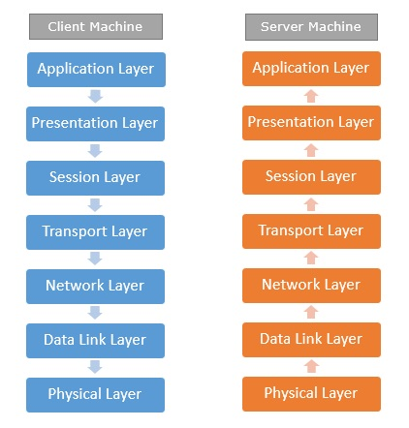

It is not necessary for every network to have all the layers. For example, network layer is not there in broadcast networks.

When a system wants to share data with another workstation or send a request over the network, it is received by the application layer. Data then proceeds to lower layers after processing till it reaches the physical layer.

At the physical layer, the data is actually transferred and received by the physical layer of the destination workstation. There, the data proceeds to upper layers after processing till it reaches application layer.

At the application layer, data or request is shared with the workstation. So each layer has opposite functions for source and destination workstations. For example, data link layer of the source workstation adds start and stop flags to the frames but the same layer of the destination workstation will remove the start and stop flags from the frames.

\*\*\*\*\*

**OSI Layer Functions:**

There are the seven OSI layers. Each layer has different functions. A list of seven layers are given below:

1. Physical Layer
2. Data-Link Layer
3. Network Layer
4. Transport Layer
5. Session Layer
6. Presentation Layer
7. Application Layer

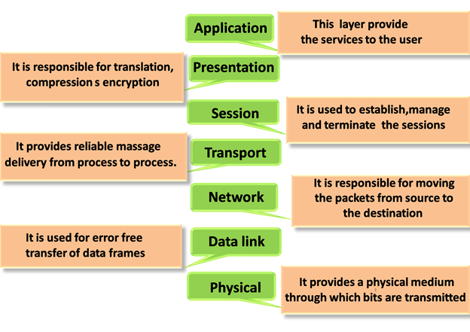

### 1.Physical layer:

* The main functionality of the physical layer is to transmit the individual bits from one node to another node.
* It is the lowest layer of the OSI model.
* It establishes, maintains and deactivates the physical connection.
* It specifies the mechanical, electrical and procedural network interface specifications.

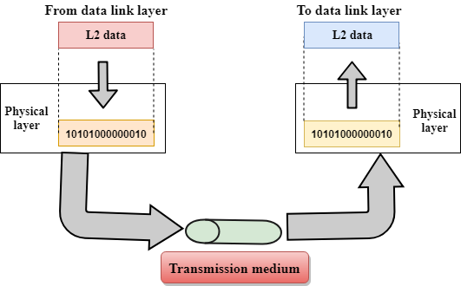

## Functions of a Physical layer:

* **Line Configuration:** It defines the way how two or more devices can be connected physically.
* [**Data Transmission**](https://www.javatpoint.com/computer-network-transmission-modes)**:** It defines the transmission mode whether it is simplex, half-duplex or full-duplex mode between the two devices on the network.
* [**Topology**](https://www.javatpoint.com/computer-network-topologies)**:** It defines the way how network devices are arranged.
* **Signals:** It determines the type of the signal used for transmitting the information.

### 2.Data-Link Layer:

* This layer is responsible for the error-free transfer of data frames.
* It defines the format of the data on the network.
* It provides a reliable and efficient communication between two or more devices.
* It is mainly responsible for the unique identification of each device that resides on a local network.
* It contains two sub-layers:
* **Logical Link Control Layer**
* **Media Access Control Layer**

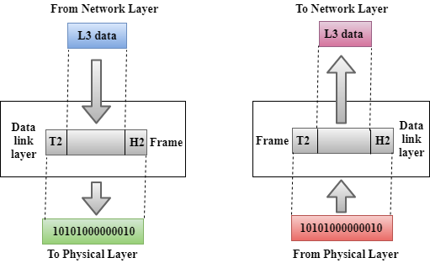

## Functions of the Data-link layer:-

* **Framing:** The data link layer translates the physical's raw bit stream into packets known as Frames. The Data link layer adds the header and trailer to the frame. The header which is added to the frame contains the hardware destination and source address.
* C:\Users\user\Desktop\osi-model5.png
* **Physical Addressing:** The Data link layer adds a header to the frame that contains a destination address. The frame is transmitted to the destination address mentioned in the header.
* **Flow Control:** Flow control is the main functionality of the Data-link layer. It is the technique through which the constant data rate is maintained on both the sides so that no data get corrupted. It ensures that the transmitting station such as a server with higher processing speed does not exceed the receiving station, with lower processing speed.
* **Error Control:** Error control is achieved by adding a calculated value CRC (Cyclic Redundancy Check) that is placed to the Data link layer's trailer which is added to the message frame before it is sent to the physical layer. If any error seems to occurr, then the receiver sends the acknowledgment for the retransmission of the corrupted frames.
* **Access Control:** When two or more devices are connected to the same communication channel, then the data link layer protocols are used to determine which device has control over the link at a given time.

### 3.Network Layer:

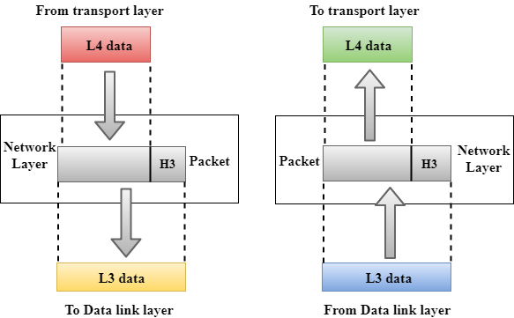

* It is a layer 3 that manages device addressing, tracks the location of devices on the network.
* It determines the best path to move data from source to the destination based on the network conditions, the priority of service, and other factors.
* The Data link layer is responsible for routing and forwarding the packets.
* Routers are the layer 3 devices, they are specified in this layer and used to provide the routing services within an internetwork.
* The protocols used to route the network traffic are known as Network layer protocols. Examples of protocols are IP and Ipv6.

## Functions of Network Layer:-

* **Internetworking:** An internetworking is the main responsibility of the network layer. It provides a logical connection between different devices.
* [**Addressing**](https://www.javatpoint.com/network-addressing)**:** A Network layer adds the source and destination address to the header of the frame. Addressing is used to identify the device on the internet.
* [**Routing**](https://www.javatpoint.com/computer-network-routing)**:** Routing is the major component of the network layer, and it determines the best optimal path out of the multiple paths from source to the destination.
* **Packetizing:** A Network Layer receives the packets from the upper layer and converts them into packets. This process is known as Packetizing. It is achieved by internet protocol (IP).

### 4.Transport Layer:

* The Transport layer is a Layer 4 ensures that messages are transmitted in the order in which they are sent and there is no duplication of data.
* The main responsibility of the transport layer is to transfer the data completely.
* It receives the data from the upper layer and converts them into smaller units known as segments.
* This layer can be termed as an end-to-end layer as it provides a point-to-point connection between source and destination to deliver the data reliably.

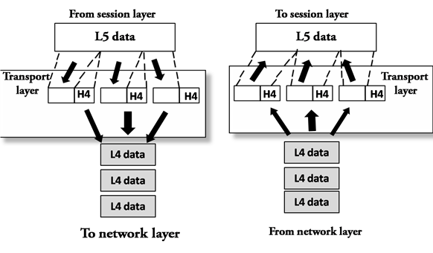

## Functions of Transport Layer:-

* **Service-point addressing:** Computers run several programs simultaneously due to this reason, the transmission of data from source to the destination not only from one computer to another computer but also from one process to another process. The transport layer adds the header that contains the address known as a service-point address or port address. The responsibility of the network layer is to transmit the data from one computer to another computer and the responsibility of the transport layer is to transmit the message to the correct process.
* **Segmentation and reassembly:** When the transport layer receives the message from the upper layer, it divides the message into multiple segments, and each segment is assigned with a sequence number that uniquely identifies each segment. When the message has arrived at the destination, then the transport layer reassembles the message based on their sequence numbers.
* **Connection control:** Transport layer provides two services Connection-oriented service and connectionless service. A connectionless service treats each segment as an individual packet, and they all travel in different routes to reach the destination. A connection-oriented service makes a connection with the transport layer at the destination machine before delivering the packets. In connection-oriented service, all the packets travel in the single route.
* **Flow control:** The transport layer also responsible for flow control but it is performed end-to-end rather than across a single link.
* **Error control:** The transport layer is also responsible for Error control. Error control is performed end-to-end rather than across the single link. The sender transport layer ensures that message reach at the destination without any error.

### 5.Session Layer:

* It is a layer 3 in the OSI model.
* The Session layer is used to establish, maintain and synchronizes the interaction between communicating devices.

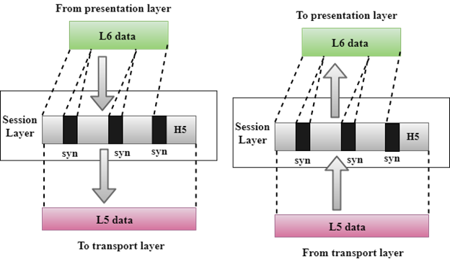

## Functions of Session layer:-

* **Dialog control:** Session layer acts as a dialog controller that creates a dialog between two processes or we can say that it allows the communication between two processes which can be either half-duplex or full-duplex.
* **Synchronization:** Session layer adds some checkpoints when transmitting the data in a sequence. If some error occurs in the middle of the transmission of data, then the transmission will take place again from the checkpoint. This process is known as Synchronization and recovery.

### 6.Presentation Layer:

* A Presentation layer is mainly concerned with the syntax and semantics of the information exchanged between the two systems.
* It acts as a data translator for a network.
* This layer is a part of the operating system that converts the data from one presentation format to another format.
* The Presentation layer is also known as the syntax layer.

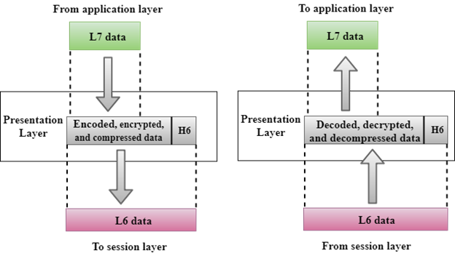

## Functions of Presentation layer:-

* **Translation:** The processes in two systems exchange the information in the form of character strings, numbers and so on. Different computers use different encoding methods, the presentation layer handles the interoperability between the different encoding methods. It converts the data from sender-dependent format into a common format and changes the common format into receiver-dependent format at the receiving end.
* **Encryption:** Encryption is needed to maintain privacy. Encryption is a process of converting the sender-transmitted information into another form and sends the resulting message over the network.
* **Compression:** Data compression is a process of compressing the data, i.e., it reduces the number of bits to be transmitted. Data compression is very important in multimedia such as text, audio, video.

### 7.Application Layer:

* An application layer serves as a window for users and application processes to access network service.
* It handles issues such as network transparency, resource allocation, etc.
* An application layer is not an application, but it performs the application layer functions.
* This layer provides the network services to the end-users.

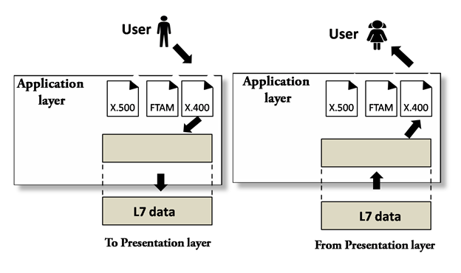

## Functions of Application layer:-

* **File transfer, access, and management (FTAM):** An application layer allows a user to access the files in a remote computer, to retrieve the files from a computer and to manage the files in a remote computer.
* **Mail services:** An application layer provides the facility for email forwarding and storage.
* Directory services: An application provides the distributed database sources and is used to provide that global information about various objects.

\*\*\*\*\*

**Internetworking Concepts, Devices, Basics, History and Architecture**

**Internetworking:**

Internet is defined as an Information super Highway, to access information over the web. However, It can be defined in many ways as follows:

* Internet is a world-wide global system of interconnected computer networks.
* Internet uses the standard Internet Protocol (TCP/IP).
* Every computer in internet is identified by a unique IP address.
* IP Address is a unique set of numbers (such as 110.22.33.114) which identifies a computer location.
* A special computer DNS (Domain Name Server) is used to give name to the IP Address so that user can locate a computer by a name.
* For example, a DNS server will resolve a name **http://www.tutorialspoint.com** to a particular IP address to uniquely identify the computer on which this website is hosted.
* Internet is accessible to every user all over the world.

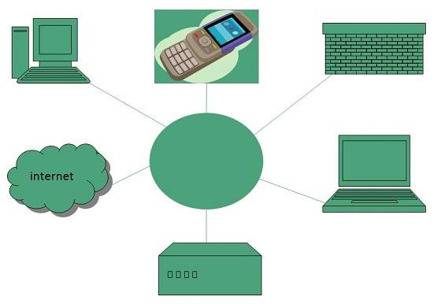

**Evolution**

The concept of Internet was originated in 1969 and has undergone several technological & Infrastructural changes as discussed below:

* The origin of Internet devised from the concept of **Advanced Research Project Agency Network (ARPANET).**
* **ARPANET** was developed by United States Department of Defense.
* Basic purpose of ARPANET was to provide communication among the various bodies of government.
* Initially, there were only four nodes, formally called **Hosts.**
* In 1972, the **ARPANET** spread over the globe with 23 nodes located at different countries and thus became known as **Internet.**
* By the time, with invention of new technologies such as TCP/IP protocols, DNS, WWW, browsers, scripting languages etc.,Internet provided a medium to publish and access information over the web.

\*\*\*\*\*

**Problems in Internetworking:**

Over the course of the last two decades, the internet has become nearly ubiquitous. From the ages of rare dial-up connections, our [relatively reliable 4G network](https://www.verizonwireless.com/archive/mobile-living/network-and-plans/what-is-3g-what-is-4g-lte-difference/) and endless options for free Wi-Fi at public establishments is its own kind of digital paradise. However, the internet isn’t perfect, and if we want to build a world where our entire population has fast, reliable, and affordable internet access, there are a number of problems we’ll need to solve.

**The Biggest Standing Internet Issues**

These are some of the biggest problems facing our development of the internet:

**1. Global inconsistencies in internet availability:** One of the internet’s biggest advantages is its ability to connect people all over the world but that world appears significantly smaller when you realize how unavailable or slow the internet is in many countries other than the United States, Japan, and other world leaders. Many African countries like Chad, Niger, and Somalia have [single-digit percentages of their respective populations](http://www.internetlivestats.com/internet-users-by-country/) with internet access, and internet speeds [vary wildly from country to country](https://www.fastmetrics.com/internet-connection-speed-by-country.php).

If we want the fullest possible use and benefit out of the internet, we need to take measures to assure the greatest number of people from countries all over the world have reliable access. [Companies like Facebook](https://www.wired.com/2016/07/facebooks-giant-internet-beaming-drone-finally-takes-flight/) are trying to solve this problem by beaming internet to remote locations via automatically piloted balloons, but it will be some time before the world is fully connected.

**2. The ever-rising demand for bandwidth:** Consumers are hungry for more bandwidth, and that increasing hunger isn’t going to wane for a long time. Consumers want higher-definition movies, faster and more frequent points of information retrieval, and more advanced user interfaces for their favorite apps and websites. That results in a [projected 30-40 percent annual increase](https://www.telegeography.com/research-services/global-bandwidth-forecast-service/) in bandwidth demand for the next several years—and somebody needs to design an infrastructural network capable of supporting that.

**3. Unexpected fluctuations in use:**  Internet companies have learned to expect a kind of ebb and flow to internet use. Late at night and early in the morning, few people are accessing content online, but during peak working hours and prime time, people stream large volumes. This isn’t problematic when you know what to anticipate; the problem comes with unexpected fluctuations, which can pop up at any time—for unpredictable reasons. [Companies like 10Gbps.io](https://10gbps.io/blog/multihomed-network-management/) are attempting to resolve this by using unmetered bandwidth dedicated servers with high uplink potential to provide ample reserve for their users.

**4. Cybercriminal access:** It’s a good thing that the internet is as widely available as it is, but that also means it’s available to hackers and cybercriminals—and wider access means more potential targets. There’s no way to eliminate cybercrime, as improving technological defenses simply results in more innovative hacking to get around them. However, we can better educate consumers and give them the resources necessary to protect themselves—even with simple measures, like choosing stronger passwords.

**5. Overreliance on major corporations:**  Chances are, you’re using an internet provider like [Comcast, AT&T, Time Warner, or CenturyLink](http://www.practicalecommerce.com/20-Top-Internet-Service-Providers). There are a small number of telecom companies capable of providing high-speed internet access, and our reliance on those major corporations leaves us vulnerable to the decisions they make—including price rate hikes and new paradigms for internet provision (including bandwidth and/or download caps).

Legislation on the provision of internet to consumers is limited, and competition is too thin to keep these companies in check with one another. Hopefully, new players or significant corporate breakups will introduce some much-needed differentiation to this group.

**6. Patchwork fixes:** This is a mentality problem rather than an infrastructural problem, but it still has a significant impact on how the internet is available (and when). Most internet providers and service providers are focused on providing uninterrupted service, and promptly respond to emergencies in an effort to minimize downtime. This isn’t bad by itself; the problem is, many organizations resort to “patchwork” fixes, temporarily correcting systems to restore internet service without addressing the infrastructural roots of the problem (or innovating new solutions that bypass them).

This keeps the internet stuck in place, and keeps technicians putting out fires rather than preventing them from happening in the first place. For example, technicians may respond to an internet outage from a [damaged underwater cable by repairing the cable](http://www.deccanchronicle.com/technology/in-other-news/161216/how-undersea-fibre-optic-cables-are-repaired.html), rather than better protecting the cable, or attempting to find a backup source of data transference.

\*\*\*\*\*

**Dealing with Incompatibility Issues:**

The only network equipment compatibility issues you're likely to run into are for wireless networks and wireless devices. The first compatibility issue is the operating system. If you're really interested in wireless networking, every computer in your house should be running Windows XP. The earlier versions of Windows just don't offer the support for wireless communications and wireless security that Windows XP offers.

#### WIRELESS ALPHABET SOUP COMPATIBILITY:-

Most of the wireless equipment you'll find today is 802.11g. If your existing equipment is 802.11b, the 802.11g network devices interoperate with wireless-b devices (this is called backward compatibility, or downward compatibility). Some 802.11g equipment is marked "wireless g-b" to indicate the compatibility, but even if you don't see that designation on the box or on the web site specifications, you can buy 802.11g devices with full confidence that they will work with your existing 802.11b equipment.

#### WIRELESS SECURITY COMPATIBILITY:-

When you buy new wireless adapters, routers, or access points to expand your network, you're going to find devices that support Wi-Fi Protected Access (WPA) security technologies. WPA is a higher-level security standard than Wired Equivalent Privacy (WEP), the previous security standard. WPA substantially raises the level of data protection and access control for wireless networks. WPA provides several benefits to enhance security, not the least of which is its support of user permissions and passwords for allowing network access. The data encryption level provided by WPA is more robust than that of WEP.

\*\*\*\*\*

**A Virtual Network:**

**Virtual networking** enables communication between multiple computers, [virtual machines (VMs)](https://www.vmware.com/topics/glossary/content/virtual-machine?SRC=WWW_US_GP_virtual-networking_SiteLink" \t "_blank), virtual servers, or other devices across different office and [data center](https://www.vmware.com/topics/glossary/content/data-center-security) locations. While physical networking connects computers through cabling and other hardware, virtual networking extends these capabilities by using software management to connect computers and servers over the Internet. It uses virtualized versions of traditional network tools, like switches and network adapters, allowing for more efficient routing and easier [network configuration](https://www.vmware.com/topics/glossary/content/network-configuration) changes.

Virtual networking enables devices across many locations to function with the same capabilities as a traditional physical network. This allows for data centers to stretch across different physical locations, and gives network administrators new and more efficient options, like the ability to easily modify the network as needs change, without having to switch out or buy more hardware; greater flexibility in provisioning the network to specific needs and applications; and the capacity to move workloads across the network infrastructure without compromising service, security, and availability.

**Virtual networking working:**

A virtual network connects virtual machines and devices, no matter their location, using software. In a physical network, layer 2 and 3 functions of the OSI model happen within physical switches and routers. Plus, physical network interface cards (NIC) and network adapters are used to connect computers and servers to the network. Virtual networking shifts these and other activities to software. A software application, called a virtual switch or vSwitch, controls and directs communication between the existing physical network and virtual parts of the network, like virtual machines. And a virtual network adapter allows computers and VMs to connect to a network, including making it possible for all the machines on a local area network (LAN) to connect to a larger network.

In a physical network, LANs are created to connect multiple devices to shared resources, like network storage, usually through Ethernet cables or Wi-Fi. But virtual networking creates the possibility for virtual LANs (VLANs), where the grouping is configured through software. This means that computers connected to different network switches can behave as if they’re all connected to the same one, and, conversely, computers that share cabling can be kept on separate networks, rather than physically connecting machines using cabling equipment and hardware.

Virtual networking delivers more centralized management and simplified network management. Disparate parts of the network can be accessed remotely for needed updates and changes, or even testing, making network management cheaper and easier.

Virtual networking is the foundation for [cloud architectures](https://www.vmware.com/topics/glossary/content/cloud-architecture) and applications, since it enables the ability to access, connect, secure, and modify cloud resources.

\*\*\*\*\*

**Internetworking Devices:**

Hardware devices that are used to connect computers, printers, fax machines and other electronic devices to a network are called **network devices**. These devices transfer data in a fast, secure and correct way over same or different networks. Network devices may be inter-network or intra-network. Some devices are installed on the device, like NIC card or RJ45 connector, whereas some are part of the network, like router, switch, etc. Let us explore some of these devices in greater detail.

**Modem:-** Modem is a device that enables a computer to send or receive data over telephone or cable lines. The data stored on the computer is digital whereas a telephone line or cable wire can transmit only analog data.

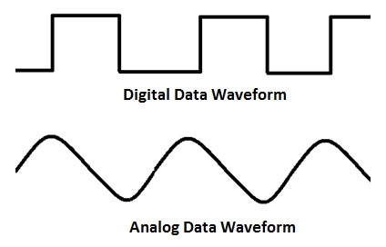

The main function of the modem is to convert digital signal into analog and vice versa. Modem is a combination of two devices **modulator** and **demodulator**. The **modulator** converts digital data into analog data when the data is being sent by the computer. The **demodulator** converts analog data signals into digital data when it is being received by the computer.

**RJ45 Connector:-** RJ45 is the acronym for **Registered Jack 45. RJ45 connector** is an 8-pin jack used by devices to physically connect to **Ethernet** based **local area networks (LANs)**. **Ethernet** is a technology that defines protocols for establishing a LAN. The cable used for Ethernet LANs are twisted pair ones and have **RJ45 connector pins** at both ends. These pins go into the corresponding socket on devices and connect the device to the network.

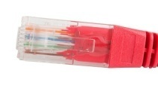

**Ethernet Card:- Ethernet card**, also known as **network interface card (NIC)**, is a hardware component used by computers to connect to **Ethernet LAN** and communicate with other devices on the LAN. The earliest **Ethernet cards** were external to the system and needed to be installed manually. In modern computer systems, it is an internal hardware component. The NIC has **RJ45 socket** where network cable is physically plugged in.

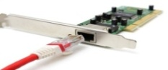

**Ethernet card speeds** may vary depending upon the protocols it supports. Old Ethernet cards had maximum speed of **10 Mbps**. However, modern cards support fast Ethernets up to a speed of **100 Mbps**. Some cards even have capacity of **1 Gbps**.

**Router:-** A **router** is a **network layer** hardware device that transmits data from one LAN to another if both networks support the same set of protocols. So a **router** is typically connected to at least two LANs and the **internet service provider** (ISP). It receives its data in the form of **packets**, which are **data frames** with their **destination address** added. Router also strengthens the signals before transmitting them. That is why it is also called **repeater**.

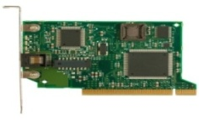

**Switch:- Switch** is a network device that connects other devices to **Ethernet** networks through **twisted pair** cables. It uses **packet switching** technique to **receive, store** and **forward data packets** on the network. The switch maintains a list of network addresses of all the devices connected to it.

On receiving a packet, it checks the destination address and transmits the packet to the correct port. Before forwarding, the packets are checked for collision and other network errors. The data is transmitted in full duplex mode

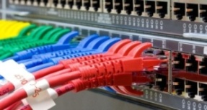

Data transmission speed in switches can be double that of other network devices like hubs used for networking. This is because switch shares its maximum speed with all the devices connected to it. This helps in maintaining network speed even during high traffic. In fact, higher data speeds are achieved on networks through use of multiple switches.

**Gateway:-** Gateway is a network device used to connect two or more dissimilar networks. In networking parlance, networks that use different protocols are dissimilar networks. A gateway usually is a computer with multiple NICs connected to different networks. A gateway can also be configured completely using software. As networks connect to a different network through gateways, these gateways are usually hosts or end points of the network.

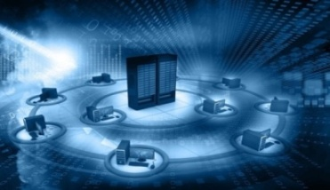

Gateway uses packet switching technique to transmit data from one network to another. In this way it is similar to a router, the only difference being router can transmit data only over networks that use same protocols.

**Wi-Fi Card:-** Wi-Fi is the acronym for wireless fidelity. Wi-Fi technology is used to achieve wireless connection to any network. Wi-Fi card is a card used to connect any device to the local network wirelessly. The physical area of the network which provides internet access through Wi-Fi is called Wi-Fi hotspot. Hotspots can be set up at home, office or any public space. Hotspots themselves are connected to the network through wires.

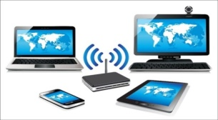

A Wi-Fi card is used to add capabilities like teleconferencing, downloading digital camera images, video chat, etc. to old devices. Modern devices come with their in-built wireless network adapter.

\*\*\*\*\*

**Repeaters:**

Repeaters are network devices operating at physical layer of the OSI model that amplify or regenerate an incoming signal before retransmitting it. They are incorporated in networks to expand its coverage area. They are also known as signal boosters.

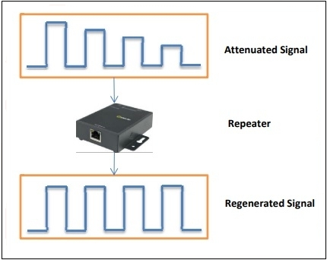

When an electrical signal is transmitted via a channel, it gets attenuated depending upon the nature of the channel or the technology. This poses a limitation upon the length of the LAN or coverage area of cellular networks. This problem is alleviated by installing repeaters at certain intervals.

Repeaters amplifies the attenuated signal and then retransmits it. Digital repeaters can even reconstruct signals distorted by transmission loss.So,repeaters are popularly incorporated to connect between two LANs thus forming a large single LAN. This is shown in the following diagram −

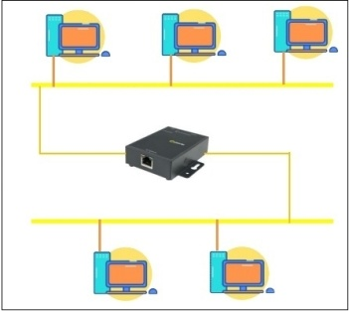

**Types of Repeaters:** According to the types of signals that they regenerate, repeaters can be classified into two categories

* **Analog Repeaters** : They can only amplify the analog signal.
* **Digital Repeaters** :They can reconstruct a distorted signal.

According to the types of networks that they connect, repeaters can be categorized into two types

* **Wired Repeaters**: They are used in wired LANs.
* **Wireless Repeaters**: They are used in wireless LANs and cellular networks.

According to the domain of LANs they connect, repeaters can be divided into two categories

* **Local Repeaters** : They connect LAN segments separated by small distance.
* **Remote Repeaters** : They connect LANs that are far from each other.

**Advantages of Repeaters:**

* Repeaters are simple to install and can easily extend the length or the coverage area of networks.
* They are cost effective.
* Repeaters don’t require any processing overhead. The only time they need to be investigated is in case of degradation of performance.
* They can connect signals using different types of cables.

**Disadvantages of Repeaters:**

* Repeaters cannot connect dissimilar networks.
* They cannot differentiate between actual signal and noise.
* They cannot reduce network traffic or congestion.
* Most networks have limitations upon the number of repeaters that can be deployed.

\*\*\*\*\*

**Bridges:**

A bridge is a network device that connects multiple LANs (local area networks) together to form a larger LAN. The process of aggregating networks is called network bridging. A bridge connects the different components so that they appear as parts of a single network. Bridges operate at the data link layer of the OSI model and hence also referred as Layer 2 switches.

The following diagram showsa bridges connecting two LANs:

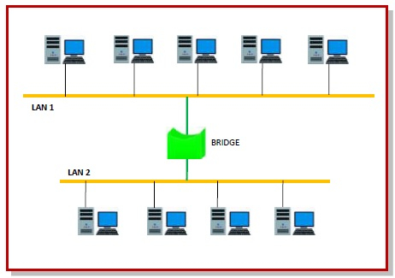

**Uses of Bridge:**

* Bridges connects two or more different LANs that has a similar protocol and provides communication between the devices (nodes) in them.
* By joining multiple LANs, bridges help in multiplying the network capacity of a single LAN.
* Since they operate at data link layer, they transmit data as data frames. On receiving a data frame, the bridge consults a database to decide whether to pass, transmit or discard the frame.
  + If the frame has a destination MAC (media access control) address in the same network, the bridge passes the frame to that node and then discards it.
  + If the frame has a destination MAC address in a connected network, it will forward the frame toward it.
* By deciding whether to forward or discard a frame, it prevents a single faulty node from bringing down the entire network.
* In cases where the destination MAC address is not available, bridges can broadcast data frames to each node. To discover new segments, they maintain the MAC address table.
* In order to provide full functional support, bridges ideally need to be transparent. No major hardware, software or architectural changes should be required for their installation.
* Bridges can switch any kind of packets, be it IP packets or AppleTalk packets, from the network layer above. This is because bridges do not examine the payload field of the data frame that arrives, but simply looks at the MAC address for switching.
* Bridges also connect virtual LANs (VLANs) to make a larger VLAN.

A wireless bridge is used to connect wireless networks or networks having a wireless segment.

\*\*\*\*\*

**Routers:**

Routers are networking devices operating at layer 3 or a network layer of the OSI model. They are responsible for receiving, analysing, and forwarding data packets among the connected computer networks. When a data packet arrives, the router inspects the destination address, consults its routing tables to decide the optimal route and then transfers the packet along this route.

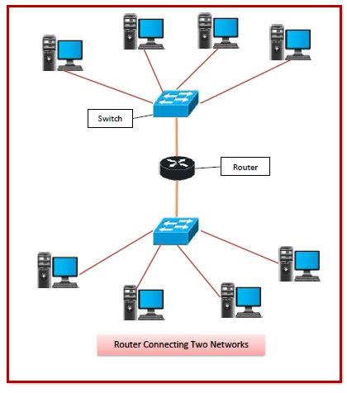

**Types of Routers:**

A variety of routers are available depending upon their usages. The main types of routers are –

* **Wireless Router:** They provide WiFi connection WiFi devices like laptops, smartphones etc. They can also provide standard Ethernet routing. For indoor connections, the range is 150 feet while its 300 feet for outdoor connections.
* **Broadband Routers:** They are used to connect to the Internet through telephone and to use voice over Internet Protocol (VoIP) technology for providing high-speed Internet access. They are configured and provided by the Internet Service Provider (ISP).
* **Core Routers:** They can route data packets within a given network, but cannot route the packets between the networks. They helps to link all devices within a network thus forming the backbone of network. It is used by ISP and communication interfaces.
* **Edge Routers:** They are low-capacity routers placed at the periphery of the networks. They connect the internal network to the external networks, and are suitable for transferring data packets across networks. They use Border Gateway Protocol (BGP) for connectivity. There are two types of edge routers, subscriber edge routers and label edge routers.
* **Brouters:**Brouters are specialised routers that can provide the functionalities of bridges as well. Like a bridge, brouters help to transfer data between networks. And like a router, they route the data within the devices of a network.

\*\*\*\*\*

**Gateways:**

A gateway is a network node that forms a passage between two networks operating with different transmission protocols. The most common type of gateways, the network gateway operates at layer 3, i.e. network layer of the OSI (open systems interconnection) model. However, depending upon the functionality, a gateway can operate at any of the seven layers of OSI model. It acts as the entry – exit point for a network since all traffic that flows across the networks should pass through the gateway. Only the internal traffic between the nodes of a LAN does not pass through the gateway.

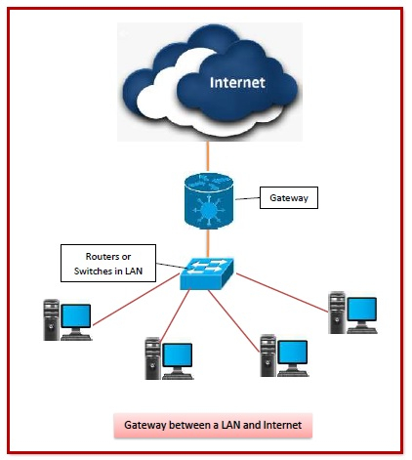

**Types of Gateways:**

On basis of direction of data flow, gateways are broadly divided into two categories −

* **Unidirectional Gateways:** They allow data to flow in only one direction. Changes made in the source node are replicated in the destination node, but not vice versa. They can be used as archiving tools.
* **Bidirectional Gateways:** They allow data to flow in both directions. They can be used as synchronization tools.

On basis of functionalities, there can be a variety of gateways, the prominent among them are as follows −

* **Network Gateway:** This is the most common type of gateway that provides as interface between two dissimilar networks operating with different protocols. Whenever the term gateway is mentioned without specifying the type, it indicates a network gateway.
* **Cloud Storage Gateway:** It is a network node or server that translates storage requests with different cloud storage service API calls, such as SOAP (Simple Object Access Protocol) or REST (REpresentational State Transfer).It facilitates integration of private cloud storage into applications without necessitating transfer of the applications into any public cloud, thus simplifying data communication.
* **Internet-To-Orbit Gateway (I2O):**It connects devices on the Internet to satellites and spacecraft orbiting the earth. Two prominent I2O gateways are Project HERMES and Global Educational Network for Satellite Operations (GENSO).
* **IoT Gateway:**IoT gateways assimilates sensor data from IoT (Internet of Things) devices in the field and translates between sensor protocols before sending it to the cloud network. They connect IoT devices, cloud network and user applications.
* **VoiP Trunk Gateway:**It facilitates data transmission between plain old telephone service (POTS) devices like landline phones and fax machines, with VoIP (voice over Internet Protocol) network.

\*\*\*\*\*

**A Brief History of the Internet:**

A [computer network](https://www.javatpoint.com/computer-network-tutorial) is a group of computers that has the potential to transmit, receive and exchange voice, data, and video traffic. A network connection can be set up with the help of either cable or wireless media. In modern times, computer networks are very important as information technology is increasing rapidly all over the world. The network and data communication are the essential factors to rise information technology in the world as technology's advancement is on the system, including the gadgets. ARPANET began the networking long ago.

In 1957, when SPUTNIK Satellite was launched by Russia. An agency named ADVANCED RESEARCH PROJECT AGENCY (ARPA) was started by American, and its first satellite was launched within 18 months after establishment. Then they used ARPANET to share the information on another computer. America's Dr. LIED LIEDER has this all responsibility. Then, ARPANET came to India in 1969, and its name changed from Indian to NETWORK.

For the United States Department of Defense, the funding of the design of the Advanced Research Projects Agency Network (ARPANET) was began by ARPA. In 1969, the network began to develop on the basis of the developed designs in the 1960s.

\*\*\*\*\*

**Growth of the Internet:**

Since its creation in 1983, the Internet has grown exponentially in terms of numbers of networks connected to it. By 1985, 100 networks, both public domain and commercial utilizing TCP/IP protocol suite became available. By 1987, the number had grown to two hundred; in 1989, it exceeded five hundred and by the end of 1991, the Internet had grown to include some 5,000 networks in over 36 countries, serving over 700,000 host computers used by over 4,000,000 people.

Over the years, there has been wave of commercialization of the Internet. Originally, commercial efforts mainly comprised vendors providing the basic networking products, and service providers offering the connectivity and basic Internet services. The Internet has now become almost a "commodity" service, and much of the latest attention has been on the use of this global information infrastructure for support of other commercial services. This has been tremendously accelerated by the widespread and rapid adoption of browsers and the World Wide Web technology, allowing users easy access to information linked throughout the globe. New products developments in technology are readily accessible as downloads that are providing increasingly sophisticated information services on top of the basic Internet data communications.

Traffic and capacity of the public Internet grew at rates of about 100% per year in the early 1990s. There was then a brief period of explosive growth in 1995 and 1996. During those two years, traffic grew by a factor of about 100, which is about 1,000% per year. In 1997, it appeared that traffic growth has slowed down to about 100% per year  and reports, such as U. S. Department of Commerce's [The Emerging Digital Economy](http://www.ecommerce.gov/emerging.html), which claim 1,000% growth rates for the Internet, appear to be inaccurate today, since they are based on a brief period of anomalously rapid growth a short while ago. Still, even a doubling each year is fantastically fast by the standards of the communications industry.  If traffic on the Internet continues to double each year, data should exceed voice on U. S. long distance networks around the year 2002.

\*\*\*\*\*

**Internet topology:**

A Network Topology is the arrangement with which computer systems or network devices are connected to each other. Topologies may define both physical and logical aspect of the network. Both logical and physical topologies could be same or different in a same network.

**Point-to-Point:-**

Point-to-point networks contains exactly two hosts such as computer, switches or routers, servers connected back to back using a single piece of cable. Often, the receiving end of one host is connected to sending end of the other and vice-versa.

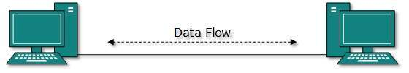

If the hosts are connected point-to-point logically, then may have multiple intermediate devices. But the end hosts are unaware of underlying network and see each other as if they are connected directly.

**Bus Topology:-**

In case of Bus topology, all devices share single communication line or cable.Bus topology may have problem while multiple hosts sending data at the same time. Therefore, Bus topology either uses CSMA/CD technology or recognizes one host as Bus Master to solve the issue. It is one of the simple forms of networking where a failure of a device does not affect the other devices. But failure of the shared communica tion line can make all other devices stop functioning.

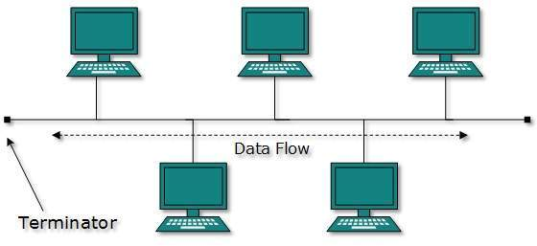

Both ends of the shared channel have line terminator. The data is sent in only one direction and as soon as it reaches the extreme end, the terminator removes the data from the line.

**Star Topology:-**

All hosts in Star topology are connected to a central device, known as hub device, using a point-to-point connection. That is, there exists a point to point connection between hosts and hub. The hub device can be any of the following:

* Layer-1 device such as hub or repeater
* Layer-2 device such as switch or bridge
* Layer-3 device such as router or gateway

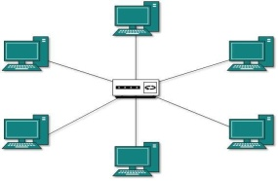

As in Bus topology, hub acts as single point of failure. If hub fails, connectivity of all hosts to all other hosts fails. Every communication between hosts, takes place through only the hub.Star topology is not expensive as to connect one more host, only one cable is required and configuration is simple.

**Ring Topology:-**

In ring topology, each host machine connects to exactly two other machines, creating a circular network structure. When one host tries to communicate or send message to a host which is not adjacent to it, the data travels through all intermediate hosts. To connect one more host in the existing structure, the admi nistrator may need only one more extra cable.

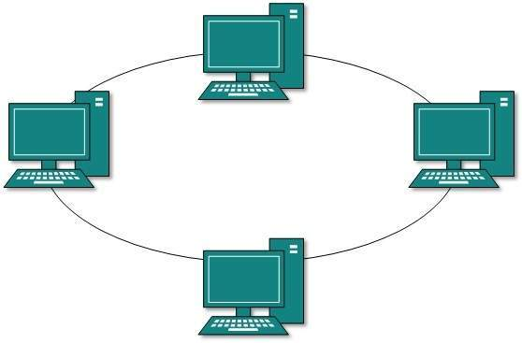

Failure of any host results in failure of the whole ring.Thus, every connection in the ring is a point of failure. There are methods which employ one more backup ring.

**Mesh Topology:-**

In this type of topology, a host is connected to one or multiple hosts.This topology has hosts in point-to-point connection with every other host or may also have hosts which are in point-to-point connection to few hosts only.

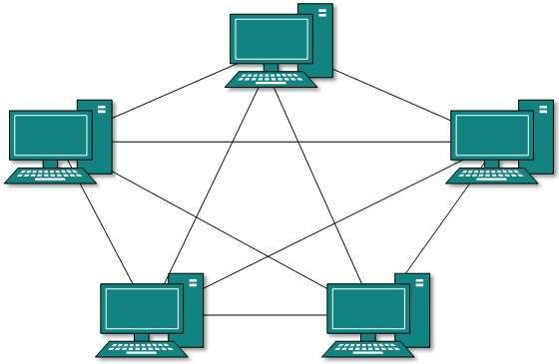

Hosts in Mesh topology also work as relay for other hosts which do not have direct point-to-point links. Mesh technology comes into two types:

* **Full Mesh**: All hosts have a point-to-point connection to every other host in the network. Thus for every new host n(n-1)/2 connections are required. It provides the most reliable network structure among all network topologies.
* **Partially Mesh**: Not all hosts have point-to-point connection to every other host. Hosts connect to each other in some arbitrarily fashion. This topology exists where we need to provide reliability to some hosts out of all.

**Tree Topology:-**

Also known as Hierarchical Topology, this is the most common form of network topology in use presently.This topology imitates as extended Star topology and inherits properties of bus topology.

This topology divides the network in to multiple levels/layers of network. Mainly in LANs, a network is bifurcated into three types of network devices. The lowermost is access-layer where computers are attached. The middle layer is known as distribution layer, which works as mediator between upper layer and lower layer. The highest layer is known as core layer, and is central point of the network, i.e. root of the tree from which all nodes fork.

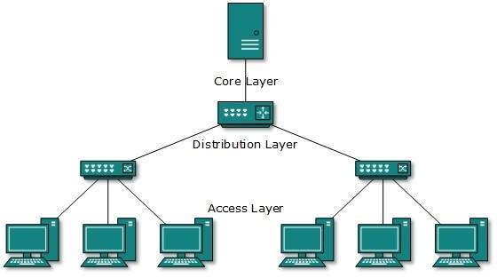

All neighboring hosts have point-to-point connection between them.Similar to the Bus topology, if the root goes down, then the entire network suffers even.though it is not the single point of failure. Every connection serves as point of failure, failing of which divides the network into unreachable segment.

**Daisy Chain:-**

This topology connects all the hosts in a linear fashion. Similar to Ring topology, all hosts are connected to two hosts only, except the end hosts.Means, if the end hosts in daisy chain are connected then it represents Ring topology.

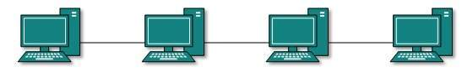

Each link in daisy chain topology represents single point of failure. Every link failure splits the network into two segments.Every intermediate host works as relay for its immediate hosts.

**Hybrid Topology:-**

A network structure whose design contains more than one topology is said to be hybrid topology. Hybrid topology inherits merits and demerits of all the incorporating topologies.

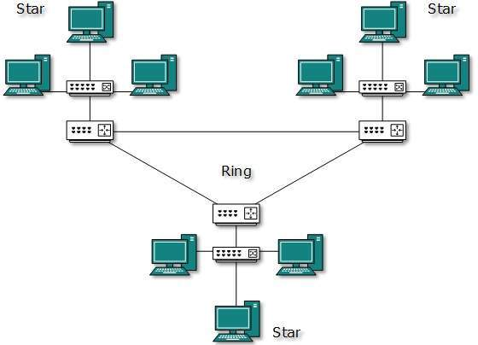

The above picture represents an arbitrarily hybrid topology. The combining topologies may contain attributes of Star, Ring, Bus, and Daisy-chain topologies. Most WANs are connected by means of Dual-Ring topology and networks connected to them are mostly Star topology networks. Internet is the best example of largest Hybrid topology.

\*\*\*\*\*

**Internal Architecture of an ISP:**

**Internet Service Provider (ISP)** is a company which provides internet connection to end user, but there are basically three levels of ISP. There are 3 levels of Internet Service Provider (ISP): Tier-1 ISP, Tier-2 ISP, and Tier-3 ISP.

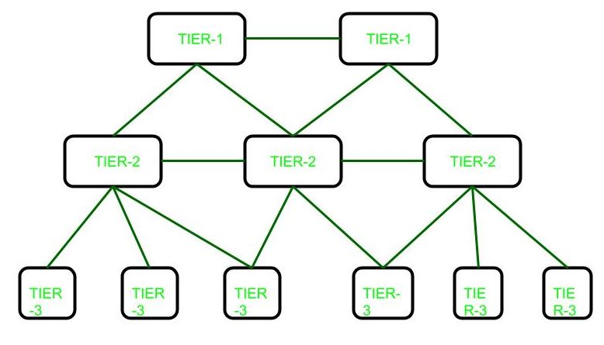

These are explained as following below.

**Tier-1 ISP:**

These ISPs are at the top of the hierarchy and they have a global reach they do not pay for any internet traffic through their network instead lower-tier ISPs have to pay a cost for passing their traffic from one geolocation to another which is not under the reach of that ISPs. Generally, ISPs at the same level connect to each other and allow free traffic passes to each other. Such ISPs are called peers. Due to this cost is saved. They build infrastructure, such as the Atlantic Internet sea cables, to provide traffic to all other Internet service providers, not to end users.

**Examples:**   
Some examples of tier 1 Internet providers:

Cogent Communications,

Hibernia Networks,

AT&T

**Tier-2 ISP:**   
These ISPs are service provider who connect between tier 1 and tier 3 ISPs. They have regional or country reach and they behave just like Tier-1 ISP for Tier-3 ISPs.

**Examples:**   
Examples of tier 2 ISPs:

Vodafone,

Easynet,

BT

**Tier-3 ISP:**   
These ISPs are closest to the end users and helps them to connect to the internet by charging some money. These ISPs work on purchasing model. These ISPs have to pay some cost to Tier-2 ISPs based on traffic generated.

**Examples:**   
Examples of Tier-3 ISPs:

Comcast,

Deutsche Telekom,

Verizon Communications

\*\*\*\*\*

**TCP/IP Part I**

**(Introduction to TCP/IP, IP, ARP, RARP, ICMP)**

**TCP/IP Basics:**

* The TCP/IP model was developed prior to the OSI model.
* The TCP/IP model is not exactly similar to the OSI model.
* The TCP/IP model consists of five layers: the application layer, transport layer, network layer, data link layer and physical layer.
* The first four layers provide physical standards, network interface, internetworking, and transport functions that correspond to the first four layers of the OSI model and these four layers are represented in TCP/IP model by a single layer called the application layer.
* TCP/IP is a hierarchical protocol made up of interactive modules, and each of them provides specific functionality.

Here, hierarchical means that each upper-layer protocol is supported by two or more lower-level protocols.

**Functions of TCP/IP layers:-**

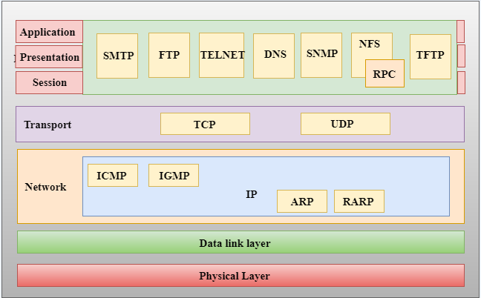

**Network Access Layer:-**

* A network layer is the lowest layer of the TCP/IP model.
* A network layer is the combination of the Physical layer and Data Link layer defined in the OSI reference model.
* It defines how the data should be sent physically through the network.
* This layer is mainly responsible for the transmission of the data between two devices on the same network.
* The functions carried out by this layer are encapsulating the IP datagram into frames transmitted by the network and mapping of IP addresses into physical addresses.
* The protocols used by this layer are ethernet, token ring, FDDI, X.25, frame relay.

**Internet Layer:-**

* An internet layer is the second layer of the TCP/IP model.
* An internet layer is also known as the network layer.
* The main responsibility of the internet layer is to send the packets from any network, and they arrive at the destination irrespective of the route they take.

\*\*\*\*\*

**Why IP Addresses?**

IP (Internet Protocol) addresses are used to identify hardware devices on a network. The addresses allow these devices to connect to one another and transfer data on a local network or over the internet.

Each address is a string of numbers separated by periods. There are four numbers in total and each number can range between 0 and 255. An example of an IP address would be: 506.457.14.512

We need billions of IP addresses to identify every computer, router and website on the internet. One day we’ll run out of unique addresses and a new IPv6 protocol has been designed to meet this need.

#### How Do I Find Out my IP Address?

If your computer is connected to both your local network and the internet, then it will have two IP addresses. You’ll have a private IP address locally, and a public IP address on the internet.

A **private IP address** is used to connect your computer or device to your home or business network. This address is normally assigned by your network router.

Private IP addresses are in the range 40.xxx.xxx.xxx or 192.168.xxx.xxx. An example of a private IP address is 192.168.1.1.

There are a few ways to discover your private IP address. For example, on Windows you can type ipconfig on the command prompt. Similarly, Mac users can type the command ifconfigin the Terminal app.

Your **public IP address** is used to connect your home or business network to the internet. This address is assigned by your internet service provider (ISP).

To find your public IP address, simply go to [WhatIsMyIP.com](https://www.whatismyip.com/) in your web browser. This site will display your public IP address and other information.

If you have a WordPress website, it will also have a public IP address. You can learn its address by visiting your hosting provider or checking the email they sent you when you signed up.

Alternatively, you can use WhatIsMyIP’s [DNS Lookup](https://www.whatismyip.com/dns-lookup/) tool. Once you type in your website’s URL the website will display its IP address.

\*\*\*\*\*

**Logical Addresses:**

Usually, computers communicate through the Internet. The packet(data) transmitted by the sender computer may pass through several LANs or WANs before reaching the destination computer. For this level of communication, we need a global addressing scheme what we call **logical addressing**. An **IP address** is used globally to refer to the logical address in the network layer of the TCP/IP protocol.

The Internet addresses are 32 bits in length; this gives us a maximum of **232** addresses. These addresses are referred to as **IPv4 (IP version 4) addresses** or popularly as **IP addresses**.

**IPV4 addresses:-**

An **IPv4 address** is a 32-bit address that uniquely and universally defines the connection of a device (for example, a computer or a router) to the Internet. They are unique so that each address defines only one connection to the Internet. Two devices on the Internet can never have the same **IPV4 address** at the same time.

On the other hand, if a device operating at the network layer has ***m*** connections to the Internet, it needs to have ***m*** addresses, for example, a router.

The **IPv4 addresses** are universal in the sense that the addressing system must be accepted by any host that wants to be connected to the Internet. That means global addressing.

### Address Space:-

IPv4 has a certain address space. An address space is the total number of addresses used by the protocol. If a protocol uses ***N*** bits to define an address, the address space is **2N**

IPv4 uses 32-bit address format, which means that the address space is 232 or 4,294,967,296

### Notations:-

There are two notations to show an **IPv4 address**:

1. Binary notation
2. Dotted decimal notation

**1) Binary Notation:-**

In binary notation, the IPv4 address is displayed as 32 bits. Each octet is often referred to as a byte. So it is common to hear an IPv4 address referred to a 4-byte address. The following is an example of an IPv4 address in binary notation: 01110111 10010101 00000001 00000011

**2) Dotted-Decimal Notation:-**

IPV4 addresses are usually written in decimal form with a decimal point (dot) separating the bytes since it’s more compatible. The following is an example: 119.149.1.3 (above one and this one is same just different notation)

\*\*\*\*\*

**TCP/IP Example:**

**When a computer is installed on a TCP/IP network** (or dials into a TCP/IP network), it must be given four pieces of network layer addressing and routing information before it can operate. This information can be provided by a configuration file, or via a DHCP server. The information is

**1.** Its IP address

**2.** A subnet mask, so it can determine what addresses are part of its subnet

**3.** The IP address of a DNS server, so it can translate application layer addresses into IP addresses

**4.** The IP address of an IP gateway (commonly called a router) leading outside of its subnet, so it can route messages addressed to computers outside of its subnet (this presumes the computer is using static routing and there is only one connection from it to the outside world through which all messages must flow; if it used dynamic routing, some routing software would be needed instead)

These four pieces of information are the minimum required. A server would also need to know its application layer address.

**In this section,** we use the simple network shown in Figure 5.13 to illustrate how TCP/IP works. This figure shows an organization that has four LANs connected by a BN. The BN also has a connection to the Internet. Each building is configured as a separate subnet. For example, Building A has the 128.192.98.x subnet, whereas Building B has the 128.192.95.x subnet. The BN is its own subnet: 128.192.254.x. Each building is connected to the BN via a router that has two IP addresses and two data link layer addresses, one for the connection into the building and one for the connection onto the BN. The organization has several Web servers spread throughout the four buildings. The DNS server and the router onto the Internet are located directly on the BN itself. For simplicity, we will assume that all networks use Ethernet as the data link layer and will only focus on Web requests at the application layer.

**In the sections below,** we describe how messages are sent through the network. For the sake of simplicity, we will initially ignore the need to establish and close TCP connections. Once you understand the basic concepts, we will then add these in to complete the example.

**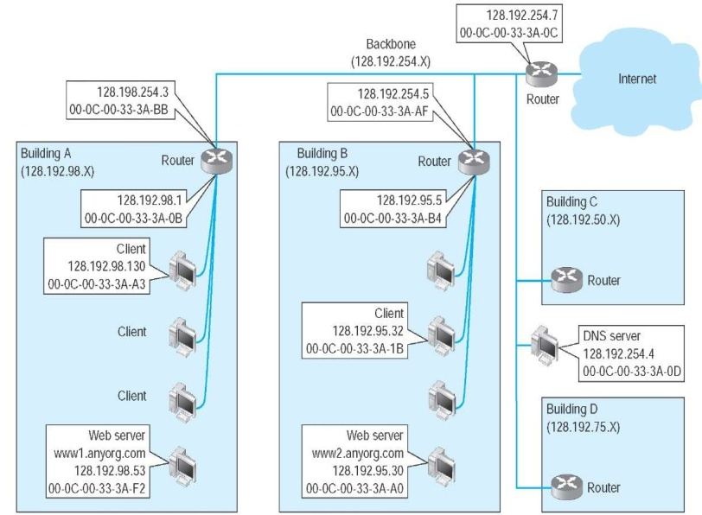**

**Example Transmission Control Protocol/Internet Protocol (TCP/IP) network**

\*\*\*\*\*

**The Concept of IP Address:**

Here, IP stands for **internet protocol**. It is a protocol defined in the TCP/IP model used for sending the packets from source to destination. The main task of IP is to deliver the packets from source to the destination based on the IP addresses available in the packet headers. IP defines the packet structure that hides the data which is to be delivered as well as the addressing method that labels the datagram with a source and destination information.

An IP protocol provides the connectionless service, which is accompanied by two transport protocols, i.e., [TCP/IP](https://www.javatpoint.com/tcp-ip-full-form) and UDP/IP, so internet protocol is also known as [TCP/IP](https://www.javatpoint.com/computer-network-tcp-ip-model) or [UDP](https://www.javatpoint.com/udp-full-form)/IP.

The first version of IP (Internet Protocol) was IPv4. After IPv4, IPv6 came into the market, which has been increasingly used on the public internet since 2006.

### History of Internet Protocol

The development of the protocol gets started in 1974 by **Bob Kahn and Vint Cerf**. It is used in conjunction with the Transmission Control Protocol (TCP), so they together named the [TCP/IP](https://www.javatpoint.com/tcp-ip-full-form).

The first major version of the internet protocol was IPv4, which was version 4. This protocol was officially declared in RFC 791 by the Internet Engineering Task Force (IETF) in 1981.

After IPv4, the second major version of the internet protocol was IPv6, which was version 6. It was officially declared by the IETF in 1998. The main reason behind the development of IPv6 was to replace IPv4. There is a big difference between IPv4 and IPv6 is that IPv4 uses 32 bits for addressing, while IPv6 uses 128 bits for addressing.

### Function:

The main function of the internet protocol is to provide addressing to the hosts, encapsulating the data into a packet structure, and routing the data from source to the destination across one or more [IP](https://www.javatpoint.com/ip-full-form) networks. In order to achieve these functionalities, [internet](https://www.javatpoint.com/internet) protocol provides two major things which are given below.

**An internet protocol defines two things:**

* Format of IP packet
* IP Addressing system

**IP packet:**

Before an IP packet is sent over the network, two major components are added in an IP packet, i.e., **header** and a **payload**.

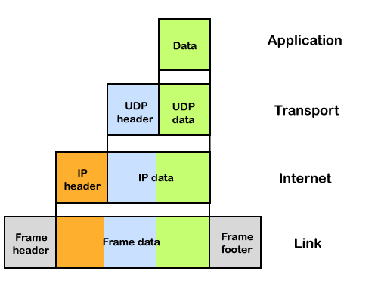

An IP header contains lots of information about the IP packet which includes:

* Source IP address: The source is the one who is sending the data.
* Destination IP address: The destination is a host that receives the data from the sender.
* Header length
* Packet length
* TTL (Time to Live): The number of hops occurs before the packet gets discarded.
* Transport protocol: The transport protocol used by the internet protocol, either it can be TCP or UDP.

There is a total of 14 fields exist in the IP header, and one of them is optional.

**Payload:** Payload is the data that is to be transported.

\*\*\*\*\*

**Address Resolution Protocol (ARP):**

Address Resolution Protocol (ARP) is a communication protocol used to find the MAC (Media Access Control) address of a device from its IP address. This protocol is used when a device wants to communicate with another device on a Local Area Network or Ethernet.

## Types of ARP:-

**There are four types of Address Resolution Protocol, which is given below:**

* Proxy ARP
* Gratuitous ARP
* Reverse ARP (RARP)
* Inverse ARP

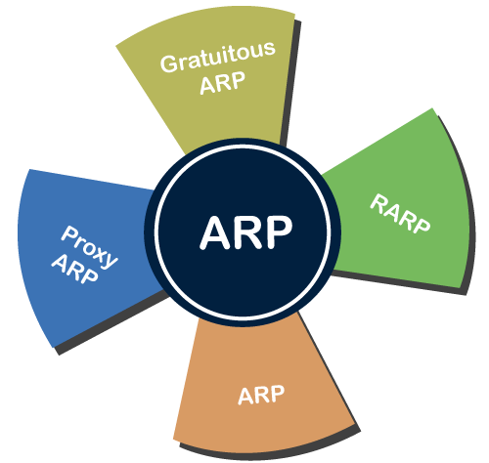

**1.Proxy ARP -** Proxy ARP is a method through which a Layer 3 devices may respond to ARP requests for a target that is in a different network from the sender. The Proxy [ARP](https://www.javatpoint.com/address-resolution-protocol) configured router responds to the ARP and map the MAC address of the router with the target [IP](https://www.javatpoint.com/ip-full-form) address and fool the sender that it is reached at its destination.

At the backend, the proxy router sends its packets to the appropriate destination because the packets contain the necessary information.

**Example -** If Host A wants to transmit data to Host B, which is on the different network, then Host A sends an ARP request message to receive a MAC address for Host B. The router responds to Host A with its own MAC address pretend itself as a destination. When the data is transmitted to the destination by Host A, it will send to the gateway so that it sends to Host B. This is known as proxy ARP.

**2.Gratuitous ARP -** Gratuitous ARP is an [ARP request](https://www.javatpoint.com/arp-request) of the host that helps to identify the duplicate IP address. It is a broadcast request for the IP address of the router. If an ARP request is sent by a switch or router to get its IP address and no ARP responses are received, so all other nodes cannot use the IP address allocated to that switch or router. Yet if a router or switch sends an ARP request for its IP address and receives an ARP response, another node uses the IP address allocated to the switch or router.

**There are some primary use cases of gratuitous ARP that are given below:**

* The gratuitous ARP is used to update the ARP table of other devices.
* It also checks whether the host is using the original IP address or a duplicate one.

**3.Reverse ARP (RARP) -** It is a networking protocol used by the client system in a local area network (LAN) to request its IPv4 address from the ARP gateway router table. A table is created by the network administrator in the gateway-router that is used to find out the MAC address to the corresponding IP address.

When a new system is set up or any machine that has no memory to store the IP address, then the user has to find the IP address of the device. The device sends a RARP broadcast packet, including its own MAC address in the address field of both the sender and the receiver hardware. A host installed inside of the local network called the RARP-server is prepared to respond to such type of broadcast packet. The RARP server is then trying to locate a mapping table entry in the IP to MAC address. If any entry matches the item in the table, then the RARP server sends the response packet along with the IP address to the requesting computer.

**4.Inverse ARP (InARP) -** Inverse ARP is inverse of the ARP, and it is used to find the IP addresses of the nodes from the data link layer addresses. These are mainly used for the frame relays, and ATM networks, where Layer 2 virtual circuit addressing are often acquired from Layer 2 signaling. When using these virtual circuits, the relevant Layer 3 addresses are available.

ARP conversions Layer 3 addresses to Layer 2 addresses. However, its opposite address can be defined by InARP. The InARP has a similar packet format as ARP, but operational codes are different.

\*\*\*\*\*

**Reverse ARP:**

Reverse Address Resolution Protocol (RARP) is a network-specific standard protocol. It is described in RFC 903. Some network hosts, such as a diskless workstation, do not know their own IP address when they are booted. To determine their own IP address, they use a mechanism similar to ARP, but now the hardware address of the host is the known parameter, and the IP address is the queried parameter.

The reverse address resolution is performed the same way as the ARP address resolution. The same packet format is used for the ARP.

An exception is the operation code field that now takes the following values−

* 3 for RARP request
* 4 for RARP reply

The physical header of the frame will now indicate RARP as the higher-level protocol (8035 hex) instead of ARP (0806 hex) or IP-(0800 hex) in the Ether type field.

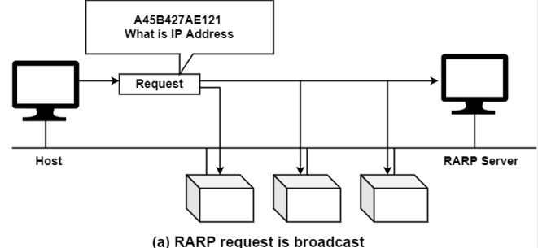

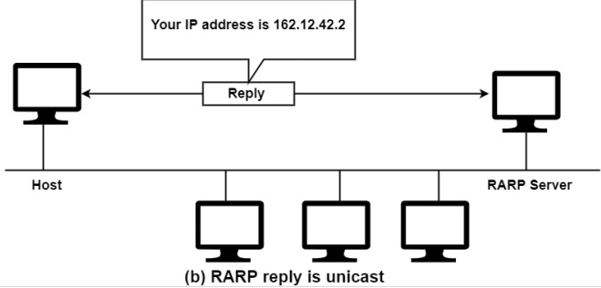

When a framework with a local disk is bootstrapped, it generally accepts its IP address from a configuration document that's read from a disk file. But a system without a disk, including an X terminal or a diskless workstation, needs some other way to accept its IP address.

The feature of RARP is for the diskless framework to read its specific hardware address from the interface card and send a RARP request asking for someone to reply with the diskless systems IP address.

The format of a RARP packet is almost identical to an ARP packet. The only difference is that the frame type is 0X8035 for a RARP request or reply, and the op-field has a value of 3 for a RARP request and 4 for a RARP reply.

The problem with RARP includes its use of a link-layer broadcast, preventing most routers from forwarding a RARP request, and the minimal information returned just the system's IP address. While the RARP concept is easy, the implementation of a RARP server is system dependent.

Some differences arise from the concept of RARP itself−

* ARP only assumes that every host knows the mapping between its own hardware address and protocol address. RARP requires one or more server hosts in the network to maintain a database of mapping between hardware address and protocol address so that they will be able to reply to requests from client hosts.
* Due to the size of this database, part of the server function is usually implemented outside the adapter−s microcode, with optionally a small cache in the microcode. The microcode part is then only responsible for reception and transmission of the RARP frames, the RARP mapping itself being taken care of by server software running as a normal process on the host machine.
* The nature of this database also requires some software to create and update the database manually.
* If there are multiple RARP servers in the network, the RARP requests only uses the first RARP reply received in response to its broadcast RARP request and discards the others.

\*\*\*\*\*

**Internet Control Message Protocol (ICMP):**

The ICMP stands for Internet Control Message Protocol. It is a network layer protocol. It is used for error handling in the network layer, and it is primarily used on network devices such as routers. As different types of errors can exist in the network layer, so ICMP can be used to report these errors and to debug those errors.

For example, some sender wants to send the message to some destination, but the router couldn't send the message to the destination. In this case, the router sends the message to the sender that I could not send the message to that destination.

The [IP](https://www.javatpoint.com/ip) protocol does not have any error-reporting or error-correcting mechanism, so it uses a message to convey the information. For example, if someone sends the message to the destination, the message is somehow stolen between the sender and the destination. If no one reports the error, then the sender might think that the message has reached the destination. If someone in-between reports the error, then the sender will resend the message very quickly.

### Position of ICMP in the network layer:-

**The ICMP resides in the**[**IP**](https://www.javatpoint.com/ip-full-form)**layer, as shown in the below diagram.**

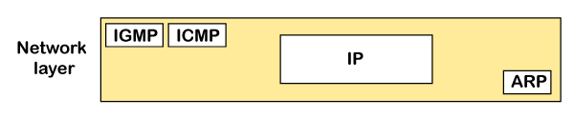

### Messages:-

**The ICMP messages are usually divided into two categories:**

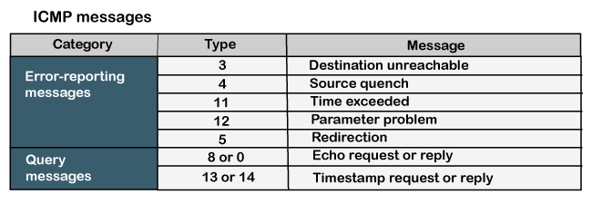

**Error-reporting messages:-** The error-reporting message means that the router encounters a problem when it processes an IP packet then it reports a message.

**Query messages:-** The query messages are those messages that help the host to get the specific information of another host. For example, suppose there are a client and a server, and the client wants to know whether the server is live or not, then it sends the ICMP message to the server.

### ICMP Message Format:-

The message format has two things; one is a category that tells us which type of message it is. If the message is of error type, the error message contains the type and the code. The type defines the type of message while the code defines the subtype of the message.

**The ICMP message contains the following fields:**

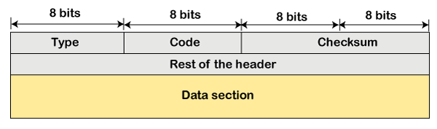

* **Type:** It is an 8-bit field. It defines the ICMP message type. The values range from 0 to 127 are defined for ICMPv6, and the values from 128 to 255 are the informational messages.
* **Code:** It is an 8-bit field that defines the subtype of the ICMP message
* **Checksum:** It is a 16-bit field to detect whether the error exists in the message or not.

**\*\*\*\*\***

**Datagram, Fragmentation and Reassembly:**

**Datagram:-**

In a connectionless communication systems, datagram refers to the smallest unit via which data is transmitted. Datagrams are data packets which contain adequate header information so that they can be individually routed by all intermediate network switching devices to the destination. These networks are called datagram networks since communication occurs via datagrams. They exist in packet switching networks.

**Features of Datagram Networks**

* Datagram switching is done at the network layer of the communication system.
* In datagram networks, each data packet or datagram is routed independently from the source to the destination even if they belong to the same message. The network treats the packet as if it exists alone.
* Since the datagrams are treated as independent units, no dedicated path is fixed for data transfer. Each datagram is routed by the intermediate routers using dynamically changing routing tables. So two successive packets from the source may follow completely separate routes to reach destination.
* In these networks, no prior resource allocation is done for the individual packets. This implies that no resources like buffers, processors, bandwidth, etc. are reserved before the communication commences.
* In datagram networks, resources are allocated on demand on a First−Come First−Serve (FCFS) basis. When a packet arrives at a router, the packet must wait if there are other packets being processed, irrespective of its source or destination.
* Datagram communication is generally guided by User Datagram Protocol or UDP.

The following diagram shows datagram packets being send by host H1 to host H2. The four datagram packets labelled as A, B, C and D, all belonging to same message are being routed separately via separate routes. The packets in the message arrives in the destination out of order. It is the responsibility of H2 to reorder the packets in order to retrieve the original message.

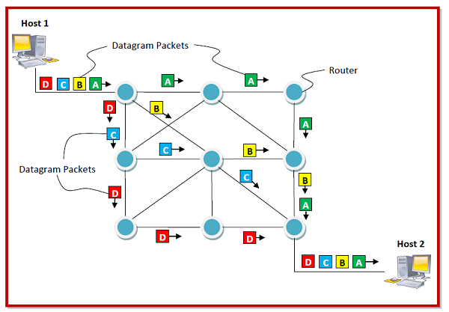

**Fragmentation:-**

**Fragmentation** is done by the network layer when the maximum size of datagram is greater than maximum size of data that can be held a frame i.e., its Maximum Transmission Unit (MTU). The network layer divides the datagram received from transport layer into fragments so that data flow is not disrupted.

* Since there are 16 bits for total length in IP header so, maximum size of IP datagram = 216 – 1 = 65, 535 bytes.

C:\Users\user\Desktop\fr.png

* It is done by network layer at the destination side and is usually done at routers.
* Source side does not require fragmentation due to wise (good) segmentation by transport layer i.e. instead of doing segmentation at transport layer and fragmentation at network layer, the transport layer looks at datagram data limit and frame data limit and does segmentation in such a way that resulting data can easily fit in a frame without the need of fragmentation.

C:\Users\user\Desktop\fr-1.png

* Receiver identifies the frame with the **identification (16 bits)** field in IP header. Each fragment of a frame has same identification number.
* Receiver identifies sequence of frames using the **fragment offset(13 bits)** field in IP header
* An overhead at network layer is present due to extra header introduced due to fragmentation.

### Fields in IP header for fragmentation –

* **Identification (16 bits) –** use to identify fragments of same frame.
* **Fragment offset (13 bits) –** use to identify sequence of fragments in the frame. It generally indicates number of data bytes preceeding or ahead of the fragment.  
  Maximum fragment offset possible = (65535 – 20) – 1 = 65514  
  {where 65535 is maximum size of datagram and 20 is minimum size of IP header}  
  So, we need ceil(log265514) = 16 bits for fragment offset but fragment offset field has only 13 bits. So, to represent efficiently we need to scale down fragment offset field by 216/213 = 8 which acts as a scaling factor. Hence, all fragments except the last fragment should have data in multiples of 8 so that fragment offset ∈ N.
* **More fragments (MF = 1 bit) –** tells if more fragments ahead of this fragment i.e. if MF = 1, more fragments are ahead of this fragment and if MF = 0, it is the last fragment.
* **Don’t fragment (DF = 1 bit) –** if we don’t want the packet to be fragmented then DF is set i.e. DF = 1.

### Reassembly of Fragments –

It takes place only at destination and not at routers since packets take independent path(datagram packet switching), so all may not meet at a router and hence a need of fragmentation may arise again. The fragments may arrive out of order also.

C:\Users\user\Desktop\fr-2.png

\*\*\*\*\*

**UNIT II**

**TCP/IP Part II** (TCP, UDP):Basics of TCP, Features of TCP, Relationship between TCP and IP, Ports and Sockets, Connections-Passive Open and Active Open, TCP connections, What Makes TCP Reliable? TCP Packet Format, Persistent TCP Connections, User Datagram Protocol, UDP Packet, Difference between UDP and TCP

**TCP/IP Part III** (DNS, Email, FTP, TFTP): Domain Name System (DNS), Electronic Mail (Email), File Transfer Protocol (FTP)**,** Trivial File Transfer Protocol (TFTP)

**TCP/IP Part IV** (WWW, HTTP, TELNET): A Brief History of WWW, Basics of WWW and Browsing, Locating Information on the Internet, HTML, Web Browser Architecture, Web Pages and Multimedia, Remote Login (TELNET).

**An Introduction to Electronic Commerce:** Aspects of Electronic Commerce, Types of E Commerce, Approaches for Developing E Commerce Solutions, Electronic Procurement, Phases in a Procurement Process, E-Procurement Models, E-Procurement Solutions, Trading Models, Buyer Side Purchasing, Supply Chain Management (SCM) and Customer Relationship Management (CRM)

**TCP/IP Part II (TCP, UDP)**

**Basics of TCP:**

* The TCP/IP model was developed prior to the OSI model.
* The TCP/IP model is not exactly similar to the OSI model.
* The TCP/IP model consists of five layers: the application layer, transport layer, network layer, data link layer and physical layer.
* The first four layers provide physical standards, network interface, internetworking, and transport functions that correspond to the first four layers of the OSI model and these four layers are represented in TCP/IP model by a single layer called the application layer.
* TCP/IP is a hierarchical protocol made up of interactive modules, and each of them provides specific functionality.

Here, hierarchical means that each upper-layer protocol is supported by two or more lower-level protocols.

**Functions of TCP/IP layers:-**



**Network Access Layer:-**

* A network layer is the lowest layer of the TCP/IP model.
* A network layer is the combination of the Physical layer and Data Link layer defined in the OSI reference model.
* It defines how the data should be sent physically through the network.
* This layer is mainly responsible for the transmission of the data between two devices on the same network.
* The functions carried out by this layer are encapsulating the IP datagram into frames transmitted by the network and mapping of IP addresses into physical addresses.
* The protocols used by this layer are ethernet, token ring, FDDI, X.25, frame relay.

**Internet Layer:-**

* An internet layer is the second layer of the TCP/IP model.
* An internet layer is also known as the network layer.
* The main responsibility of the internet layer is to send the packets from any network, and they arrive at the destination irrespective of the route they take.

\*\*\*\*\*

**Features of TCP:**

The following are the features of a TCP protocol:

* **Transport Layer Protocol:** TCP is a transport layer protocol as it is used in transmitting the data from the sender to the receiver.
* **Reliable**: TCP is a reliable protocol as it follows the flow and error control mechanism. It also supports the acknowledgment mechanism, which checks the state and sound arrival of the data. In the acknowledgment mechanism, the receiver sends either positive or negative acknowledgment to the sender so that the sender can get to know whether the data packet has been received or needs to resend.
* **Order of the data is maintained**: This protocol ensures that the data reaches the intended receiver in the same order in which it is sent. It orders and numbers each segment so that the TCP layer on the destination side can reassemble them based on their ordering.
* **Connection-oriented**: It is a connection-oriented service that means the data exchange occurs only after the connection establishment. When the data transfer is completed, then the connection will get terminated.
* **Full duplex**: It is a full-duplex means that the data can transfer in both directions at the same time.
* **Stream-oriented**: TCP is a stream-oriented protocol as it allows the sender to send the data in the form of a stream of bytes and also allows the receiver to accept the data in the form of a stream of bytes. TCP creates an environment in which both the sender and receiver are connected by an imaginary tube known as a virtual circuit. This virtual circuit carries the stream of bytes across the internet.

\*\*\*\*\*

**Relationship between TCP and IP:**

The TCP/IP model is the default method of data communication on the Internet.  It was developed by the United States Department of Defense to enable the accurate and correct transmission of data between devices. It breaks messages into packets to avoid having to resend the entire message in case it encounters a problem during transmission. Packets are automatically reassembled once they reach their destination. Every packet can take a different route between the source and the destination computer, depending on whether the original route used becomes congested or unavailable.

TCP/IP divides communication tasks into layers that keep the process standardized, without hardware and software providers doing the management themselves. The data packets must pass through four layers before they are received by the destination device, then TCP/IP goes through the layers in reverse order to put the message back into its original format.

As a connection based protocol, the TCP establishes and maintains a connection between applications or devices until they finish exchanging data. It determines how the original message should be broken into packets, numbers and reassembles the packets, and sends them on to other devices on the network, such as routers, security gateways, and switches, then on to their destination. TCP also sends and receives packets from the network layer, handles the transmission of any dropped packets, manages flow control, and ensures all packets reach their destination.

A good example of how this works in practice is when an email is sent using SMTP from an email server. To start the process, the TCP layer in the server divides the message into packets, numbers them, and forwards them to the IP layer, which then transports each packet to the destination email server. When packets arrive, they are handed back to the TCP layer to be reassembled into the original message format and handed back to the email server, which delivers the message to a user’s email inbox.

TCP/IP uses a three-way handshake to establish a connection between a device and a server, which ensures multiple TCP socket connections can be transferred in both directions concurrently. Both the device and server must synchronize and acknowledge packets before communication begins, then they can negotiate, separate, and transfer TCP socket connections.

## The 4 Layers of the TCP/IP Model:-

The TCP/IP model defines how devices should transmit data between them and enables communication over networks and large distances. The model represents how data is exchanged and organized over networks. It is split into four layers, which set the standards for data exchange and represent how data is handled and packaged when being delivered between applications, devices, and servers.

The four layers of the TCP/IP model are as follows:

1. **Datalink layer:**- The datalink layer defines how data should be sent, handles the physical act of sending and receiving data, and is responsible for transmitting data between applications or devices on a network. This includes defining how data should be signaled by hardware and other transmission devices on a network, such as a computer’s device driver, an Ethernet cable, a network interface card (NIC), or a wireless network. It is also referred to as the link layer, network access layer, network interface layer, or physical layer and is the combination of the physical and data link layers of the [Open Systems Interconnection (OSI) model](https://www.fortinet.com/resources/cyberglossary/osi-model), which standardizes communications functions on computing and telecommunications systems.
2. **Internet layer:-** The internet layer is responsible for sending packets from a network and controlling their movement across a network to ensure they reach their destination. It provides the functions and procedures for transferring data sequences between applications and devices across networks.
3. **Transport layer:-**  The transport layer is responsible for providing a solid and reliable data connection between the original application or device and its intended destination. This is the level where data is divided into packets and numbered to create a sequence. The transport layer then determines how much data must be sent, where it should be sent to, and at what rate. It ensures that data packets are sent without errors and in sequence and obtains the acknowledgment that the destination device has received the data packets.
4. **Application layer:-**  The application layer refers to programs that need TCP/IP to help them communicate with each other. This is the level that users typically interact with, such as email systems and messaging platforms. It combines the session, presentation, and application layers of the OSI model.

\*\*\*\*\*

**Ports and Sockets:**

**Ports:-** A port is a physical docking point using which an external device can be connected to the computer. It can also be programmatic docking point through which information flows from a program to the computer or over the Internet.

A network port which is provided by the Transport Layer protocols of Internet Protocol suite, such as Transmission Control Protocol (TCP) and User Diagram Protocol (UDP) is a number which serving endpoint communication between two computers.

To determine what protocol incoming traffic should be directed to, different port numbers are used. They allow a single host with a single IP address to run network services. Each port number have a distinct service, and for each host can have 65535 ports per IP address. **Internet Assigned Numbers Authority  (IANA)**is responsible for managing the uses of these ports. There are three categories for ports by IANA –

* 0 to 1023 – well known ports or system ports.

Some well-known ports are −

| **Port number** | **Transport protocol** | **Service name** |
| --- | --- | --- |
| 20,21 | TCP | File Transfer Protocol |
| 23 | TCP | Telnet |
| 25 | TCP | Simple Mail Transfer Protocol(SMTP) |
| 53 | TCP and UDP | Domain Name System(DNS) |
| 110 | TCP | Post Office Protocol(POP3) |
| 123 | UDP | Network Time Protocol(NTP) |

* **1024 to 49151** – registered ports assigned by IANA to a specific service upon application by a requesting entity.
* **49152 to 65 535**– dynamic (private, high) ports range from 49,152 to 65,535. Can be used by private or customer service or temporal purposes.

**Sockets:-** Sockets allow communication between two different processes on the same or different machines. To be more precise, it's a way to talk to other computers using standard Unix file descriptors. In Unix, every I/O action is done by writing or reading a file descriptor. A file descriptor is just an integer associated with an open file and it can be a network connection, a text file, a terminal, or something else.

To a programmer, a socket looks and behaves much like a low-level file descriptor. This is because commands such as read() and write() work with sockets in the same way they do with files and pipes.

Sockets were first introduced in 2.1BSD and subsequently refined into their current form with 4.2BSD. The sockets feature is now available with most current UNIX system releases.

**Where is Socket Used?**

A Unix Socket is used in a client-server application framework. A server is a process that performs some functions on request from a client. Most of the application-level protocols like FTP, SMTP, and POP3 make use of sockets to establish connection between client and server and then for exchanging data.

**Socket Types:-** There are four types of sockets available to the users. The first two are most commonly used and the last two are rarely used.

Processes are presumed to communicate only between sockets of the same type but there is no restriction that prevents communication between sockets of different types.

* **Stream Sockets** − Delivery in a networked environment is guaranteed. If you send through the stream socket three items "A, B, C", they will arrive in the same order − "A, B, C". These sockets use TCP (Transmission Control Protocol) for data transmission. If delivery is impossible, the sender receives an error indicator. Data records do not have any boundaries.
* **Datagram Sockets** − Delivery in a networked environment is not guaranteed. They're connectionless because you don't need to have an open connection as in Stream Sockets − you build a packet with the destination information and send it out. They use UDP (User Datagram Protocol).
* **Raw Sockets** − These provide users access to the underlying communication protocols, which support socket abstractions. These sockets are normally datagram oriented, though their exact characteristics are dependent on the interface provided by the protocol. Raw sockets are not intended for the general user; they have been provided mainly for those interested in developing new communication protocols, or for gaining access to some of the more cryptic facilities of an existing protocol.
* **Sequenced Packet Sockets** − They are similar to a stream socket, with the exception that record boundaries are preserved. This interface is provided only as a part of the Network Systems (NS) socket abstraction, and is very important in most serious NS applications. Sequenced-packet sockets allow the user to manipulate the Sequence Packet Protocol (SPP) or Internet Datagram Protocol (IDP) headers on a packet or a group of packets, either by writing a prototype header along with whatever data is to be sent, or by specifying a default header to be used with all outgoing data, and allows the user to receive the headers on incoming packets.

\*\*\*\*\*

**Connections-Passive Open and Active Open:**

TCP/IP is based on the client/server model of operation, and TCP connection setup is based on the existence of these roles as well. The client and server each prepare for the connection by performing an OPEN operation. However, there are two different kinds of OPEN:

* **Active OPEN:** A client process using TCP takes the “active role” and initiates the connection by actually sending a TCP message to start the connection (a SYN message).
* **Passive OPEN:** A server process designed to use TCP, however, takes a more “laid-back” approach. It performs a passive OPEN by contacting TCP and saying “I am here, and I am waiting for clients that may wish to talk to me to send me a message on the following port number”. The OPEN is called passive because aside from indicating that the process is listening, the server process does nothing.

A passive OPEN can in fact specify that the server is waiting for an active OPEN from a specific client, though not all TCP/IP APIs support this capability. More commonly, a server process is willing to accept connections from all comers. Such a passive OPEN is said to be unspecified.

**Preparation For Connection:-**

Both the client and the server create the TCB for the connection at the time that they perform the OPEN. The client already knows the IP addresses and port numbers for both the client process and the server process it is trying to reach, so it can use these to uniquely identify the connection and the TCB that goes with it.

For the server, the concept of a TCB at this stage of the game is a bit more complex. If the server is in fact waiting for a particular client, it can identify the connection using its own socket and the socket of the client for which it is waiting. Normally, however, the server doesn't know what client is trying to reach it. In fact, it could be contacted by more than one client nearly at the same time.

In this case, the server creates a TCB with an unspecified (zero) client socket number, and waits for an active OPEN to be received. It then binds the socket number of the client to the TCB for the passive OPEN as part of the connection process. To allow it to handle multiple incoming connections, the server process may in fact perform several unspecified passive OPENs simultaneously.

\*\*\*\*\*

**TCP connections:**

Establishing a TCP connection requires that both the client and server participate in what is known as a [three-way handshake](https://www.imperva.com/learn/performance/cdn-and-ssl-tls/#ssl-handshake). The process can be broken down as follows:

1. A client sends the server a SYN packet—a connection request from its source port to a server’s destination port.
2. The server responds with a SYN/ACK packet, acknowledging the receipt of the connection request.
3. The client receives the SYN/ACK packet and responds with an ACK packet of its own.

\*\*\*\*\*

**What Makes TCP Reliable?**

TCP provides for the recovery of segments that get lost, are damaged, duplicated or received out of their correct order. TCP is described as a 'reliable' protocol because it attempts to recover from these errors.

The sequencing is handled by labling every segment with a sequence number. These sequence numbers permit TCP to detect dropped segments. TCP also requires that an acknowledge message be returned after transmitting data.

To verify that the segments are not damaged, a CRC check is performed on every segment that is sent, and every segment that is received. Because every packet has a time to live field, and that field is decremented during each forwarding cycle, TCP must re-calculate the CRC value for the segment at each hop. Segments that do not match the CRC check are discarded.

\*\*\*\*\*

**TCP Packet Format:**

TCP wraps each data packet with a header containing 10 mandatory fields totaling 20 bytes (or octets). Each header holds information about the connection and the current data being sent.The 10 TCP header fields are as follows:

1. **Source port** – The sending device’s port.
2. **Destination port** – The receiving device’s port.
3. **Sequence number** – A device initiating a TCP connection must choose a random initial sequence number, which is then incremented according to the number of transmitted bytes.
4. **Acknowledgment number** – The receiving device maintains an acknowledgment number starting with zero. It increments this number according to the number of bytes received.
5. **TCP data offset** – This specifies the size of the TCP header, expressed in 32-bit words. One word represents four bytes.
6. **Reserved data** – The reserved field is always set to zero.
7. **Control flags** – TCP uses nine control flags to manage data flow in specific situations, such as the initiating of a reset.
8. **Window size TCP checksum** – The sender generates a checksum and transmits it in every packet header. The receiving device can use the checksum to check for errors in the received header and payload.
9. **Urgent pointer** – If URG control flag is set, this value indicates an offset from the sequence number, indicating the last urgent data byte.
10. **mTCP optional data** – These are optional fields for setting maximum segment sizes, selective acknowledgments and enabling window scaling for more efficient use of high-bandwidth networks.

\*\*\*\*\*

**Persistent TCP Connections:**

Persistent connections provide a mechanism by which a client and a server can signal the close of a TCP connection. This signaling takes place using the Connection[1](https://condor.depaul.edu/dmumaugh/readings/handouts/SE435/HTTP/footnode.html" \l "foot382) header field. Once a close has been signaled, the client must not send any more requests on that connection. Prior to persistent connections, a separate TCP connection was established to fetch each URL, increasing the load on HTTP servers and causing congestion on the Internet. The use of inline images and other associated data often require a client to make multiple requests of the same server in a short amount of time. Persistent HTTP connections have a number of advantages:

* By opening and closing fewer TCP connections, CPU time is saved in routers and hosts (clients, servers, proxies, gateways, tunnels, or caches), and memory used for TCP protocol control blocks can be saved in hosts.
* HTTP requests and responses can be pipelined in a connection. Pipelining allows a client to make multiple requests without waiting for each response, allowing a single TCP connection to be used much more efficiently, with much lower elapsed time.
* Network congestion is reduced by reducing the number of packets caused by TCP opens (three-way handshakes' cost), and by allowing TCP sufficient time to determine the congestion state of the network.
* Latency on subsequent requests is reduced since there is no time spent in TCP's connection opening handshake.
* HTTP can evolve more gracefully, since errors can be reported without the penalty of closing the TCP connection. Clients using future versions of HTTP might optimistically try a new feature, but if communicating an older server, retry with old semantics after an error is reported.

\*\*\*\*\*

**User Datagram Protocol:**

The User Datagram Protocol (UDP) is simplest Transport Layer communication protocol available of the TCP/IP protocol suite. It involves minimum amount of communication mechanism. UDP is said to be an unreliable transport protocol but it uses IP services which provides best effort delivery mechanism.

In UDP, the receiver does not generate an acknowledgement of packet received and in turn, the sender does not wait for any acknowledgement of packet sent. This shortcoming makes this protocol unreliable as well as easier on processing.

**Requirement of UDP:-** A question may arise, why do we need an unreliable protocol to transport the data? We deploy UDP where the acknowledgement packets share significant amount of bandwidth along with the actual data. For example, in case of video streaming, thousands of packets are forwarded towards its users. Acknowledging all the packets is troublesome and may contain huge amount of bandwidth wastage. The best delivery mechanism of underlying IP protocol ensures best efforts to deliver its packets, but even if some packets in video streaming get lost, the impact is not calamitous and can be ignored easily. Loss of few packets in video and voice traffic sometimes goes unnoticed.

**Features:-**

* UDP is used when acknowledgement of data does not hold any significance.
* UDP is good protocol for data flowing in one direction.
* UDP is simple and suitable for query based communications.
* UDP is not connection oriented.
* UDP does not provide congestion control mechanism.
* UDP does not guarantee ordered delivery of data.
* UDP is stateless.
* UDP is suitable protocol for streaming applications such as VoIP, multimedia streaming.

**UDP Header:-** UDP header is as simple as its function.

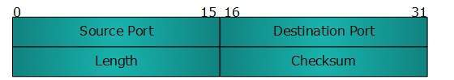

UDP header contains four main parameters:

* **Source Port**  - This 16 bits information is used to identify the source port of the packet.
* **Destination Port**  - This 16 bits information, is used identify application level service on destination machine.
* **Length**  - Length field specifies the entire length of UDP packet (including header). It is 16-bits field and minimum value is 8-byte, i.e. the size of UDP header itself.
* **Checksum**  - This field stores the checksum value generated by the sender before sending. IPv4 has this field as optional so when checksum field does not contain any value it is made 0 and all its bits are set to zero.

**UDP application:-**

Here are few applications where UDP is used to transmit data:

* Domain Name Services
* Simple Network Management Protocol
* Trivial File Transfer Protocol
* Routing Information Protocol
* Kerberos

\*\*\*\*\*

**UDP Packet:**

UDP wraps datagrams with a UDP header, which contains four fields totaling eight bytes.

The fields in a UDP header are:

* + **Source port** – The port of the device sending the data. This field can be set to zero if the destination computer doesn’t need to reply to the sender.
  + **Destination port** – The port of the device receiving the data. UDP port numbers can be between 0 and 65,535.
  + **Length** – Specifies the number of bytes comprising the UDP header and the UDP payload data. The limit for the UDP length field is determined by the underlying IP protocol used to transmit the data.
  + **Checksum** – The checksum allows the receiving device to verify the integrity of the packet header and payload. It is optional in IPv4 but was made mandatory in IPv6.

\*\*\*\*\*

**Difference between UDP and TCP:**

As we know that both TCP (Transmission Control Protocol) and UDP (User Datagram Protocol) are the most widely used Internet protocols among which TCP is connection oriented − once a connection is established, data can be sent bidirectional. UDP is a simpler, connectionless Internet protocol. Multiple messages are sent as packets in chunks using UDP. Now on the basis of features of attributes we can distinguish between TCP and UDP

Following are the important differences between TCP and UDP.

| **Sr. No.** | **Key** | **TCP (Transmission Control Protocol)** | **UDP (User Datagram Protocol)** |
| --- | --- | --- | --- |
| 1 | Definition | It is a communications protocol, using which the data is transmitted between systems over the network. In this, the data is transmitted into the form of packets. It includes error-checking, guarantees the delivery and preserves the order of the data packets. | It is same as the TCP protocol except this doesn’t guarantee the error-checking and data recovery. If you use this protocol, the data will be sent continuously, irrespective of the issues in the receiving end. |
| 2 | Design | TCP is a connection oriented protocol. | UDP is a connection less protocol. |
| 3 | Reliable | As TCP provides error checking support and also guarantees delivery of data to the destination router this make it more reliable as compared to UDP. | While on other hand UDP does provided only basic error checking support using checksum so the delivery of data to the destination cannot be guaranteed in UDP as compared to that in case of TCP. |
| 4 | Data transmission | In TCP the data is transmitted in a particular sequence which means that packets arrive in-order at the receiver. | On other hand there is no sequencing of data in UDP in order to implement ordering it has to be managed by the application layer. |
| 5 | Performance | TCP is slower and less efficient in performance as compared to UDP. Also TCP is heavy-weight as compared to UDP. | On other hand UDP is faster and more efficient than TCP. |
| 6 | Retransmission | Retransmission of data packets is possible in TCP in case packet get lost or need to resend. | On other hand retransmission of packets is not possible in UDP. |

\*\*\*\*\*

**TCP/IP Part III (DNS, Email, FTP, TFTP)**

**Domain Name System (DNS):**

An application layer protocol defines how the application processes running on different systems, pass the messages to each other.

* DNS stands for Domain Name System.
* DNS is a directory service that provides a mapping between the name of a host on the network and its numerical address.
* DNS is required for the functioning of the internet.
* Each node in a tree has a domain name, and a full domain name is a sequence of symbols specified by dots.
* DNS is a service that translates the domain name into IP addresses. This allows the users of networks to utilize user-friendly names when looking for other hosts instead of remembering the IP addresses.
* For example, suppose the FTP site at EduSoft had an IP address of 132.147.165.50, most people would reach this site by specifying ftp.EduSoft.com. Therefore, the domain name is more reliable than IP address.

DNS is a TCP/IP protocol used on different platforms. The domain name space is divided into three different sections: generic domains, country domains, and inverse domain.

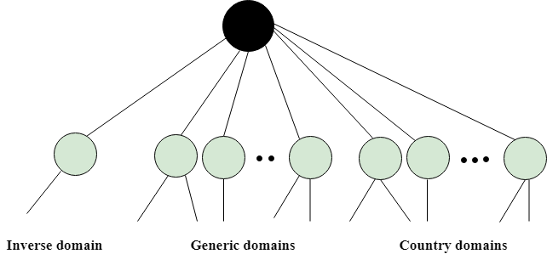

**Generic Domains:-**

* It defines the registered hosts according to their generic behavior.
* Each node in a tree defines the domain name, which is an index to the DNS database.
* It uses three-character labels, and these labels describe the organization type.

|  |  |
| --- | --- |
| **Label** | **Description** |
| aero | Airlines and aerospace companies |
| biz | Businesses or firms |
| com | Commercial Organizations |
| coop | Cooperative business Organizations |
| edu | Educational institutions |
| gov | Government institutions |
| info | Information service providers |
| int | International Organizations |
| mil | Military groups |
| museum | Museum & other nonprofit organizations |
| name | Personal names |
| net | Network Support centers |
| org | Nonprofit Organizations |
| pro | Professional individual Organizations |

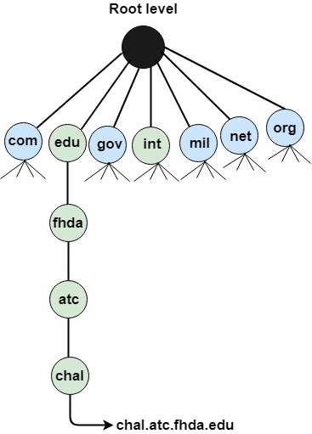

**Country Domain:-**

The format of country domain is same as a generic domain, but it uses two-character country abbreviations (e.g., us for the United States) in place of three character organizational abbreviations.

**Inverse Domain:-**

The inverse domain is used for mapping an address to a name. When the server has received a request from the client, and the server contains the files of only authorized clients. To determine whether the client is on the authorized list or not, it sends a query to the DNS server and ask for mapping an address to the name.

**Working of DNS:**

* DNS is a client/server network communication protocol. DNS clients send requests to the. server while DNS servers send responses to the client.
* Client requests contain a name which is converted into an IP address known as a forward DNS lookups while requests containing an IP address which is converted into a name known as reverse DNS lookups.
* DNS implements a distributed database to store the name of all the hosts available on the internet.
* If a client like a web browser sends a request containing a hostname, then a piece of software such as **DNS resolver** sends a request to the DNS server to obtain the IP address of a hostname. If DNS server does not contain the IP address associated with a hostname, then it forwards the request to another DNS server. If IP address has arrived at the resolver, which in turn completes the request over the internet protocol.

\*\*\*\*\*

**Electronic Mail (Email):**

E-mail is defined as the transmission of messages on the Internet. It is one of the most commonly used features over communications networks that may contain text, files, images, or other attachments. Generally, it is information that is stored on a computer sent through a network to a specified individual or group of individuals.

Email messages are conveyed through email servers; it uses multiple protocols within the [TCP/IP suite. For example,](https://www.javatpoint.com/tcp-ip-full-form)[SMTP is a protocol, stands for simple mail transfer protocol and used to send messages whereas other protocols IMAP or POP are used to retrieve messages from a mail server. If you want to login to your mail account, you just need to enter a valid email address, password, and the mail servers used to send and receive messages.](https://www.javatpoint.com/simple-mail-transfer-protocol)

Although most of the webmail servers automatically configure your mail account, therefore, you only required to enter your email address and password. However, you may need to manually configure each account if you use an email client like Microsoft Outlook or Apple Mail. In addition, to enter the email address and password, you may also need to enter incoming and outgoing mail servers and the correct port numbers for each one.

Email messages include three components, which are as follows:

* **Message envelope:** It depicts the email's electronic format.
* **Message header:** It contains email subject line and sender/recipient information.
* **Message body:** It comprises images, text, and other file attachments.

The email was developed to support rich text with custom formatting, and the original email standard is only capable of supporting plain text messages. In modern times, email supports [HTML](https://www.javatpoint.com/html-tutorial)

(Hypertext markup language), which makes it capable of emails to support the same formatting as [websites](https://www.javatpoint.com/website)

. The email that supports HTML can contain links, images, [CSS layouts](https://www.javatpoint.com/css-layout)

, and also can send files or "email attachments" along with messages. Most of the mail servers enable users to send several attachments with each message. The attachments were typically limited to one megabyte in the early days of email. Still, nowadays, many mail servers are able to support email attachments of 20 megabytes or more in size.

In **1971**, as a test e-mail message, Ray Tomlinson sent the first e-mail to himself. This email was contained the text "something like QWERTYUIOP." However, the e-mail message was still transmitted through ARPANET, despite sending the e-mail to himself. Most of the electronic mail was being sent as compared to postal mail till **1996**.

\*\*\*\*\*

**File Transfer Protocol (FTP):**

* FTP stands for File transfer protocol.
* FTP is a standard internet protocol provided by TCP/IP used for transmitting the files from one host to another.
* It is mainly used for transferring the web page files from their creator to the computer that acts as a server for other computers on the internet.
* It is also used for downloading the files to computer from other servers.

**Objectives of FTP**

* It provides the sharing of files.
* It is used to encourage the use of remote computers.
* It transfers the data more reliably and efficiently.

Although transferring files from one system to another is very simple and straightforward, but sometimes it can cause problems. For example, two systems may have different file conventions. Two systems may have different ways to represent text and data. Two systems may have different directory structures. FTP protocol overcomes these problems by establishing two connections between hosts. One connection is used for data transfer, and another connection is used for the control connection.

**Mechanism of FTP:**

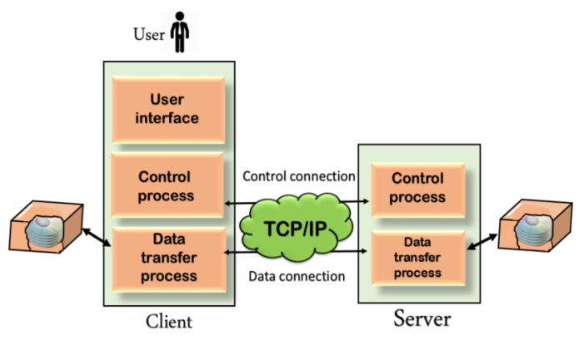

The above figure shows the basic model of the FTP. The FTP client has three components: the user interface, control process, and data transfer process. The server has two components: the server control process and the server data transfer process.

**There are two types of connections in FTP:**

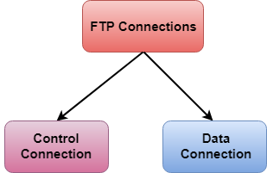

**1.Control Connection:** The control connection uses very simple rules for communication. Through control connection, we can transfer a line of command or line of response at a time. The control connection is made between the control processes. The control connection remains connected during the entire interactive FTP session.

**2.Data Connection:** The Data Connection uses very complex rules as data types may vary. The data connection is made between data transfer processes. The data connection opens when a command comes for transferring the files and closes when the file is transferred.

**FTP Clients:**

* FTP client is a program that implements a file transfer protocol which allows you to transfer files between two hosts on the internet.
* It allows a user to connect to a remote host and upload or download the files.
* It has a set of commands that we can use to connect to a host, transfer the files between you and your host and close the connection.
* The FTP program is also available as a built-in component in a Web browser. This GUI based FTP client makes the file transfer very easy and also does not require to remember the FTP commands.

**Advantages of FTP:**

* **Speed:** One of the biggest advantages of FTP is speed. The FTP is one of the fastest way to transfer the files from one computer to another computer.
* **Efficient:** It is more efficient as we do not need to complete all the operations to get the entire file.
* **Security:** To access the FTP server, we need to login with the username and password. Therefore, we can say that FTP is more secure.
* **Back & forth movement:** FTP allows us to transfer the files back and forth. Suppose you are a manager of the company, you send some information to all the employees, and they all send information back on the same server.

**Disadvantages of FTP:**

* The standard requirement of the industry is that all the FTP transmissions should be encrypted. However, not all the FTP providers are equal and not all the providers offer encryption. So, we will have to look out for the FTP providers that provides encryption.
* FTP serves two operations, i.e., to send and receive large files on a network. However, the size limit of the file is 2GB that can be sent. It also doesn't allow you to run simultaneous transfers to multiple receivers.
* Passwords and file contents are sent in clear text that allows unwanted eavesdropping. So, it is quite possible that attackers can carry out the brute force attack by trying to guess the FTP password.
* It is not compatible with every system.

\*\*\*\*\*

**Trivial File Transfer Protocol (TFTP):**

TFTP Server is used for simple file transfer (typically for boot-loading remote devices).

[Trivial File Transfer Protocol (TFTP)](http://en.wikipedia.org/wiki/Trivial_File_Transfer_Protocol) is a simple protocol for exchanging files between two TCP/IP machines. TFTP servers allow connections from a [TFTP Client](https://www.keil.com/pack/doc/mw/Network/html/group__net_t_f_t_pc___func.html) for sending and receiving files. The TFTP protocol supports only file send and receive operations. File delete, move, and rename are not supported. Due to its limitations, TFTP is a complement to the regular [FTP](https://www.keil.com/pack/doc/mw/Network/html/group__net_f_t_ps___func.html) and not a replacement. It is only used when its simplicity is important, and its lack of features is acceptable. The most common application is bootstrapping, although it can be used for other purposes as well.

The TFTP Server can also be used to upload HTML pages onto the [HTTP Server](https://www.keil.com/pack/doc/mw/Network/html/group__net_h_t_t_p___func.html) or to download log files to a remote PC. In this case, the [File System Component](https://www.keil.com/pack/doc/mw/FileSystem/html/index.html) must be used, and the [HTTP Server](https://www.keil.com/pack/doc/mw/Network/html/group__net_h_t_t_p___func.html) must be properly configured.

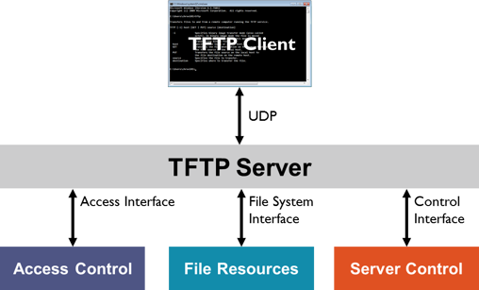

**1.**[**Control Interface**](https://www.keil.com/pack/doc/mw/Network/html/group__tftp__server__user__api.html) explains how to start/stop the TFTP Server and to manage built-in user accounts.

**2.**[**Access Interface**](https://www.keil.com/pack/doc/mw/Network/html/group__tftp__server__access.html) shows how to filter out hosts, which are **not allowed** to connect to the TFTP Server.

**3.**[**File System Interface**](https://www.keil.com/pack/doc/mw/Network/html/group__tftp__server__fs__interface.html) gives you details about the functions that are used to read/write data on the TFTP server's storage device.

**4.**[**Configuration**](https://www.keil.com/pack/doc/mw/Network/html/group__using__tftp__server__conf.html) explains the configuration options of the TFTP server.

**TFTP Client:--**

TFTP Client is used to connect to a TFTP Server for simple file transfer.

A [TFTP](http://en.wikipedia.org/wiki/Trivial_File_Transfer_Protocol) Client can exchange files with a [**TFTP Server**](https://www.keil.com/pack/doc/mw/Network/html/group__net_t_f_t_ps___func.html). File delete, file move, and file rename are not impossible, because the TFTP protocol does not support these file operations in general.

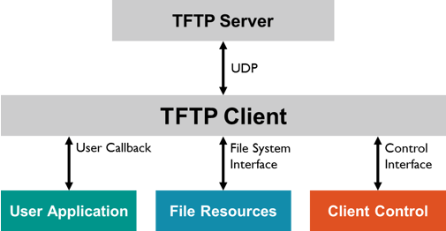

**1.**[**Control Interface**](https://www.keil.com/pack/doc/mw/Network/html/group__tftpc__user__api.html)**:** explains how to start the TFTP Client.

**2.**[**User Callback**](https://www.keil.com/pack/doc/mw/Network/html/group__tftpc__operation.html)**:** describes the operation of a TFTP client session and how an event notification is sent to the user application.

**3.**[**File System Interface**](https://www.keil.com/pack/doc/mw/Network/html/group__tftpc__fs__interface.html)**:** gives you details about the functions that are used to read/write data on the TFTP server's storage device.

**4.**[**Configuration**](https://www.keil.com/pack/doc/mw/Network/html/group__using__tftpc__conf.html)**:** explains the configuration options of the TFTP client.

\*\*\*\*\*

**TCP/IP Part IV (WWW, HTTP, TELNET)**

**A Brief History of WWW:**

The web is a wonderful place. It connects people from across the globe, keeps us updated with our friends and family, and creates revolutions never before seen in our lifetime. It has certainly come a long way since its humble beginnings back in the early 1980's..

**World Wide Web** thumbnail Dribbbled by [Zachary VanDeHey](https://dribbble.com/shots/635658-World-Wide-Web) and featured in Smashing Magazine's [“Redesign The Web”](http://www.smashingmagazine.com/2012/08/01/poster-design-contest-redesign-the-web-redesign-the-world-best-entries/) Poster Contest

In this article I'm going to look at the journey the World Wide Web's gone through to become the powerhouse that it is today and establish what we can learn from the past.

In order to understand the history of the World Wide Web it's important to understand the differences between [the World Wide Web](https://en.wikipedia.org/wiki/World_Wide_Web) and [The Internet](https://en.wikipedia.org/wiki/Internet). Many people refer to them as the same thing, but in fact, although the end result is the common perception of most everyday users, they are very different.

The internet is a series of huge computer networks that allows many computers to connect and communicate with each other globally. Upon the internet reside a series of languages which allow information to travel between computers. These are known as protocols. For instance, some common protocols for transferring emails are IMAP, POP3 and SMTP. Just as email is a layer on the internet, the World Wide Web is another layer which uses different protocols.

The World Wide Web uses three protocols:

* **HTML (Hypertext markup language)** - The language that we write our web pages in.
* **HTTP (Hypertext Transfer Protocol )** - Although other protocols can be used such as FTP, this is the most common protocol. It was developed specifically for the World Wide Web and favored for its simplicity and speed. This protocol requests the 'HTML' document from the server and serves it to the browser.
* **URLS** (Uniform resource locator) - The last part of the puzzle required to allow the web to work is a URL. This is the address which indicates where any given document lives on the web. It can be defined as <protocol>://<node>/<location>

**Basics of WWW and Browsing:**

World Wide Web, which is also known as a Web, is a collection of websites or web pages stored in web servers and connected to local computers through the internet. These websites contain text pages, digital images, audios, videos, etc. Users can access the content of these sites from any part of the world over the internet using their devices such as computers, laptops, cell phones, etc. The WWW, along with internet, enables the retrieval and display of text and media to your device.

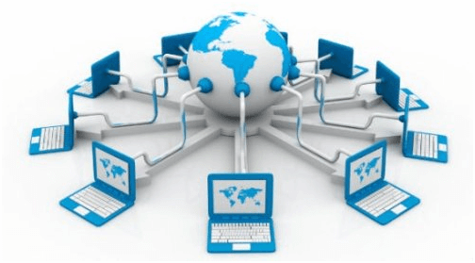

The building blocks of the Web are web pages which are formatted in HTML and connected by links called "hypertext" or hyperlinks and accessed by HTTP. These links are electronic connections that link related pieces of information so that users can access the desired information quickly. Hypertext offers the advantage to select a word or phrase from text and thus to access other pages that provide additional information related to that word or phrase.

A web page is given an online address called a Uniform Resource Locator (URL). A particular collection of web pages that belong to a specific URL is called a website, e.g., *www.facebook.com*, *www.google.com*, etc. So, the World Wide Web is like a huge electronic book whose pages are stored on multiple servers across the world.

Small websites store all of their WebPages on a single server, but big websites or organizations place their WebPages on different servers in different countries so that when users of a country search their site they could get the information quickly from the nearest server.

So, the web provides a communication platform for users to retrieve and exchange information over the internet. Unlike a book, where we move from one page to another in a sequence, on World Wide Web we follow a web of hypertext links to visit a web page and from that web page to move to other web pages. You need a browser, which is installed on your computer, to access the Web.

**Browsing:**

A browser is a software program that is used to explore, retrieve, and display the information available on the World Wide Web. This information may be in the form of pictures, web pages, videos, and other files that all are connected via hyperlinks and categorized with the help of URLs (Uniform Resource Identifiers). For example, you are viewing this page by using a browser.

A browser is a client program as it runs on a user computer or mobile device and contacts the webserver for the information requested by the user. The web server sends the data back to the browser that displays the results on internet supported devices. On behalf of the users, the browser sends requests to web servers all over the internet by using [HTTP](https://www.javatpoint.com/http-full-form) (Hypertext Transfer Protocol). A browser requires a smartphone, computer, or tablet and internet to work.

### Features of Web Browser:- Most Web browsers offer common features such as:

1. **Refresh button:** Refresh button allows the website to reload the contents of the web pages. Most of the web browsers store local copies of visited pages to enhance the performance by using a caching mechanism. Sometimes, it stops you from seeing the updated information; in this case, by clicking on the refresh button, you can see the updated information.
2. **Stop button:** It is used to cancel the communication of the web browser with the server and stops loading the page content. For example, if any malicious site enters the browser accidentally, it helps to save from it by clicking on the stop button.
3. **Home button:** It provides users the option to bring up the predefined home page of the website.
4. **Web address bar:** It allows the users to enter a web address in the address bar and visit the website.
5. **Tabbed browsing:** It provides users the option to open multiple websites on a single window. It helps users to read different websites at the same time. For example, when you search for anything on the browser, it provides you a list of search results for your query. You can open all the results by right-clicking on each link, staying on the same page.
6. **Bookmarks:** It allows the users to select particular website to save it for the later retrieval of information, which is predefined by the users.

\*\*\*\*\*

**Locating Information on the Internet:**

Four Steps to Locating Information on the Internet

**Step One:**

* Define and refine the research question
* Narrow the topic to several specific questions
* Keep refining research questions. It is easy to get off on a side track and waste time on topics that are related, but don't really address the question that you are researching
* Graphic organizers and outlines are useful
* Develop a list of key words for your research questions

**Step Two**

* Locate Sources: using search engines listed below
* Utilize Multiple web pages – 3 required for presentation
* Going on the Internet:
  + First choice: [www.google.com](http://www.google.com) [www.av.com](http://www.av.com)
  + Second Choice: [www.yahoo.com](http://www.yahooligans.com) or [www.wikipedia.org](http://www.wikipedia.org)
  + Third Choice: [www.dogpile](http://www.dogpile) [www.mamma.com](http://www.mamma.com) [www.yahooligans.com](http://www.yahoo.com)
  + Look first for good sources, don't just start taking notes from the first thing that you find. Reading the website information is a must. Do not just copy and paste. Know your topic information inside and out before you present.

**Step Three**

* + - Check the source of the information that you find:
    - Who posted this information?
    - Is this a reliable source?
    - Is this a biased source?
    - Is this site trying to sell you something?
    - Always confirm information found on this page with another source on or off the Internet.

**Step Four**

* Look at Content
* Does the information on this page address my research question?
* easy to read?
* subheadings?
* table of Contents?
* Copy and paste the Web address (URL) so you can credit the source information in your work. You must have all URLs on a reference slide listed for any information, pictures, and sound files you used in your presentation.

\*\*\*\*\*

**HTML:**

**HTML** stands for **Hyper Text Markup Language.** It is a formatting language used to define the appearance and contents of a web page. It allows us to organize text, graphics, audio, and video on a web page.

**Key Points:**

* The word Hypertext refers to the text which acts as a link.
* The word markup refers to the symbols that are used to define structure of the text. The markup symbols tells the browser how to display the text and are often called tags.
* The word Language refers to the syntax that is similar to any other language.

HTML was created by **Tim Berners-Lee** at **CERN.**

### HTML Versions

The following table shows the various versions of HTML:

|  |  |
| --- | --- |
| **Version** | **Year** |
| HTML 1.0 | 1991 |
| HTML 2.0 | 1995 |
| HTML 3.2 | 1997 |
| HTML 4.0 | 1999 |
| XHTML | 2000 |
| HTML5 | 2012 |

## HTML Tags:- Tag is a command that tells the web browser how to display the text, audio, graphics or video on a web page.

**Key Points:**

* Tags are indicated with pair of angle brackets.
* They start with a less than (<) character and end with a greater than (>) character.
* The tag name is specified between the angle brackets.
* Most of the tags usually occur in pair: the start tag and the closing tag.
* The start tag is simply the tag name is enclosed in angle bracket whereas the closing tag is specified including a forward slash (/).
* Some tags are the empty i.e. they don’t have the closing tag.
* Tags are not case sensitive.
* The starting and closing tag name must be the same. For example <b> hello </i> is invalid as both are different.
* If you don’t specify the angle brackets (<>) for a tag, the browser will treat the tag name as a simple text.
* The tag can also have attributes to provide additional information about the tag to the browser.

## Basic tags

The following table shows the Basic HTML tags that define the basic web page:

|  |  |
| --- | --- |
| **Tag** | **Description** |
| <html> </html> | Specifies the document as a web page. |
| <head> </head> | Specifies the descriptive information about the web documents. |
| <title> </title> | Specifies the title of the web page. |
| <body> </body> | Specifies the body of a web document. |

The following code shows how to use basic tags.

<html>

<head> Heading goes here…</head>

<title> Title goes here…</title>

<body> Body goes here…</body>

</html>

\*\*\*\*\*

**Web Browser Architecture:**

**Web Browser** is an application software that allows us to view and explore information on the web. User can request for any web page by just entering a URL into address bar.

Web browser can show text, audio, video, animation and more. It is the responsibility of a web browser to interpret text and commands contained in the web page.

Earlier the web browsers were text-based while now a days graphical-based or voice-based web browsers are also available. Following are the most common web browser available today:

|  |  |
| --- | --- |
| **Browser** | **Vendor** |
| Internet Explorer | Microsoft |
| Google Chrome | Google |
| Mozilla Firefox | Mozilla |
| Netscape Navigator | Netscape Communications Corp. |
| Opera | Opera Software |
| Safari | Apple |
| Sea Monkey | Mozilla Foundation |
| K-meleon | K-meleon |

### Architecture:- There are a lot of web browser available in the market. All of them interpret and display information on the screen however their capabilities and structure varies depending upon implementation. But the most basic component that all web browser must exhibit are listed below:

* Controller/Dispatcher
* Interpreter
* Client Programs

**Controller** works as a control unit in CPU. It takes input from the keyboard or mouse, interpret it and make other services to work on the basis of input it receives.

**Interpreter** receives the information from the controller and execute the instruction line by line. Some interpreter are mandatory while some are optional For example, HTML interpreter program is mandatory and java interpreter is optional.

**Client Program** describes the specific protocol that will be used to access a particular service. Following are the client programs tat are commonly used:

* HTTP
* SMTP
* FTP
* NNTP
* POP

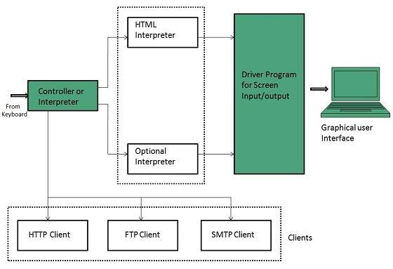

\*\*\*\*\*

**Web Pages and Multimedia:**

**Web Pages:**

**web page** is a document available on world wide web. Web Pages are stored on web server and can be viewed using a web browser.

A web page can contain huge information including text, graphics, audio, video and hyper links. These hyper links are the link to other web pages.

### Static Web page:-

**Static web pages** are also known as flat or stationary web page. They are loaded on the client’s browser as exactly they are stored on the web server. Such web pages contain only static information. User can only read the information but can’t do any modification or interact with the information.

Static web pages are created using only HTML. Static web pages are only used when the information is no more required to be modified.

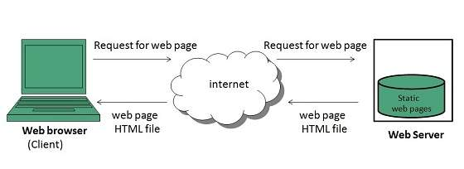

### Dynamic Web page:-

**Dynamic web page** shows different information at different point of time. It is possible to change a portion of a web page without loading the entire web page. It has been made possible using **Ajax** technology.

#### Server-side dynamic web page:-

It is created by using server-side scripting. There are server-side scripting parameters that determine how to assemble a new web page which also include setting up of more client-side processing.

#### Client-side dynamic web page:-

It is processed using client side scripting such as JavaScript. And then passed in to **Document Object Model (DOM).**

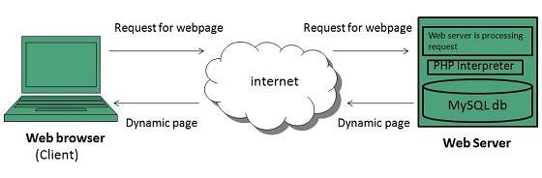

## Scripting Languages:-

Scripting languages are like programming languages that allow us to write programs in form of script. These scripts are interpreted not compiled and executed line by line.

### Client-side Scripting:-

**Client-side scripting** refers to the programs that are executed on client-side. Client-side scripts contains the instruction for the browser to be executed in response to certain user’s action.

Client-side scripting programs can be embedded into HTML files or also can be kept as separate files.

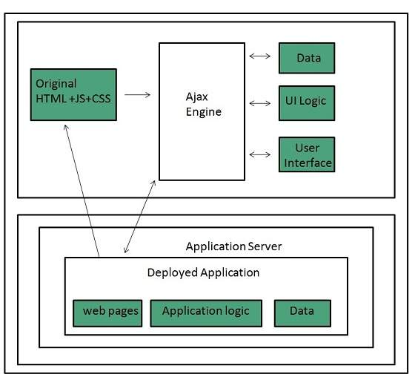

### Server-side Scripting:-

**Sever-side scripting** acts as an interface for the client and also limit the user access the resources on web server. It can also collects the user’s characteristics in order to customize response.

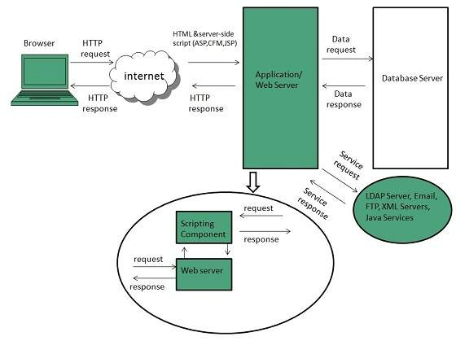

\*

**Multimedia:**

Multimedia comes in many different formats. It can be almost anything you can hear or see, like images, music, sound, videos, records, films, animations, and more.

Web pages often contain multimedia elements of different types and formats.

**Browser Support:-**

The first web browsers had support for text only, limited to a single font in a single color.

Later came browsers with support for colors, fonts, images, and multimedia!

**Multimedia Formats:-**

Multimedia elements (like audio or video) are stored in media files.

The most common way to discover the type of a file, is to look at the file extension.

Multimedia files have formats and different extensions like: .wav, .mp3, .mp4, .mpg, .wmv, and .avi.

Common Video Formats

|  |  |
| --- | --- |
|  | There are many video formats out there.  The MP4, WebM, and Ogg formats are supported by HTML.  The MP4 format is recommended by YouTube. |

|  |  |  |
| --- | --- | --- |
| **Format** | **File** | **Description** |
| MPEG | .mpg .mpeg | MPEG. Developed by the Moving Pictures Expert Group.  The first popular video format on the web. Not supported any  more in HTML. |
| AVI | .avi | AVI (Audio Video Interleave). Developed by Microsoft.  Commonly used in video cameras and TV hardware. Plays well  on Windows computers, but not in web browsers. |
| WMV | .wmv | WMV (Windows Media Video). Developed by Microsoft.  Commonly used in video cameras and TV hardware. Plays well  on Windows computers, but not in web browsers. |
| QuickTime | .mov | QuickTime. Developed by Apple. Commonly used in video  cameras and TV hardware. Plays well on Apple computers, but  not in web browsers. |
| RealVideo | .rm .ram | RealVideo. Developed by Real Media to allow video streaming  with low bandwidths. Does not play in web browsers. |
| Flash | .swf .flv | Flash. Developed by Macromedia. Often requires an extra  component (plug-in) to play in web browsers. |
| Ogg | .ogg | Theora Ogg. Developed by the Xiph.Org Foundation. Supported  by HTML. |
| WebM | .webm | WebM. Developed by Mozilla, Opera, Adobe, and Google.  Supported by HTML. |
| MPEG-4 or MP4 | .mp4 | MP4. Developed by the Moving Pictures Expert Group.  Commonly used in video cameras and TV hardware. Supported  by all browsers and  recommended by YouTube. |

\*\*\*\*\*

**Remote Login (TELNET):**

* The main task of the internet is to provide services to users. For example, users want to run different application programs at the remote site and transfers a result to the local site. This requires a client-server program such as FTP, SMTP. But this would not allow us to create a specific program for each demand.
* The better solution is to provide a general client-server program that lets the user access any application program on a remote computer. Therefore, a program that allows a user to log on to a remote computer. A popular client-server program Telnet is used to meet such demands. Telnet is an abbreviation for **Terminal Network**.
* Telnet provides a connection to the remote computer in such a way that a local terminal appears to be at the remote side.

## There are two types of login:

## Local Login:-

### C:\Users\user\Desktop\computer-network-telnet.png

### When a user logs into a local computer, then it is known as local login.

### When the workstation running terminal emulator, the keystrokes entered by the user are accepted by the terminal driver. The terminal driver then passes these characters to the operating system which in turn, invokes the desired application program.

### However, the operating system has special meaning to special characters. For example, in UNIX some combination of characters have special meanings such as control character with "z" means suspend. Such situations do not create any problem as the terminal driver knows the meaning of such characters. But, it can cause the problems in remote login.

### Remote login:-

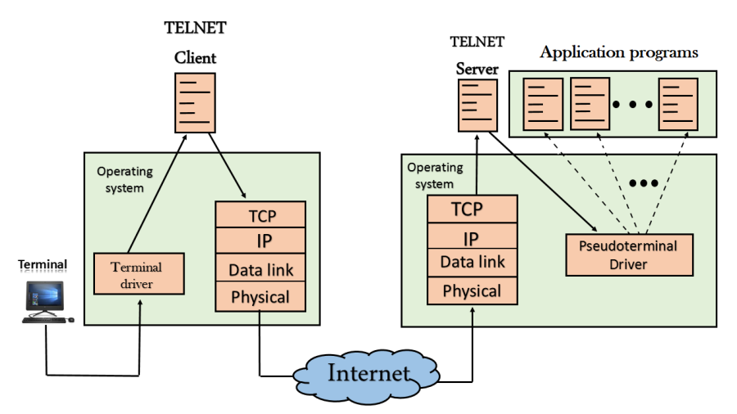

* + When the user wants to access an application program on a remote computer, then the user must perform remote login.

## How remote login occurs:

### At the local site:-

The user sends the keystrokes to the terminal driver, the characters are then sent to the TELNET client. The TELNET client which in turn, transforms the characters to a universal character set known as network virtual terminal characters and delivers them to the local TCP/IP stack

### At the remote site:-

The commands in NVT forms are transmitted to the TCP/IP at the remote machine. Here, the characters are delivered to the operating system and then pass to the TELNET server. The TELNET server transforms the characters which can be understandable by a remote computer. However, the characters cannot be directly passed to the operating system as a remote operating system does not receive the characters from the TELNET server. Therefore it requires some piece of software that can accept the characters from the TELNET server. The operating system then passes these characters to the appropriate application program.

## Network Virtual Terminal (NVT):-

## C:\Users\user\Desktop\computer-network-telnet3.png

* + The network virtual terminal is an interface that defines how data and commands are sent across the network.
  + In today's world, systems are heterogeneous. For example, the operating system accepts a special combination of characters such as end-of-file token running a DOS operating system ctrl+z while the token running a UNIX operating system is ctrl+d.
  + TELNET solves this issue by defining a universal interface known as network virtual interface.
  + The TELNET client translates the characters that come from the local terminal into NVT form and then delivers them to the network. The Telnet server then translates the data from NVT form into a form which can be understandable by a remote computer.

\*\*\*\*\*

**An Introduction to Electronic Commerce**

**Aspects of Electronic Commerce:**

E-Commerce or Electronics Commerce is a methodology of modern business, which addresses the need of business organizations, vendors and customers to reduce cost and improve the quality of goods and services while increasing the speed of delivery. Ecommerce refers to the paperless exchange of business information using the following ways −

* Electronic Data Interchange (EDI)
* Electronic Mail (e-mail)
* Electronic Bulletin Boards
* Electronic Fund Transfer (EFT)
* Other Network-based technologies

**Features:-**

E-Commerce provides the following features −

* **Non-Cash Payment** − E-Commerce enables the use of credit cards, debit cards, smart cards, electronic fund transfer via bank's website, and other modes of electronics payment.
* **24x7 Service availability** − E-commerce automates the business of enterprises and the way they provide services to their customers. It is available anytime, anywhere.
* **Advertising / Marketing** − E-commerce increases the reach of advertising of products and services of businesses. It helps in better marketing management of products/services.
* **Improved Sales** − Using e-commerce, orders for the products can be generated anytime, anywhere without any human intervention. It gives a big boost to existing sales volumes.
* **Support** − E-commerce provides various ways to provide pre-sales and post-sales assistance to provide better services to customers.
* **Inventory Management** − E-commerce automates inventory management. Reports get generated instantly when required. Product inventory management becomes very efficient and easy to maintain.
* **Communication improvement** − E-commerce provides ways for faster, efficient, reliable communication with customers and partners.

\*\*\*\*\*

**Types of E Commerce:**

Generally speaking, when we think of e-commerce, we think of an online commercial transaction between a supplier and a client. However, and although this idea is right, we can be more specific and actually divide e-commerce into six major types, all with different characteristics.

## ****There are 6 basic types of e-commerce:****

1. Business-to-Business (B2B)
2. Business-to-Consumer (B2C)
3. Consumer-to-Consumer (C2C)
4. Consumer-to-Business (C2B).
5. Business-to-Administration (B2A)
6. Consumer-to-Administration (C2A)

### ****1.Business-to-Business (B2B):-**** Business-to-Business (B2B) e-commerce encompasses all electronic transactions of goods or services conducted ​​between companies. Producers and traditional commerce wholesalers typically operate with this type of electronic commerce.

### ****2.Business-to-Consumer (B2C):-**** The Business-to-Consumer type of e-commerce is distinguished by the establishment of electronic business relationships between businesses and final consumers. It corresponds to the retail section of e-commerce, where traditional retail trade normally operates.

These types of relationships can be easier and more dynamic, but also more sporadic or discontinued. This type of commerce has developed greatly, due to the advent of the web, and there are already many virtual stores and malls on the Internet, which sell all kinds of consumer goods, such as computers, software, books, [shoes](http://josefinas.com/), cars, food, financial products, digital publications, etc.

When compared to buying retail in traditional commerce, the consumer usually has more information available in terms of informative content and there is also a widespread idea that you’ll be buying cheaper, without jeopardizing an equally personalized customer service, as well as ensuring quick processing and delivery of your order.

### ****3.Consumer-to-Consumer (C2C):-**** Consumer-to-Consumer (C2C) type e-commerce encompasses all electronic transactions of goods or services conducted ​​between consumers. Generally, these transactions are conducted through a third party, which provides the online platform where the transactions are actually carried out.

### ****4. Consumer-to-Business (C2B):-**** In C2B there is a complete reversal of the traditional sense of exchanging goods. This type of e-commerce is very common in crowd sourcing based projects. A large number of individuals make their services or products available for purchase for companies seeking precisely these types of services or products.

Examples of such practices are the sites where designers present several proposals for a company logo and where only one of them is selected and effectively purchased. Another platform that is very common in this type of commerce are the markets that sell royalty-free photographs, images, media and design elements, such as [iStockphoto](http://www.istockphoto.com/).

### ****5. Business-to-Administration (B2A):-**** This part of e-commerce encompasses all transactions conducted online between companies and public administration. This is an area that involves a large amount and a variety of services, particularly in areas such as fiscal, social security, employment, legal documents and registers, etc. These types of services have increased considerably in recent years with investments made in e-government.

### ****6.Consumer-to-Administration (C2A):-**** The Consumer-to-Administration model encompasses all electronic transactions conducted between individuals and public administration.

Examples of applications include:

* Education – disseminating information, distance learning, etc.
* Social Security – through the distribution of information, making payments, etc.
* Taxes – filing tax returns, payments, etc.
* Health – appointments, information about illnesses, payment of health services, etc.

Both models involving Public Administration (B2A and C2A) are strongly associated to the idea of efficiency and easy usability of the services provided to citizens by the government, with the support of information and communication technologies.

\*\*\*\*\*

**Approaches for Developing E Commerce Solutions:**

**1.Increase eCommerce Search Usability:-**

To optimize the UX of your online store even more, organize your web store for these two main groups of potential customers:

* Visitors who know what they want to buy.
* Visitors who only want to browse.

Customers who know exactly what they are looking for want to find the right information as quickly as possible. Designing a high-performing search experience is a key feature for your users because if users can’t find what they are looking for, they will buy it from another store.

The second category is potential customers who just want to browse through the online store and compare items. They will use navigation menus and move between product categories and pages. To make their experience smooth, organize the menu bar and categories in intuitive easy-to-use sections.

Your website’s search and navigation functions need to be well-designed and user-oriented in order to be effective and help improve the overall experience customers have on your eCommerce site.

To boost conversions as part of your eCommerce strategy you can improve the search usability in the following fields:

* Design and behavior of the search field.
* Search scope selection.
* How should the autocomplete be designed?
* Results layout and features.
* Filtering and sorting the search results on the results page.

## 2. Use High-Quality Photographs and Good Product Descriptions:-

High-quality product images and photos are an essential part of your eCommerce digital strategy and necessary for attracting the attention of potential customers. Outside the brick-and-mortar world, customers can’t touch the product and are making their [buying decisions](https://www.communigator.co.uk/blog/consumer-decision-making-process/) entirely dependent on product imagery and feedback.

Showing good viewable thumbnails in the search results page will help users find the desired product in one click and get a better idea of what you are offering.

Additionally, make your product descriptions concise and straight to the point. Avoid fluff and create a comprehensive list of features and benefits. Your target customers want to know everything about a potential purchase and how this product would help them and improve their everyday life, and keep this a consistent theme in your eCommerce digital strategy.

## 3. Try Personalizing the Home Page:-

[Personalization](https://devrix.com/tutorial/increase-ecommerce-sales-personalization/) is a technique that records what customers viewed or visited on their last session on your website and makes new buying suggestions on every following visit based on past experience in the store. This can be a personalization based on previous behavior such as previous purchases or based on real-time data such as a location or time.

59% of online shoppers believe that it is easier to find more interesting products on personalized online retail stores”, invespcro.com, Online Shopping Personalization – Statistics and Trends

Amazon is the pioneer of the **user-centric shopping experience**. Their homepage helps people easily find the right product in the personalized block in the first section when you log in under the “related to items you’ve viewed” tag.

This allows visitors to concentrate on the category that they are most interested in and shop without any distractions, which means a better customer experience for them and an improved conversion rate for you.

## 4. Focus on Consistent and Unique Content:-

Why? Because content marketing is still the most effective eCommerce business strategy you can apply today. The world of advertising is constantly changing, consumers are trying to avoid ads in many ways. With a strong [eCommerce content marketing strategy](https://devrix.com/tutorial/ecommerce-content-marketing-creating-content-drives-sales/)implemented the right way, you can provide more value to your customers.

To do this, you first need to understand your customers – their wants, needs, and pain points as well as their customer journey. It’s essential that you know your target market well, and in particular how they consume content and what kind of information they need depending on each stage of their journey.

To ensure you focus your eCommerce business strategy on the right areas, do tests with headlines, measure how well different types of content work, which generates the most traffic to your online store, and which of them led to the most sales.

If your target audience are millennials we have great ideas on [how you can attract them to your eCommerce website](https://devrix.com/tutorial/best-practices-for-attracting-millennials-to-your-ecommerce-website/).

## 5. Optimize Shopping Cart Functionality:-

To prevent customers from abandoning their shopping carts, you should ensure that your shopping cart functions welland is easy to navigate. The way to understand weaknesses is to analyze the performance frequently. Evaluate your analytics data to see at which stages customers tend to drop off and brainstorm ideas on how to improve them. Then, use [A/B testing](https://devrix.com/tutorial/ab-testing-wordpress-definitive-guide/) to determine which solution has the highest potential to reduce shopping cart abandonment.

During the optimization process, pay attention to the [user journey](https://devrix.com/tutorial/conversion-path-define-user-journey-website/). Clear the checkout page and remove distractions and/or possible places to exit. This will prevent any confusion during the checkout process. Plenty of conversion studies have shown that the fewer clicks during checkout, the higher your conversion rate will be.

Here’s a little bonus for readers that own a WooCommerce shop – check Tyche Softwares’ [Abandoned Cart Pro Plugin](https://www.tychesoftwares.com/store/premium-plugins/woocommerce-abandoned-cart-pro/) for minimizing cart abandonment rates.

## 6. Build Email Lists:-

If your eCommerce business strategy doesn’t include [email marketing](https://devrix.com/tutorial/12-ways-increase-conversion-email-marketing-automation/) as a communication channel, you are missing out on huge sales. **Use sign-up forms**, give something in exchange for an e-mail address like a discount code or even a small present. Make sure you win the customer’s trust and never send out emails without the user’s consent, otherwise you risk winding up in the SPAM folder and no one wants to ruin their brand like that.

Include sign-up fields at the end of your blog posts or buying guides. If the visitors enjoyed the content you provided them, they will be happy to keep in touch and get information about news, discounts, and promotions and thus be willing to leave their email.

## 7. Improve Your Social Media Strategy:-

The [social media strategy](https://devrix.com/tutorial/social-media-strategies-for-e-commerce-to-boost-your-lead-conversion/) your eCommerce marketing team prepares should be connected with your content strategy. This means repurposing your website content across your social media channels. as it will guarantee you a larger audience and boost your visibility.

Social networks such as [Instagram](https://devrix.com/tutorial/how-to-use-instagram-to-grow-your-ecommerce-sales/), Snapchat, and Pinterest, are usually best for an eCommerce marketing strategy focused on selling products, however, don’t underestimate Twitter and Facebook as more than 75% of all internet users are also there.

\*\*\*\*\*

**Electronic Procurement:**

E-Procurement is short for electronic procurement and describes the purchasing of goods or services with electronic systems often via digital networks such as the Internet. Electronic procurement is usually an integral part of [e-commerce](https://en.ryte.com/wiki/E-Commerce) and thus also of e-business. In the area of ​​e-procurement, modern communication methods are combined with classical procurement procedures and the associated processes are managed electronically or digitally. The electronic processing of orders is called e-fulfillment. The advantage of e-procurement is time and thus cost savings in the handling of order processes.

**Types of e-procurement systems:-**

There are various features that can be used to classify e-procurement systems. The system participants play a role for example. Usually, e-procurement is usually carried out in the B2B area. The type of goods procured through the system is also a factor. In addition, the costs of the procurement process are relevant as well as the relationships between the responsible persons within the eProcurement cycle.

In principle, three different systems can be distinguished on the basis of the listed features:

* Supplier systems (sell-side solutions): The supplier implements the e-procurement system. It provides the necessary platform and customers can procure their goods there. The supplier determines both the goods availability and the prices.
* Purchaser systems (buy-side solutions): In this case, the purchaser defines the conditions such as prices and quantities for their procurement process. If, for example, large industrial companies have a need for spare parts, a call for tender can be posted through the e-procurement system. A number of suppliers have the possibility to obtain the contract for the production of these parts via the system.
* Marketplaces (many-to-many solutions): These systems are mixed with both procurement and delivery systems. Manufacturers can offer their goods and customers can specify their needs at the same time. The marketplace is then usually regulated by a third party. A modern example of such a marketplace is the trade platform Alibaba, which also partially blends the B2B with the B2C area.

\*\*\*\*\*

**Phases in a Procurement Process:**

**PHase 1: IDENTIFY A NEED FOR PRODUCTS AND/OR SERVICES:-**

Before the procurement process can begin, a specific need must be recognized. For example, an organization may be interested in purchasing new computer monitors, re-ordering their monthly supply of paper products, or acquiring updated software.

Depending on the company structure, this step might be managed by the business owners, department heads, executive team, staff, and/or procurement managers. In this stage, a budget will be set and a comprehensive view of spending will often be assessed.

**PHase 2: CREATE AND SUBMIT A PURCHASE REQUEST:-**

A purchase request (or purchase requisition) is a formal request for goods or services and is generally submitted using specialized procurement software. Oftentimes, the purchase request will originate with an employee or manager, then be reviewed by the organization’s procurement team.

When a purchase request is approved, it becomes a purchase order. However, should the request be denied, it will typically be returned to the submitter with a brief explanation. A rejected purchase order, while not ideal, can be a good learning opportunity.

**PHase 3: EVALUATE AND SELECT SUPPLIERS/VENDORS:-**

The next step is to assess various vendors, then choose one that meets key requirements. Some organizations maintain a catalog of approved vendors, featuring various suppliers that have already proven themselves.

Soliciting vendors is a process that can range from simple to complex, with its scope determined by the requirement(s) at hand. Usually, several requests for quotation (RFQ) will be sent to various vendors, so that the organization/procurement team can compare prices and options.

Remember that price shouldn’t be the only determinant when choosing a vendor. For best results, consider the “big picture” of what a vendor can offer, including:

* Ease of communication
* Company ethics
* Accountability
* Production capabilities

After a vendor has been selected, investing time and energy into the relationship is important. A good relationship with a supplier can unlock better savings and service, delivering maximum value in the long term.

### PHase 4: NEGOTIATE THE TERMS OF A CONTRACT WITH THE SELECTED SUPPLIER

Once you have chosen the best-fit vendor, it’s time to move on to contract negotiations. In terms of successful procurement, this is one of the most critical stages by far.

It is in this stage that you will outline – and agree to – pricing, as well as details such as delivery schedules, specific terms and conditions, and more. It can often be useful to assess previous contracts to pinpoint opportunities for improvement, allowing you to take a more informed approach going forward.

### PHase 5: FINALIZE A PURCHASE ORDER

After the final contract has been approved, the next order of business is the purchase order (PO). The contract typically governs the full buyer/supplier relationship, while a purchase order zooms in on a specific purchase.

Think of this document as another formal contract, which fully details the following:

* Total costs/price
* Detailed description of the goods and/or services
* Quantity
* Any other specific terms and conditions

### PHase 6: ORDER MANAGEMENT:-

As the goods/services are delivered, there should be someone responsible, ideally the end-user of the product or services, for checking that all standards have been met: delivery deadlines, product quantities, and quality, etc. If there are issues with the items (e.g. damaged products), you have the option to reject the delivery. Clear communication with the vendor is key in the event of any delivery problems.

\*\*\*\*\*

**E-Procurement Models:**

**AD HOC MODEL*:-***

The term ad hoc implies that procurement is carried out without clear consideration or planning. An organization carrying out procurement in this way will not have defined procurement policies, procedures or processes. Typically, a variety of staff in different departments will undertake ‘buying’ activity for the agency and this will probably only be co-ordinated through the accounting system. There will be no anticipation of the procurement requirements for the agency and suppliers will be able to dictate their own terms and conditions. The language and philosophy of procurement will be absent. Buying will be perceived as a simple task and, at best, a basic clerical activity.

**PROCESS MODEL:-**

Organizations operating within a Process model view procurement as a number of actions which bring about a series of results. An agency managing procurement in this way will still not have clear policies, but will have a set of formal ‘buying’ processes. Procurement decisions will tend to be made in the absence of any formal procurement structure. The language and philosophy of procurement still remains immature with procurement not being seen as a core competence, but as a minor element of finance.

#### POLICY MODEL:-

An organization operating within a policy model will view procurement as a regulated activity. The agency will recognize the importance of procurement as an activity with established procurement plans and policies. Although there will be clear evidence of a procurement department managing procurement activities, there will be limited and/or inconsistent co-ordination. The language and philosophy of procurement will be accepted as formal procurement processes will exist.However, formal training of procurement staff is not given priority.

#### TACTICAL MODEL:-

An organization operating within the Tactical model will have recognised the importance of procurement and it will be seen as a distinct function. Reliable procurement processes will exist to ensure that procurement activity is carried out in accordance with standard practices across the agency and there will be established methods of mandating approved procurement practices that reduce ‘maverick’ spend and other anomalous buying behaviour. Procurement policies will be established across all major aspects of procurement. The language and philosophy of procurement will now be maturing with procurement recognised as a value-adding function and represented at senior level by a Chief Procurement Officer (or similar title).

#### STRATEGIC MODEL:-

An organization operating at a Strategic level of maturity will have a well-designed and established procurement function. The organisation will see procurement as a strategic activity that is aligned with the strategic goals and longer-term plans of the agency. Supplier selection procedures, supplier relationship management and contract management processes will have been developed to ensure that the outcomes of buying decisions match the strategic intent of the original buying decision. All positions within the procurement team will be filled with staff possessing recognized training and education in addition to relevant experience. Continuous professional development will be encouraged throughout the team and cross-disciplinary and cross-functional interactions between staff and end–users will be seen as the norm. The language and philosophy of procurement will be mature within the agency with procurement decisions governed by an overarching set of procurement policies.

\*\*\*\*\*

**E-Procurement Solutions:**

An e-procurement solution or software is enterprise software that integrates and automates the entire procurement cycle in an organization. E-procurement solutions enhance the transparency of the spending and approval processes in the procurement cycle. Businesses can choose the e-Procurement solution provider based on the features provided by them. Unlike conventional procurement solutions, e-procurement transactions are done via the Internet. E-procurement not only includes the use of internet applications but uses Intranet and Extranet applications. E-Procurement solutions are classified based on the type of procurement activity that is taken care of.

Some of the e-procurement types like e-sourcing or web-ERP have already received a lot of attention and are being used by companies, other lesser-known types like e-informing or e-reverse auctioning are yet to mature and gain popularity among businesses. A brief of various forms of e-Procurement solutions is given below.

**E-sourcing solution –**It is a type of procurement solution that focuses on identifying new suppliers for a spend category. The search for prospective suppliers is done via the Internet. By identifying new suppliers, businesses can increase competitiveness in the tactical [procurement process.](https://www.cflowapps.com/procurement-process/)The offers from various suppliers, product and service reviews are available online for comparison by the buyers. The supply risk associated with various categories can be reduced by using an e-sourcing solution. E-sourcing supports the specification phase of procurement.

**E-ordering solution –**e-Ordering is concerned with the creation and approval of purchase requisitions, submitting PRs, and receiving goods and services that are ordered through a procurement solution that operates via the Internet. Typically, the goods and services ordered via e-ordering solutions are indirect goods and services (not related to goods and services). The ordering catalog provided by the software is used by all employees. Ordering of indirect goods or services may happen in an ad-hoc manner.

**E-tendering –**The tendering process involves sending RFPs and RFIs to suppliers identified in the sourcing process and receiving their responses. When the tendering process is carried out via the Internet, it is referred to as e-Tendering. E-tendering is supported by an e-tendering system or software. The analysis and comparison of received tenders can be performed by the tendering software. The scope of e-tendering process ends with an assessment of tenders, closing or negotiation with the vendor is not included in its scope. E-tendering supports the selection phase in procurement and facilitates the RFI and RFP activities.

**Web-based ERP –**Web-based ERP is concerned with the process of creating and approving purchase requisitions that are ordered via the Internet. The main intent of e-ordering and web-ERP solutions is similar. The goods and services ordered by a web-ERP system are directly related to the product. These are referred to as direct goods and services. Supporting software systems for the web-ERP system are used only by the employees of the purchasing department. Ordering of direct goods and services happens in a planned manner.

**E-reverse auctioning –**Surplus goods and services are usually auctioned off by a business to other buying organizations. The buying organizations submit bids to the selling organization for the purchase of goods. The auction operates in an upward or a downward pricing mechanism. A reverse auction operates in the opposite fashion where a buying organization asks for goods and services it requires from a number of suppliers. E-reverse auctioning is the reverse auctioning function done through Internet technology. E-reverse auctioning focuses on the price of goods and services auctioned, other factors like the quality, reputation of suppliers, etc. are taken care of by the preceding phases in [procurement.](https://www.cflowapps.com/procurement/)E-reverse auctioning closes the deal between the buyer and the seller when a mutual agreement is reached.

**E-informing –**The informing process is not directly associated with the steps of the [procurement process.](https://www.cflowapps.com/procurement-process/)E-informing is concerned with the gathering and distributing purchasing information from and to internal and external parties with the help of Internet technology. Publishing purchasing management information on an extranet that is accessible to internal clients and suppliers is a type of e-informing. The data gathered by e-informing software is used for purchasing intelligence and spend control management.

**E-contract management –**All the activities related to a supplier contract are managed by the e-contract management solution. Management of receivables, contract settlements, payments, performance securities, contract variations, and auditing and control activities are covered under e-contract management.

**E-Purchasing solution –**An e-purchasing solution is used for procuring low-value, high-volume goods, and services. The E-tendering solution is used for procuring high-value, low-volume goods. Using an e-purchasing solution simplifies the purchase of goods and services. The main component upon which an e-purchasing solution is built in the e-catalog. The suppliers publish the items online for buyers to choose from. Choosing from published items, placing the order, receiving the order, and payment – everything is done online.

**E-Invoicing solution –**An e-invoicing solution presents the customer with an invoice for payment. In most companies, the Finance or Accounts payable department issues [invoices for approval, processing, and payment.](https://www.cflowapps.com/automate-invoice-approval-workflow/)

\*\*\*\*\*

**Trading Models:**

E-commerce business models can generally be categorized into the following categories.

* Business - to - Business (B2B)
* Business - to - Consumer (B2C)
* Consumer - to - Consumer (C2C)
* Consumer - to - Business (C2B)
* Business - to - Government (B2G)
* Government - to - Business (G2B)
* Government - to - Citizen (G2C)

**Business - to – Business:-** A website following the B2B business model sells its products to an intermediate buyer who then sells the product to the final customer. As an example, a wholesaler places an order from a company's website and after receiving the consignment, sells the end product to the final customer who comes to buy the product at one of its retail outlets.

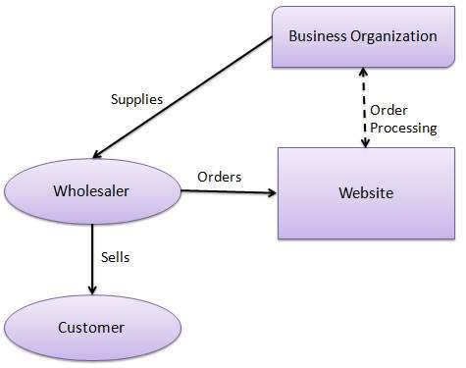

**Business - to – Consumer:-** A website following the B2C business model sells its products directly to a customer. A customer can view the products shown on the website. The customer can choose a product and order the same. The website will then send a notification to the business organization via email and the organization will dispatch the product/goods to the customer.

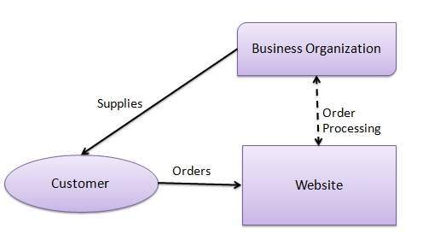

**Consumer - to – Consumer:-** A website following the C2C business model helps consumers to sell their assets like residential property, cars, motorcycles, etc., or rent a room by publishing their information on the website. Website may or may not charge the consumer for its services. Another consumer may opt to buy the product of the first customer by viewing the post/advertisement on the website.

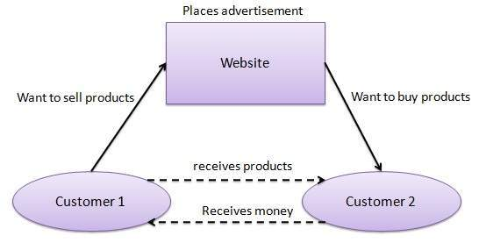

**Consumer - to – Business:-** In this model, a consumer approaches a website showing multiple business organizations for a particular service. The consumer places an estimate of amount he/she wants to spend for a particular service. For example, the comparison of interest rates of personal loan/car loan provided by various banks via websites. A business organization who fulfills the consumer's requirement within the specified budget, approaches the customer and provides its services.

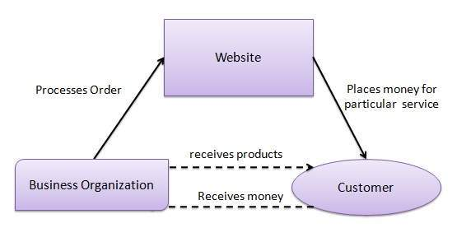

**Business - to – Government:-** B2G model is a variant of B2B model. Such websites are used by governments to trade and exchange information with various business organizations. Such websites are accredited by the government and provide a medium to businesses to submit application forms to the government.

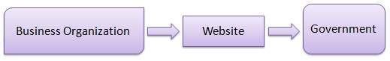

**Government - to – Business:-** Governments use B2G model websites to approach business organizations. Such websites support auctions, tenders, and application submission functionalities.

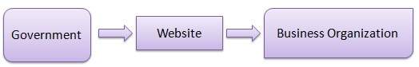

**Government - to – Citizen:-** Governments use G2C model websites to approach citizen in general. Such websites support auctions of vehicles, machinery, or any other material. Such website also provides services like registration for birth, marriage or death certificates. The main objective of G2C websites is to reduce the average time for fulfilling citizen’s requests for various government services.

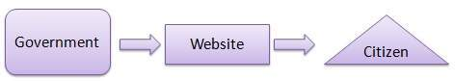

\*\*\*\*\*

**Buyer Side Purchasing:**

A business involved in buy-side activities will purchase stocks, bonds, and other financial products based on the needs and strategy of their company's or client's portfolio. The buy-side activity takes place in many settings not limited to the financial institutions mentioned above. They also include [trusts](https://www.investopedia.com/terms/t/trust.asp), [equity funds](https://www.investopedia.com/terms/e/equityfund.asp), and [high-net-worth individuals](https://www.investopedia.com/terms/h/hnwi.asp).

The whole point of buy-side investing is to create value for a firm's clients. They do this by identifying and purchasing [underpriced](https://www.investopedia.com/terms/u/underpricing.asp) assets that they believe will appreciate over time. Since the buy-side involves buying large blocks of market securities, the most prestigious companies often have a great deal of market power. These market titans are also closely watched by investors and the media.

\*\*\*\*\*

**Supply Chain Management (SCM) & Customer Relationship Management (CRM):**

**Supply Chain Management (SCM):-**

Global supply and production chains and increasing digitalization are not just a challenge for companies, but also an opportunity. By organizing the future **flow of goods and information** through supply chain management, companies can not only balance out market uncertainties but also create a flexible network of services.

Supply chain management represents the **overview and optimization of physical and digital supply chains**, from raw material suppliers to the end consumer. An efficient SCM enables supply and production processes at competitive prices and a constant flow within the value chain. Here, it’s not about optimizing the weakest link in the supply chain, but that every link plays its part.

An **open and transparent exchange of information** between dealers, suppliers, and producers guarantees that companies can react flexibly and quickly to fluctuations in demand, as with the [bullwhip effect](https://www.ionos.com/startupguide/productivity/bullwhip-effect/). This ensures that the flow of goods is as uninterrupted as possible and inventories don’t accumulate. The supply chain can only be made more efficient if **short communication channels, big data analytics, and innovative technologies** are used to influence suppliers and the flow of goods.

Central to efficient supply chain management is the implementation of modern information and communication technology in the form of software solutions and machine learning. The faster, more uniform, and automated the data exchange, the better the links in the supply chain interlock.

**The three fields of application of supply chain management (SCM):-**

SCM can be split into three fields of application:

**Product flow**: Not only do companies need to maintain a good relationship with affiliate companies; companies also need to know which sub-contractors are used along the supply chain. Only if they are fully aware of a product’s journey from the raw material suppliers to manufacturing and to the end consumer can they manage the product flow of deliveries and returns.

**Information flow**: Information must flow in two directions along the supply chain. To deliver products efficiently, companies must rely on customer behavior. How much are they buying? Are there places where consumers request certain products? Are there regular peaks in demand? These transfers of data from sales outlets to companies make sure supply flows are effectively managed. Information about transport routes and a comprehensive communication infrastructure are an integral part of SCM.

**Financial flow**: Financial flows take place parallel to and in connection with production processes. Each link in the value chain has its own financial interests and wants to benefit from the cooperation. The control and optimization of financial flows is essential for SCM in order to reduce costs and increase profits for all involved.

**Customer Relationship Management (CRM):-**

Customer relationship management (CRM) is the combination of practices, strategies and technologies that companies use to manage and analyze customer interactions and data throughout the [customer lifecycle](https://searchcustomerexperience.techtarget.com/definition/Customer-Life-Cycle). The goal is to improve customer service relationships and assist in [customer retention](https://searchcustomerexperience.techtarget.com/definition/customer-retention) and drive sales growth. CRM systems compile customer data across different channels, or points of contact, between the customer and the company, which could include the company's website, telephone, live chat, direct mail, marketing materials and [social networks](https://whatis.techtarget.com/definition/social-media). CRM systems can also give customer-facing staff members detailed information on customers' personal information, purchase history, buying preferences and concerns.

### Components of CRM:-

At the most basic level, CRM software consolidates customer information and documents it into a single CRM database so business users can more easily access and manage it.

Over time, many [additional functions have been added to CRM systems](https://searchcustomerexperience.techtarget.com/infographic/The-history-and-evolution-of-CRM) to make them more useful. Some of these functions include recording various customer interactions over email, phone, social media or other channels; depending on system capabilities, [automating various workflow automation processes](https://searcherp.techtarget.com/definition/ERP-enterprise-resource-planning), such as tasks, calendars and alerts; and giving managers the ability to track performance and productivity based on information logged within the system.

* **Marketing automation.** CRM tools with [marketing automation](https://searchcustomerexperience.techtarget.com/definition/marketing-automation) capabilities can automate repetitive tasks to enhance marketing efforts at different points in the lifecycle for lead generation. For example, as sales prospects come into the system, it might automatically send email marketing content, with the goal of turning a [sales lead](https://searchitchannel.techtarget.com/definition/lead) into a full-fledged customer.
* **Sales force automation.** [Sales force automation](https://whatis.techtarget.com/definition/sales-force-automation-SFA) tools track customer interactions and automate certain business functions of the sales cycle that are necessary to follow leads, obtain new customers and build customer loyalty.
* **Contact center automation.** Designed to reduce tedious aspects of a contact center agent's job, [contact center](https://searchcustomerexperience.techtarget.com/definition/contact-center) automation might include prerecorded audio that assists in customer problem-solving and information dissemination. Various software tools that integrate with the agent's desktop tools can handle customer requests in order to cut down on the length of calls and to simplify customer service processes. Automated contact center tools, such as [chatbots](https://searchcustomerexperience.techtarget.com/definition/chatbot), can improve customer user experiences.
* **Geolocation technology, or location-based services.** Some CRM systems include technology that can create geographic marketing campaigns based on customers' physical locations, sometimes integrating with popular location-based GPS (global positioning system) apps. [Geolocation](https://searchmobilecomputing.techtarget.com/definition/geolocation) technology can also be used as a networking or contact management tool in order to find sales prospects based on a location.
* **Workflow automation.** CRM systems help businesses optimize processes by streamlining mundane workloads, enabling employees to focus on creative and more high-level tasks.
* **Lead management.** Sales leads can be tracked through CRM, enabling sales teams to input, track and analyze data for leads in one place.
* **Human resource management (**[**HRM**](https://searchhrsoftware.techtarget.com/definition/human-resource-management-HRM)**).** CRM systems help track employee information, such as contact information, performance reviews and benefits within a company. This enables the HR department to more effectively manage the internal workforce.
* **Analytics.** Analytics in CRM help create better customer satisfaction rates by analyzing user data and helping create targeted marketing campaigns.
* **Artificial intelligence.** [AI](https://searchenterpriseai.techtarget.com/definition/AI-Artificial-Intelligence) technologies, such as [Salesforce Einstein](https://searchcustomerexperience.techtarget.com/definition/Salesforce-Einstein), have been built into [CRM platforms](https://searchcustomerexperience.techtarget.com/feature/AI-powered-CRM-platforms-compared) to automate repetitive tasks, identify customer-buying patterns to predict future customer behaviors and more.
* **Project management.** Some CRM systems include features to help users keep track of client project details such as objectives, strategic alignment, processes, risk management and progress.
* **Integration with other software.** Many CRM systems can integrate with other software, such as call center and enterprise resource planning (ERP) systems.

**\*\*\*\*\***

**UNIT III**

**Introduction to Web Technology:** Features Required for Enabling e-commerce, Web pages-Types and Issues, Tiers, The Concept of a Tier, A Concept of Microsoft and Java Technologies, Web Pages, Static Web Pages, Plug-ins, Introduction to Frames and Forms.

**Dynamic Web Pages:** Need for Dynamic Web Pages, Magic of Dynamic Web Pages, Overview of Dynamic Web Page Technologies, Overview of Dynamic HTML (DHTML), Common Gateway Interface (CGI), Microsoft’s Active Server Pages (ASP), Basics of ASP Technology, ASP Example, Modern Trends in ASP, Java and the Concept a Virtual Machine, Java Servlets and Java Sever Pages(JSP), Java Servlets, Java Sever pages (JSP).

**Active Web Pages:** Active Web pages is a Better Solution, Java Applets, Why are Active Web Pages Powerful? When not to use Active Web Pages, Lifecycle of Java Applets, Java Beans, Active X Controls.

**Introduction to Web Technology**

**Features Required for Enabling e-commerce:**

An [eCommerce](https://www.shiprocket.in/blog/what-is-ecommerce-how-it-operates/) website is essential for running an online business. However, it is equally important to have one with all the important eCommerce features to assure success. A good eCommerce website will offer all the means to the customer and the merchant to help them get involved in a fruitful transaction. Here are the top 10 features for an eCommerce website which you should look out for:

## ****Shopping Cart:-****

This is an integral part of any eCommerce store, the [shopping cart](https://www.shiprocket.in/blog/shopping-cart-abandonment/). This is where your end consumers store their products to continue with the checkout process. A flexible cart allows both the guest user and registered user to checkout. In comparison, the guest checkout does not require the user to sign up on the site, hence making the process faster.

## ****Payment Gateway Integrations:-****

A good eCommerce website gives you the option of integrating with diverse payment gateways by not limiting your choices to a selected few. It is an integral feature of eCommerce websites that can make or break the customer experience. [Shiprocket 360](https://360.shiprocket.in/) comes with pre-approved payment gateways that you can easily integrate with your online store.

## ****Order Management:-****

A wholesome order management panel simplifies the merchants’ task to get the deed information regarding buyer cancellation, refunds, COD order verification, exchange order status update, and more. The panel helps the merchant manage his order fulfillment and oversee the completion of the same.

## ****Security:-****

This feature is one of the most important feature as it ensures that no crucial data such as credit card information is saved and for all prepaid shipments the checkout is carried out through a secure [payment gateway](https://www.shiprocket.in/blog/best-payment-gateway/). The passwords are hashed and not stored in a readable format. All web pages should be protected by SSL. The servers are secure and protected using state of the art services.

## ****Scalable Infrastructure:-****

Your hosting infrastructure should be able to scale as you get more and more traffic. A higher latency leads to drops in transaction rates and leads to loss of marketing dollars. CDN should be used to improve the website’s performance and to manage the products online. It also provides excellent uptime, ensuring that the website is readily available everywhere and at any time.

## ****Mobile Compatibility:-****

Great [eCommerce websites](https://www.shiprocket.in/blog/how-to-build-a-new-ecommerce-website/) usually offer three types of solutions for mobile compatibility. First is ensuring that the mobile view is responsive and properly accommodated according to the device. The WAP is a mobile-specific template which optimizes the website in size and generates less loading time. API’s for building mobile apps is essential since everyone now likes to browse via phones. It is one of the most relevant features of eCommerce websites as it drives engagement and visits on a relatively large channel.

## ****Reports**** and Analytics:-

The reports should be available as exports which contain detailed information regarding the orders, customer database, and product reports in terms of catalogue. It is quite useful for analyzing the growth of the business. The websites should be pre-integrated with marketing tools and [analytics](https://www.shiprocket.in/blog/ecommerce-analytics-tools/) to better market the brand and read reports about the performance of the store.

## ****Logistics integration:-****

Integrating logistics services allows not only seamless shipping but also ensures that the merchant and the consumer get real time courier updates along with order tracking capability. This allows the user to manage shipments from the same panel instead of approaching the courier partners separately.

[Shiprocket](https://www.shiprocket.in/) is a platform that can help you with shipping across 26000+ pin codes, at the cheapest rates starting from Rs. 22/500g. The best part is that Shiprocket has integrations with 17+ courier partners. This gives you a wider pin code reach as compared to shipping with a single courier partner. Also, you can manage undelivered orders from an automated NDR panel that you find in the app. Furthermore, you get a customizable tracking page that gives the buyer a chance to give their feedback on undelivered orders and also take quick action on them.

## ****Communications**** and Regular Updates:-

Provisions to send and receive timely notifications regarding your orders are available on the panel. This way a merchant can keep his customers informed about the status of the order and receive the same via the system.

## ****Content Management Systems:-****

Content Management System is used to manage the website content such as, Logo, banner, Footer links, Policies, and [Products](https://www.shiprocket.in/blog/products-sell-online-from-home/) from the back end itself.

\*\*\*\*\*

**Web pages-Types and Issues:**

**web page** is a document available on world wide web. Web Pages are stored on web server and can be viewed using a web browser.

A web page can contain huge information including text, graphics, audio, video and hyper links. These hyper links are the link to other web pages.

Collection of linked web pages on a web server is known as **website.** There is unique **Uniform Resource Locator (URL)** is associated with each web page.

### Static Web page:-

**Static web pages** are also known as flat or stationary web page. They are loaded on the client’s browser as exactly they are stored on the web server. Such web pages contain only static information. User can only read the information but can’t do any modification or interact with the information.

Static web pages are created using only HTML. Static web pages are only used when the information is no more required to be modified.



### Dynamic Web page:-

**Dynamic web page** shows different information at different point of time. It is possible to change a portaion of a web page without loading the entire web page. It has been made possible using **Ajax** technology.

#### Server-side dynamic web page:-

It is created by using server-side scripting. There are server-side scripting parameters that determine how to assemble a new web page which also include setting up of more client-side processing.

#### Client-side dynamic web page:-

It is processed using client side scripting such as JavaScript. And then passed in to **Document Object Model (DOM).**



## Scripting Languages:-

Scripting languages are like programming languages that allow us to write programs in form of script. These scripts are interpreted not compiled and executed line by line.

Scripting language is used to create dynamic web pages.

### Client-side Scripting:-

**Client-side scripting** refers to the programs that are executed on client-side. Client-side scripts contains the instruction for the browser to be executed in response to certain user’s action.

Client-side scripting programs can be embedded into HTML files or also can be kept as separate files.



### Server-side Scripting:-

**Sever-side scripting** acts as an interface for the client and also limit the user access the resources on web server. It can also collects the user’s characteristics in order to customize response.



\*

\*

**Issues:-**

**1.Messy Code:-**

A lot of coding is involved in the building of a website, especially as you add more functions and features to your site. If your code is unorganized and messy, it can result in a variety of issues. Not only can it affect how your website is supposed to function, but it can affect the ability of search engines to properly index your site’s content, thereby hurting your search rankings.

**2. Presence Of Broken Links:-**

Broken links are links on your site that don’t work, whether they are links directing visitors to a page off of your website or that exists on your website. When you click on a broken link, you’ll be taken to a 404 page, which displays a message indicating that the page could not be found. There are several issues with having broken links. Visitors will be frustrated if they click on a link and it doesn’t take them to where they’re expecting to go. This reflects poorly on your site and on your brand. If you can’t maintain your website, how can visitors be expected to trust in the quality of your brand?

Broken links also indicate to Google and other search engines that you’re not keeping your website up to date. This can hurt your search engine rankings. When your rankings decline, so will your website’s exposure, resulting in fewer visitors.

**3. Poor Or Outdated Website Design:-**

The overall design of a website needs to be both functional and aesthetically pleasing. Visitors will judge how your website looks, after all. However, website design trends change relatively often. This means that if it’s been a few years since you’ve updated your site, it’s likely now outdated. The more outdated it looks, the more unprofessional your brand will appear to be. You need to update your site regularly to adhere to modern website design principles.

**4. Slow Loading Time:-**

Slow loading times can absolutely kill the website experience of your visitors. Few people have the patience to wait more than a few seconds for a page to load–especially when they’ve become so accustomed to how quickly other high-quality websites load. If your site won’t load, they can find a site that will. Generally speaking, the majority of your visitors will expect your page to load within two seconds. If it takes more than three seconds to load, expect to lose around 90 percent of the visitors trying to visit that page. 79 percent of all visitors who experience slow loading speeds won’t come back to your website.

If that wasn’t bad enough, losing visitors as a result of slow loading times will cause your bounce rate to spike. The bounce rate is a metric referring to how many people leave your page without engaging further. A high bounce rate will hurt your search engine rankings.

**5. Cluttered Homepage:-**

Your homepage is the introduction to not just your website, but to your business. As such, you need to make sure it leaves a good first impression on new visitors. One of the more common mistakes businesses make on their homepage is trying to present too much information. This causes it to become cluttered. A cluttered homepage can be overwhelming and difficult to read, making it hard for visitors to find what they’re looking for.

\*\*\*\*\*

**Tiers:**

In client server computing, the clients requests a resource and the server provides that resource. A server may serve multiple clients at the same time while a client is in contact with only one server.

The different structures for two tier and three tier are given as follows –

## Two - Tier Client/Server Structure:-

The two tier architecture primarily has two parts, a client tier and a server tier.The client tier sends a request to the server tier and the server tier responds with the desired information.

An example of a two tier client/server structure is a web server. It returns the required web pages to the clients that requested them.

An illustration of the two-tier client/server structure is as follows −

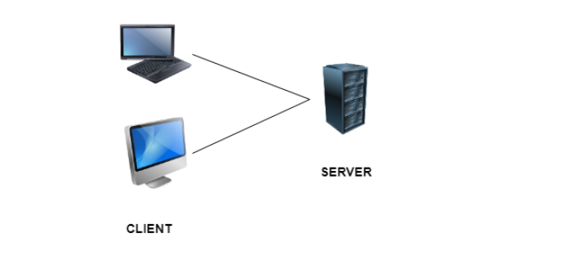

### Advantages of Two - Tier Client/Server Structure

Some of the advantages of the two-tier client/server structure are −

* This structure is quite easy to maintain and modify.
* The communication between the client and server in the form of request response messages is quite fast.

### Disadvantages of Two - Tier Client/Server Structure

A major disadvantage of the two-tier client/server structure is −

* If the client nodes are increased beyond capacity in the structure, then the server is not able to handle the request overflow and performance of the system degrades.

## Three - Tier Client/Server Structure:-

The three tier architecture has three layers namely client, application and data layer. The client layer is the one that requests the information. In this case it could be the GUI, web interface etc. The application layer acts as an interface between the client and data layer. It helps in communication and also provides security. The data layer is the one that actually contains the required data.

An illustration of the three-tier client/server structure is as follows −

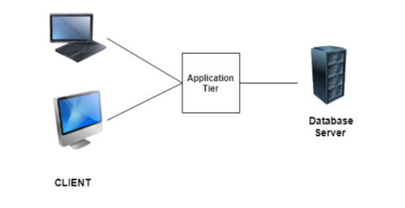

### Advantages of Three - Tier Client/Server Structure

Some of the advantages of the three-tier client/server structure are −

* The three tier structure provides much better service and fast performance.
* The structure can be scaled according to requirements without any problem.
* Data security is much improved in the three tier structure.

### Disadvantages of Three - Tier Client/Server Structure

A major disadvantage of the three-tier client/server structure is −

* Three - tier client/server structure is quite complex due to advanced features.

\*\*\*\*\*

**The Concept of a Tier:**

The web tier consists of components that handle the interaction between clients and the business tier. Its primary tasks are the following:

* Dynamically generate content in various formats for the client.
* Collect input from users of the client interface and return appropriate results from the components in the business tier.
* Control the flow of screens or pages on the client.
* Maintain the state of data for a user's session.
* Perform some basic logic and hold some data temporarily in JavaBeans components.

\*\*\*\*\*

**A Concept of Microsoft and Java Technologies:**

**Concept of Microsoft:-**

Microsoft is a leading global vendor of computer [software](https://searchapparchitecture.techtarget.com/definition/software); hardware for computer, mobile and gaming systems; and cloud services. Microsoft's corporate headquarters is located in Redmond, Wash., and it has offices in more than 60 countries.

### Company origins:-

Microsoft's roots go back at least as far as 1975, when the first commercially available [personalcomputer](https://whatis.techtarget.com/definition/personal-computer-PC) appeared on the cover of *Popular Electronics* magazine. The Altair 8800 was a rudimentary system, but it found a market for home-based computers and created a new demand for software to use with these systems.

Bill Gates and his friend Paul Allen immediately saw the potential. Gates contacted the manufacturer Micro Instrumentation and Telemetry Systems (MITS) and offered to write a program for the new computer. Gates and Allen created an interpreter for [BASIC](https://whatis.techtarget.com/definition/BASIC-Beginners-All-purpose-Symbolic-Instruction-Code) -- then a [mainframe](https://searchdatacenter.techtarget.com/definition/mainframe) programming language -- to use with the Altair.

MITS hired Gates and Allen in 1975. But by 1976, they had left to devote more time to their own fledgling company, Microsoft, which they incorporated in 1981. The company went public in March 1986.

### Microsoft Office:-

Building on the success of its operating systems, Microsoft moved into the development of productivity software.

Microsoft Office first appeared in 1990. The productivity package features a number of bundled applications and includes the word processor named Word, [Excel](https://searchenterprisedesktop.techtarget.com/definition/Excel) spreadsheet, Access database, PowerPoint presentation creator, [Outlook](https://searchwindowsserver.techtarget.com/definition/Microsoft-Outlook) email client and other tools in the same package. In addition to the desktop applications for Windows and Mac OS operating systems, Microsoft also offers Office Mobile for smartphones.

**Concept of Java Technologies:**

Java technology is both a programming language and a platform.

## The Java Programming Language

The Java programming language is a high-level language that can be characterized by all of the following buzzwords:

|  |  |
| --- | --- |
| * Simple * Object oriented * Distributed * Multithreaded * Dynamic | * Architecture neutral * Portable * High performance * Robust * Secure |

Each of the preceding buzzwords is explained in [The Java Language Environment](http://www.oracle.com/technetwork/java/langenv-140151.html) , a white paper written by James Gosling and Henry McGilton.

In the Java programming language, all source code is first written in plain text files ending with the .java extension. Those source files are then compiled into .class files by the javac compiler. A .class file does not contain code that is native to your processor; it instead contains bytecodes — the machine language of the Java Virtual Machine[1](https://docs.oracle.com/javase/tutorial/getStarted/intro/definition.html#FOOT) (Java VM). The java launcher tool then runs your application with an instance of the Java Virtual Machine.

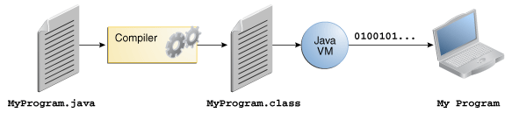

**An overview of the software development process:-**

Because the Java VM is available on many different operating systems, the same .class files are capable of running on Microsoft Windows, the Solaris Operating System (Solaris OS), Linux, or Mac OS. Some virtual machines, such as the [Java SE HotSpot at a Glance](http://www.oracle.com/technetwork/java/javase/tech/index-jsp-136373.html), perform additional steps at runtime to give your application a performance boost. This includes various tasks such as finding performance bottlenecks and recompiling (to native code) frequently used sections of code.

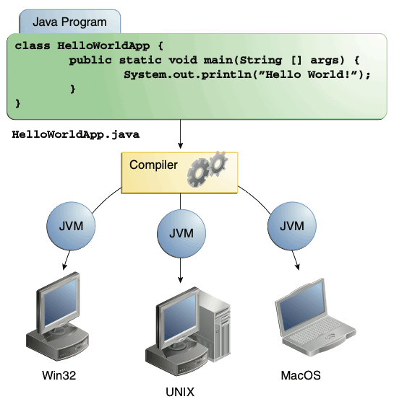

Through the Java VM, the same application is capable of running on multiple platforms.

\*\*\*\*\*

**Web Pages:**

A webpage is a document written in HTML and can be viewed on any web browser. It is contained within the web server, which can be accessed by entering the URL for that web page, and once it is loaded, it appears on the user's web browser. Each webpage is linked with a unique URL; hence two pages cannot have the same URL.

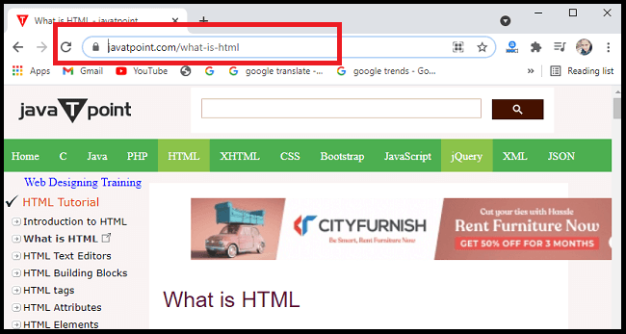

A webpage may contain **text, links for other pages, graphics, videos, etc**. Moreover, it is mainly used to provide information to the user in text, images, etc.

A webpage is a part of a website; it means a website contains different web pages. Such as **javaTpoint.com** is a website, and the page currently you are accessing is the webpage. It can be understood as an example of a book. So, a Website is like a complete book, and a webpage is like a page of that book.

The WWW or Internet contains millions of web pages, and daily, a lot is being added. Tim Berners-Lee developed **the first webpage.**

Let's understand some basic terms that are used with Webpage:

* **WebSite**: A website is a collection of several web pages. These pages are linked together with hyperlinks. A website has a unique domain name, and we can access it by entering that domain name in the URL.
* **Search Engine:** A search engine is an internet service that helps users find any information available on the internet. Some examples of search engines are **Google, Yahoo, Bing,** It is usually accessed with the help of Web browser.
* **Web Browser:** A web browser or simply browser is application software used to access the internet. Some examples of Web browsers are **Google Chrome, Microsoft Internet Explorer, Safari, etc**. It does two things:
  + It connects to a web server on the internet and requests a page that the user wants to view; once it finds that page, it displays it on its device.
  + It can interpret the set of HTML tags within a page to display the page in the correct format.
* **Webserver:** A web server can be understood as a computer that hosts or provide a website on the internet. It contains webserver software and component files of a website such as **HTML document, images, CSS stylesheet, and JS files.**
* **HTML:** HTML is an abbreviation of **Hyper-Text Markup Language**. A markup language is a computer language that specifies how a page should be formatted. With the help of HTML, one can specify fonts, colors, images, headings, and everything that he wants to display on a page displayed by the browser.

\*\*\*\*\*

**Static Web Pages:**

**Static web pages** are also known as flat or stationary web page. They are loaded on the client’s browser as exactly they are stored on the web server. Such web pages contain only static information. User can only read the information but can’t do any modification or interact with the information.

Static web pages are created using only HTML. Static web pages are only used when the information is no more required to be modified.



\*\*\*\*\*

**Plug-ins:**

A plug-in is piece of code written in a standard JavaScript file. These files provide useful jQuery methods which can be used along with jQuery library methods.

There are plenty of jQuery plug-in available which you can download from repository link at <https://jquery.com/plugins>.

## How to use Plugins:- To make a plug-in's methods available to us, we include plug-in file very similar to jQuery library file in the <head> of the document.

We must ensure that it appears after the main jQuery source file, and before our custom JavaScript code.

Following example shows how to include **jquery.plug-in.js** plugin −

<html>

<head>

<title>The jQuery Example</title>

<script type = "text/javascript"

src = "https://ajax.googleapis.com/ajax/libs/jquery/2.1.3/jquery.min.js">

</script>

<script src = "jquery.plug-in.js" type = "text/javascript"></script>

<script src = "custom.js" type = "text/javascript"></script>

<script type = "text/javascript" language = "javascript">

$(document).ready(function() {

.......your custom code.....

});

</script>

</head>

<body>

.............................

</body>

</html>

\*\*\*\*\*

**Introduction to Frames and Forms:**

**Frames:-**

HTML frames are used to divide your browser window into multiple sections where each section can load a separate HTML document. A collection of frames in the browser window is known as a frameset. The window is divided into frames in a similar way the tables are organized: into rows and columns.

## Disadvantages of Frames:-

There are few drawbacks with using frames, so it's never recommended to use frames in your webpages −

* Some smaller devices cannot cope with frames often because their screen is not big enough to be divided up.
* Sometimes your page will be displayed differently on different computers due to different screen resolution.
* The browser's *back* button might not work as the user hopes.
* There are still few browsers that do not support frame technology.

## Creating Frames:-

To use frames on a page we use <frameset> tag instead of <body> tag. The <frameset> tag defines, how to divide the window into frames. The **rows** attribute of <frameset> tag defines horizontal frames and **cols** attribute defines vertical frames. Each frame is indicated by <frame> tag and it defines which HTML document shall open into the frame.

**Note** − The <frame> tag deprecated in HTML5. Do not use this element.

### Example:-

Following is the example to create three horizontal frames −

<!DOCTYPE html>

<html>

<head>

<title>HTML Frames</title>

</head>

<frameset rows = "10%,80%,10%">

<frame name = "top" src = "/html/top\_frame.htm" />

<frame name = "main" src = "/html/main\_frame.htm" />

<frame name = "bottom" src = "/html/bottom\_frame.htm" />

<noframes>

<body>Your browser does not support frames.</body>

</noframes>

</frameset>

</html>

**Forms:-**

HTML Forms are required, when you want to collect some data from the site visitor. For example, during user registration you would like to collect information such as name, email address, credit card, etc.

A form will take input from the site visitor and then will post it to a back-end application such as CGI, ASP Script or PHP script etc. The back-end application will perform required processing on the passed data based on defined business logic inside the application.

There are various form elements available like text fields, textarea fields, drop-down menus, radio buttons, checkboxes, etc.

The HTML **<form>** tag is used to create an HTML form and it has following syntax −

<form action = "Script URL" method = "GET|POST">

form elements like input, textarea etc.

</form>

## HTML Form Controls:-

There are different types of form controls that you can use to collect data using HTML form −

* Text Input Controls
* Checkboxes Controls
* Radio Box Controls
* Select Box Controls
* File Select boxes
* Hidden Controls

## Text Input Controls:-

There are three types of text input used on forms −

* **Single-line text input controls** − This control is used for items that require only one line of user input, such as search boxes or names. They are created using HTML **<input>** tag.
* **Password input controls** − This is also a single-line text input but it masks the character as soon as a user enters it. They are also created using HTMl <input> tag.
* **Multi-line text input controls** − This is used when the user is required to give details that may be longer than a single sentence. Multi-line input controls are created using HTML **<textarea>** tag.

## Single-line text input controls:-

This control is used for items that require only one line of user input, such as search boxes or names. They are created using HTML <input> tag.

### Example

Here is a basic example of a single-line text input used to take first name and last name –

<!DOCTYPE html>

<html>

<head>

<title>Text Input Control</title>

</head>

<body>

<form >

First name: <input type = "text" name = "first\_name" />

<br>

Last name: <input type = "text" name = "last\_name" />

</form>

</body>

</html>

## Password input controls:-

This is also a single-line text input but it masks the character as soon as a user enters it. They are also created using HTML <input>tag but type attribute is set to **password**.

### Example

Here is a basic example of a single-line password input used to take user password −

<!DOCTYPE html>

<html>

<head>

<title>Password Input Control</title>

</head>

<body>

<form >

User ID : <input type = "text" name = "user\_id" />

<br>

Password: <input type = "password" name = "password" />

</form>

</body>

</html>

## Multiple-Line Text Input Controls:-

This is used when the user is required to give details that may be longer than a single sentence. Multi-line input controls are created using HTML <textarea> tag.

### Example

Here is a basic example of a multi-line text input used to take item description −

<!DOCTYPE html>

<html>

<head>

<title>Multiple-Line Input Control</title>

</head>

<body>

<form>

Description : <br />

<textarea rows = "5" cols = "50" name = "description">

Enter description here...

</textarea>

</form>

</body>

</html>

## Checkbox Control:-

Checkboxes are used when more than one option is required to be selected. They are also created using HTML <input> tag but type attribute is set to **checkbox.**.

### Example

Here is an example HTML code for a form with two checkboxes −

<!DOCTYPE html>

<html>

<head>

<title>Checkbox Control</title>

</head>

<body>

<form>

<input type = "checkbox" name = "maths" value = "on"> Maths

<input type = "checkbox" name = "physics" value = "on"> Physics

</form>

</body>

</html>

## Radio Button Control:-

Radio buttons are used when out of many options, just one option is required to be selected. They are also created using HTML <input> tag but type attribute is set to **radio**.

### Example

Here is example HTML code for a form with two radio buttons −

<!DOCTYPE html>

<html>

<head>

<title>Radio Box Control</title>

</head>

<body>

<form>

<input type = "radio" name = "subject" value = "maths"> Maths

<input type = "radio" name = "subject" value = "physics"> Physics

</form>

</body>

</html>

## Select Box Control:-

A select box, also called drop down box which provides option to list down various options in the form of drop down list, from where a user can select one or more options.

### Example

Here is example HTML code for a form with one drop down box

<!DOCTYPE html>

<html>

<head>

<title>Select Box Control</title>

</head>

<body>

<form>

<select name = "dropdown">

<option value = "Maths" selected>Maths</option>

<option value = "Physics">Physics</option>

</select>

</form>

</body>

</html>

## File Upload Box:-

If you want to allow a user to upload a file to your web site, you will need to use a file upload box, also known as a file select box. This is also created using the <input> element but type attribute is set to **file**.

### Example

Here is example HTML code for a form with one file upload box −

<!DOCTYPE html>

<html>

<head>

<title>File Upload Box</title>

</head>

<body>

<form>

<input type = "file" name = "fileupload" accept = "image/\*" />

</form>

</body>

</html>

**Button Controls:-**

There are various ways in HTML to create clickable buttons. You can also create a clickable button using <input>tag by setting its type attribute to **button**.

## Hidden Form Controls:-

Hidden form controls are used to hide data inside the page which later on can be pushed to the server. This control hides inside the code and does not appear on the actual page. For example, following hidden form is being used to keep current page number. When a user will click next page then the value of hidden control will be sent to the web server and there it will decide which page will be displayed next based on the passed current page.

### Example

Here is example HTML code to show the usage of hidden control –

<!DOCTYPE html>

<html>

<head>

<title>File Upload Box</title>

</head>

<body>

<form>

<p>This is page 10</p>

<input type = "hidden" name = "pagename" value = "10" />

<input type = "submit" name = "submit" value = "Submit" />

<input type = "reset" name = "reset" value = "Reset" />

</form>

</body>

</html>

\*\*\*\*\*

**Dynamic Web Pages**

**Need for Dynamic Web Pages:**

A dynamic page displays different content for different users while retaining the same layout and design. Such pages, usually written in CGI, AJAX, ASP or ASP.NET, take more time to load than simple static pages. They’re frequently implemented to show information that changes frequently, e.g., weather updates or stock prices.

Dynamic pages usually contain application programs for different services and require server-side resources like databases. A database allows the page creator to separate the website’s design from the content to be displayed to users. Once they upload content into the database, it is retrieved by the website in response to a user request.

**Two Types of Dynamic Web Pages:-**

* **Client-side Scripting:**A web page that changes in response to an action within it (“client-side event”) uses client-side scripting. These scripts generate “client-side content” on the user’s computer, rather than the webserver.
* **Server-side Scripting:**A web page that changes when it’s loaded or visited, or based on what’s submitted to it, uses server-side scripting. When the pages are loaded, server-side content is generated. Examples include login pages, shopping carts and submission forms.

**How are Dynamic Web Pages Processed?**

When the webserver receives a user request for a dynamic page, it does not send the page directly to the requesting browser as it would do with a static page. Instead, it passes the page to the *application server* which then completes three activities:

* Read the code on the page
* Finish the page according to the code’s instructions
* Remove the code from the page

This results in a static page that’s passed back to the web server by the application server, and then to the requesting browser for display.

The application server cannot communicate directly with the database, so it requires a *database driver* that functions as an interpreter and lets the application read and manipulate data that would otherwise be indecipherable.

\*\*\*\*\*

**Magic of Dynamic Web Pages:**

A dynamic web page is a web page that displays different content each time it's viewed. For example, the page may change with the time of day, the user that accesses the webpage, or the type of user interaction. There are two types of dynamic web pages.

### CLIENT-SIDE SCRIPTING:-

Web pages that change in response to an action within that web page, such as a mouse or a keyboard action, use client-side scripting.

Client-side scripts generate client-side content. Client-side content is content that's generated on the user's computer rather than the server. In these cases, the user's web browser would download the web page content from the server, process the code that's embedded in the web page, and then display the updated content to the user.

Scripting languages such as JavaScript and Flash allow a web page to respond to client-side events.

### SERVER-SIDE SCRIPTING:-

Web pages that change when a web page is loaded or visited use server-side scripting. Server-side content is content that's generated when a web page is loaded. For example, login pages, forums, submission forms, and shopping carts, all use server-side scripting since those web pages change according to what is submitted to it.

Scripting languages such as PHP, ASP, ASP.NET, JSP, ColdFusion and Perl allow a web page to respond to submission events.

\*\*\*\*\*

**Overview of Dynamic Web Page Technologies:**

A server-side dynamic web page is a web page whose construction is controlled by an application server processing server-side scripts. In server-side scripting, parameters determine how the assembly of every new web page proceeds, including the setting up of more client-side processing.

A client-side dynamic web page processes the web page using HTML scripting running in the browser as it loads. JavaScript and other scripting languages determine the way the HTML in the received page is parsed into the Document Object Model, or DOM, that represents the loaded web page. The same client-side techniques can then dynamically update or change the DOM in the same way. Even though a web page can be dynamic on the client-side, it can still be hosted on a static hosting service such as GitHub Pages or Amazon S3 as long as there isn’t any server-side code included.

A dynamic web page is then reloaded by the user or by a computer program to change some variable content. The updating information could come from the server, or from changes made to that page’s DOM. This may or may not truncate the browsing history or create a saved version to go back to, but a dynamic web page update using AJAX technologies will neither create a page to go back to, nor truncate the web browsing history forward of the displayed page. Using AJAX, the end user gets one dynamic page managed as a single page in the web browser while the actual web content rendered on that page can vary. The AJAX engine sits only on the browser requesting parts of its DOM, the DOM, for its client, from an application server.

\*\*\*\*\*

**Overview of Dynamic HTML (DHTML):**

**DHTML stands for Dynamic Hypertext Markup language i.e., Dynamic HTML.**

Dynamic HTML is not a markup or programming language but it is a term that combines the features of various web development technologies for creating the web pages dynamic and interactive.

The DHTML application was introduced by Microsoft with the release of the 4th version of IE (Internet Explorer) in 1997.

## Components of Dynamic HTML

DHTML consists of the following four components or languages:Difference between JDK, JRE, and JVM

* HTML 4.0
* CSS
* JavaScript
* DOM.

### HTML 4.0:-

HTML is a client-side markup language, which is a core component of the DHTML. It defines the structure of a web page with various defined basic elements or tags.

### CSS:-

CSS stands for Cascading Style Sheet, which allows the web users or developers for controlling the style and layout of the HTML elements on the web pages.

### JavaScript:-

JavaScript is a scripting language which is done on a client-side. The various browser supports JavaScript technology. DHTML uses the JavaScript technology for accessing, controlling, and manipulating the HTML elements. The statements in JavaScript are the commands which tell the browser for performing an action.

### DOM:-

DOM is the document object model. It is a w3c standard, which is a standard interface of programming for HTML. It is mainly used for defining the objects and properties of all elements in HTML.

## Uses of DHTML:-

Following are the uses of DHTML (Dynamic HTML):

* It is used for designing the animated and interactive web pages that are developed in real-time.
* DHTML helps users by animating the text and images in their documents.
* It allows the authors for adding the effects on their pages.
* It also allows the page authors for including the drop-down menus or rollover buttons.
* This term is also used to create various browser-based action games.
* It is also used to add the ticker on various websites, which needs to refresh their content automatically.

## Features of DHTML:-

Following are the various characteristics or features of DHTML (Dynamic HTML):

* Its simplest and main feature is that we can create the web page dynamically.
* **Dynamic Style** is a feature, that allows the users to alter the font, size, color, and content of a web page.
* It provides the facility for using the events, methods, and properties. And, also provides the feature of code reusability.
* It also provides the feature in browsers for data binding.
* Using DHTML, users can easily create dynamic fonts for their web sites or web pages.
* With the help of DHTML, users can easily change the tags and their properties.
* The web page functionality is enhanced because the DHTML uses low-bandwidth effect.

\*\*\*\*\*

**Common Gateway Interface (CGI):**

The Common Gateway Interface, or CGI, is a set of standards that define how information is exchanged between the web server and a custom script.

The CGI specs are currently maintained by the NCSA and NCSA defines CGI is as follows −

The Common Gateway Interface, or CGI, is a standard for external gateway programs to interface with information servers such as HTTP servers.

The current version is CGI/1.1 and CGI/1.2 is under progress.

## Web Browsing:-

To understand the concept of CGI, lets see what happens when we click a hyper link to browse a particular web page or URL.

* Your browser contacts the HTTP web server and demand for the URL ie. filename.
* Web Server will parse the URL and will look for the filename in if it finds that file then sends back to the browser otherwise sends an error message indicating that you have requested a wrong file.
* Web browser takes response from web server and displays either the received file or error message.

However, it is possible to set up the HTTP server so that whenever a file in a certain directory is requested that file is not sent back; instead it is executed as a program, and whatever that program outputs is sent back for your browser to display. This function is called the Common Gateway Interface or CGI and the programs are called CGI scripts. These CGI programs can be a PERL Script, Shell Script, C or C++ program etc.

## CGI Architecture Diagram:-

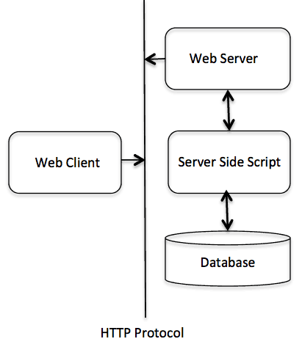

## Web Server Support & Configuration

Before you proceed with CGI Programming, make sure that your Web Server supports CGI and it is configured to handle CGI Programs. All the CGI Programs be executed by the HTTP server are kept in a pre-configured directory. This directory is called CGI Directory and by convention it is named as /cgi-bin. By convention PERL CGI files will have extention as **.cgi**.

## First CGI Program

#!/usr/bin/perl

print "Content-type:text/html\r\n\r\n";

print '<html>';

print '<head>';

print '<title>Hello Word - First CGI Program</title>';

print '</head>';

print '<body>';

print '<h2>Hello Word! This is my first CGI program</h2>';

print '</body>';

print '</html>';

1;

### Output:-

Hello Word! This is my first CGI program

\*\*\*\*\*

**Microsoft’s Active Server Pages (ASP):**

ASP stands for Active Server Page. ASP was developed by Microsoft to allow programmers to create a dynamic website. It is the first server side script engine and now has been superseded by ASP.NET. ASP is an HTML page that includes one or more scripts. Scripts are processed by an ASP interpreter on a web server by using input requested for a page to access data from a database before delivering it to the receiver.

File Extension: .asp (for ASP)

File Extension: .aspx (for ASP.NET)

ASP supports multiple programming languages like JavaScript and C#. It is similar to other scripting languages just like PHP, and JSP. When your browser URL show an ".asp" or ".aspx" suffix, then you are visiting an ASP page.

ASP is a feature of Microsoft Internet Information Server (IIS), but as it handles HTML page, it is supported by all browsers. You can create an ASP file by including Jscript or VBScript in an HTML file.

**What ASP Can Do:-**

* It responds to user's request submitted from HTML forms.
* It is simple and provides a greater speed in comparison to Perl and CGI.
* It is secured as ASP code is hidden in the browser and can't be viewed.
* It can add or change the content of the web page.
* It can access any type of data and returns the result to browser.

**ASP: Application Service Provider:-** ASP also stands for Application Service Provider. An ASP is business providing internet applications and other related services to their customers across a wide area network.

ASPs are a way for companies to outsource their services related to information technology to the customers. They may be private enterprises or government organizations.

\*\*\*\*\*

**Basics of ASP Technology:**

ASP.NET is a web development platform, which provides a programming model, a comprehensive software infrastructure and various services required to build up robust web applications for PC, as well as mobile devices.

ASP.NET works on top of the HTTP protocol, and uses the HTTP commands and policies to set a browser-to-server bilateral communication and cooperation.

ASP.NET is a part of Microsoft .Net platform. ASP.NET applications are compiled codes, written using the extensible and reusable components or objects present in .Net framework. These codes can use the entire hierarchy of classes in .Net framework.

The ASP.NET application codes can be written in any of the following languages:

* C#
* Visual Basic.Net
* Jscript
* J#

ASP.NET is used to produce interactive, data-driven web applications over the internet. It consists of a large number of controls such as text boxes, buttons, and labels for assembling, configuring, and manipulating code to create HTML pages.

**ASP.NET Web Forms Model:-**

ASP.NET web forms extend the event-driven model of interaction to the web applications. The browser submits a web form to the web server and the server returns a full markup page or HTML page in response.

All client side user activities are forwarded to the server for stateful processing. The server processes the output of the client actions and triggers the reactions.

Now, HTTP is a stateless protocol. ASP.NET framework helps in storing the information regarding the state of the application, which consists of:

* Page state
* Session state

The page state is the state of the client, i.e., the content of various input fields in the web form. The session state is the collective information obtained from various pages the user visited and worked with, i.e., the overall session state. To clear the concept, let us take an example of a shopping cart.

User adds items to a shopping cart. Items are selected from a page, say the items page, and the total collected items and price are shown on a different page, say the cart page. Only HTTP cannot keep track of all the information coming from various pages. ASP.NET session state and server side infrastructure keeps track of the information collected globally over a session.

The ASP.NET runtime carries the page state to and from the server across page requests while generating ASP.NET runtime codes, and incorporates the state of the server side components in hidden fields.

This way, the server becomes aware of the overall application state and operates in a two-tiered connected way.

**The ASP.NET Component Model:-**

The ASP.NET component model provides various building blocks of ASP.NET pages. Basically it is an object model, which describes:

* Server side counterparts of almost all HTML elements or tags, such as <form> and <input>.
* Server controls, which help in developing complex user-interface. For example, the Calendar control or the Gridview control.

ASP.NET is a technology, which works on the .Net framework that contains all web-related functionalities. The .Net framework is made of an object-oriented hierarchy. An ASP.NET web application is made of pages. When a user requests an ASP.NET page, the IIS delegates the processing of the page to the ASP.NET runtime system.

The ASP.NET runtime transforms the .aspx page into an instance of a class, which inherits from the base class page of the .Net framework. Therefore, each ASP.NET page is an object and all its components i.e., the server-side controls are also objects.

\*\*\*\*\*

**ASP Example:**

<!DOCTYPEhtml>  
<html>  
<body>  
<%  
response.write("MyfirstASPscript!")  
%>  
</body>  
</html>

**Output:**

ASP can output plain text:

Hello World!

\*\*\*\*\*

**Modern Trends in ASP:**

Talking About Key Trends for ASP.Net, ASP.NET is a popular open source web framework developed by Microsoft to allow willing developers to build dynamic web pages and web applications based on HTML5, CSS & JavaScript. ASP.NET is still one of the best web development technologies because it offers better features and functionality that helps to enhance your application and grow your business. In fact, ASP.NET is not limited to script languages- it supports Visual Basic, C#, and J# and you can create compelling [ASP.NET applications](https://www.brainvire.com/aspdotnet-application-development/) using Visual Studio, which is again a Microsoft product.

Here we will discuss the key trends for ASP .NET which is important and beneficial for the developers and the industry.

**A New Framework:-**

If you are using ASP.NET core for [.Net Development](https://www.brainvire.com/aspdotnet-application-development/) for a long time or enthusiastic about it, then you might be aware that Microsoft already announced a new framework named ASP.NET Core 1.0 to build cloud-based, Internet-connected applications but it came as a surprise to the renowned developers. [ASP.NET](https://www.brainvire.ca/asp-net-web-application-development/) Core is a cross-platform, high-performance and lightweight framework with which you can build IoT apps, development tools on Windows, Linux & macOS and deploy to the cloud.

Talking About Key Trends for ASP.Net, With the new version of Core 2.0, Microsoft gave developers the privilege to create .NET Core console apps, xUnit test projects, standard class libraries and provided a better support for multiple target frameworks. The latest version Core 2.1 is bundled with improved security, commitment to GDPR(General data protection regulation), SignalR(provides a simplified scale-out model, new JavaScript client with no jQuery dependency), Razor class libraries that you can share across multiple projects and a lot more.

**Big Data & IoT:-**

Nowadays, trends revolving around Big data & IoT is not new. With Big Data present in the picture, it became easy for the industry to store huge amounts of data on the cloud that can be accessed easily from any place and it helped the analytics to take proper decisions in real-time depending on the organized data. Now, the interesting part is that ASP.NET platform allows the industry to take advantage of IoT and Big Data technologies. IIS or Internet Information Server is one of the most powerful web servers from Microsoft that is used to host ASP.NET web applications and the combination of both can deliver a highly scalable solution which is indeed an advantage for any business!

**Cloud Service:-**

Cloud service became popular in recent times because of its storage property. A huge amount of data can be stored and accessed from anywhere around the world and that too, anytime! With an increasing trend of business to shift towards cloud, Microsoft developed Azure, an operating system for the cloud to play with big data and provide a complete analytics solution. Through Azure, the [.NET application](https://www.brainvire.com/aspdotnet-application-development/) whose business logic is based on ASP .NET can be deployed on the cloud that has been developed using ASP .NET MVC front-end.

Talking About Key Trends for ASP.Net, With the latest releases of the software and .NET technologies in the market, .NET is becoming a popular choice of the framework because it provides flexible business application within budget. Whether you are developing dynamic websites or mobile apps or business intelligence applications- reliable & scalable ASP .NET is your best solution in 2018!

\*\*\*\*\*

**Java and the Concept a Virtual Machine:**

JVM (Java Virtual Machine) is an abstract machine. It is a specification that provides runtime environment in which java bytecode can be executed.

JVMs are available for many hardware and software platforms (i.e. JVM is platform dependent).

### What is JVM

1. **A specification** where working of Java Virtual Machine is specified. But implementation provider is independent to choose the algorithm. Its implementation has been provided by Oracle and other companies.
2. **An implementation** Its implementation is known as JRE (Java Runtime Environment).
3. **Runtime Instance** Whenever you write java command on the command prompt to run the java class, an instance of JVM is created.

### What it does

The JVM performs following operation:

* Loads code
* Verifies code
* Executes code
* Provides runtime environment

JVM provides definitions for the:

* Memory area
* Class file format
* Register set
* Garbage-collected heap
* Fatal error reporting etc.

## JVM Architecture:

Let's understand the internal architecture of JVM. It contains classloader, memory area, execution engine etc.

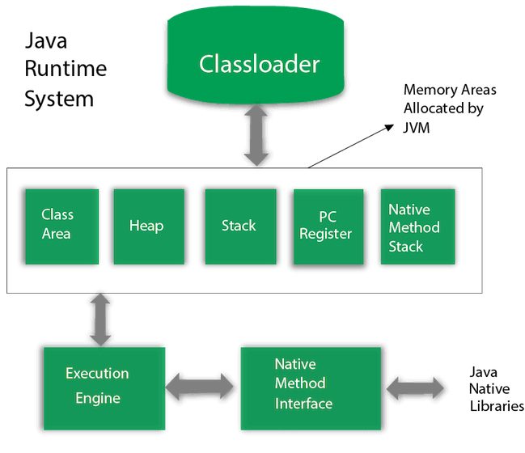

### 1) Classloader:-

Classloader is a subsystem of JVM which is used to load class files. Whenever we run the java program, it is loaded first by the classloader. There are three built-in classloaders in Java.

* **Bootstrap ClassLoader**: This is the first classloader which is the super class of Extension classloader. It loads the rt.jar file which contains all class files of Java Standard Edition like java.lang package classes, java.net package classes, java.util package classes, java.io package classes, java.sql package classes etc.
* **Extension ClassLoader**: This is the child classloader of Bootstrap and parent classloader of System classloader. It loades the jar files located inside $JAVA\_HOME/jre/lib/ext directory.
* **System/Application ClassLoader**: This is the child classloader of Extension classloader. It loads the classfiles from classpath. By default, classpath is set to current directory. You can change the classpath using "-cp" or "-classpath" switch. It is also known as Application classloader.

### 2) Class(Method) Area:-

Class(Method) Area stores per-class structures such as the runtime constant pool, field and method data, the code for methods.

### 3) Heap:-

It is the runtime data area in which objects are allocated.

### 4) Stack:-

Java Stack stores frames. It holds local variables and partial results, and plays a part in method invocation and return.

Each thread has a private JVM stack, created at the same time as thread.

A new frame is created each time a method is invoked. A frame is destroyed when its method invocation completes.

### 5) Program Counter Register:-

PC (program counter) register contains the address of the Java virtual machine instruction currently being executed.

### 6) Native Method Stack:-

It contains all the native methods used in the application.

### 7) Execution Engine:-

It contains:

* **A virtual processor**
* **Interpreter:** Read bytecode stream then execute the instructions.
* **Just-In-Time(JIT) compiler:** It is used to improve the performance. JIT compiles parts of the byte code that have similar functionality at the same time, and hence reduces the amount of time needed for compilation. Here, the term "compiler" refers to a translator from the instruction set of a Java virtual machine (JVM) to the instruction set of a specific CPU.

### 8) Java Native Interface:-

Java Native Interface (JNI) is a framework which provides an interface to communicate with another application written in another language like C, C++, Assembly etc. Java uses JNI framework to send output to the Console or interact with OS libraries.

\*\*\*\*\*

**Java Servlets and Java Sever Pages(JSP):**

**Java Servlets:-**

Servlets provide a component-based, platform-independent method for building Webbased applications, without the performance limitations of CGI programs. Servlets have access to the entire family of Java APIs, including the JDBC API to access enterprise databases.

**Why to Learn Servlet?**

Using Servlets, you can collect input from users through web page forms, present records from a database or another source, and create web pages dynamically.

Java Servlets often serve the same purpose as programs implemented using the Common Gateway Interface (CGI). But Servlets offer several advantages in comparison with the CGI.

* Performance is significantly better.
* Servlets execute within the address space of a Web server. It is not necessary to create a separate process to handle each client request.
* Servlets are platform-independent because they are written in Java.
* Java security manager on the server enforces a set of restrictions to protect the resources on a server machine. So servlets are trusted.
* The full functionality of the Java class libraries is available to a servlet. It can communicate with applets, databases, or other software via the sockets and RMI mechanisms that you have seen already.

**Applications of Servlet:-**

* Read the explicit data sent by the clients (browsers). This includes an HTML form on a Web page or it could also come from an applet or a custom HTTP client program.
* Read the implicit HTTP request data sent by the clients (browsers). This includes cookies, media types and compression schemes the browser understands, and so forth.
* Process the data and generate the results. This process may require talking to a database, executing an RMI or CORBA call, invoking a Web service, or computing the response directly.
* Send the explicit data (i.e., the document) to the clients (browsers). This document can be sent in a variety of formats, including text (HTML or XML), binary (GIF images), Excel, etc.
* Send the implicit HTTP response to the clients (browsers). This includes telling the browsers or other clients what type of document is being returned (e.g., HTML), setting cookies and caching parameters, and other such tasks.

\*

**Java Sever Pages(JSP):**

Java Server Pages (JSP) is a server-side programming technology that enables the creation of dynamic, platform-independent method for building Web-based applications. JSP have access to the entire family of Java APIs, including the JDBC API to access enterprise databases.

## Why to Learn JSP?

JavaServer Pages often serve the same purpose as programs implemented using the **Common Gateway Interface (CGI)**. But JSP offers several advantages in comparison with the CGI.

* Performance is significantly better because JSP allows embedding Dynamic Elements in HTML Pages itself instead of having separate CGI files.
* JSP are always compiled before they are processed by the server unlike CGI/Perl which requires the server to load an interpreter and the target script each time the page is requested.
* JavaServer Pages are built on top of the Java Servlets API, so like Servlets, JSP also has access to all the powerful Enterprise Java APIs, including **JDBC, JNDI, EJB, JAXP,** etc.
* JSP pages can be used in combination with servlets that handle the business logic, the model supported by Java servlet template engines.

Finally, JSP is an integral part of Java EE, a complete platform for enterprise class applications. This means that JSP can play a part in the simplest applications to the most complex and demanding.

## Applications of JSP:-

As mentioned before, JSP is one of the most widely used language over the web. I'm going to list few of them here:

### JSP vs. Active Server Pages (ASP)

The advantages of JSP are twofold. First, the dynamic part is written in Java, not Visual Basic or other MS specific language, so it is more powerful and easier to use. Second, it is portable to other operating systems and non-Microsoft Web servers.

### JSP vs. Pure Servlets

It is more convenient to write (and to modify!) regular HTML than to have plenty of println statements that generate the HTML.

### JSP vs. Server-Side Includes (SSI)

SSI is really only intended for simple inclusions, not for "real" programs that use form data, make database connections, and the like.

### JSP vs. JavaScript

JavaScript can generate HTML dynamically on the client but can hardly interact with the web server to perform complex tasks like database access and image processing etc.

### JSP vs. Static HTML

Regular HTML, of course, cannot contain dynamic information.

\*\*\*\*\*

**Java Servlets:**

Servlets provide a component-based, platform-independent method for building Webbased applications, without the performance limitations of CGI programs. Servlets have access to the entire family of Java APIs, including the JDBC API to access enterprise databases. This tutorial will teach you how to use Java Servlets to develop your web based applications in simple and easy steps.

Using Servlets, you can collect input from users through web page forms, present records from a database or another source, and create web pages dynamically.

Java Servlets often serve the same purpose as programs implemented using the Common Gateway Interface (CGI). But Servlets offer several advantages in comparison with the CGI.

* Performance is significantly better.
* Servlets execute within the address space of a Web server. It is not necessary to create a separate process to handle each client request.
* Servlets are platform-independent because they are written in Java.
* Java security manager on the server enforces a set of restrictions to protect the resources on a server machine. So servlets are trusted.
* The full functionality of the Java class libraries is available to a servlet. It can communicate with applets, databases, or other software via the sockets and RMI mechanisms that you have seen already.

**Applications of Servlet:-**

* Read the explicit data sent by the clients (browsers). This includes an HTML form on a Web page or it could also come from an applet or a custom HTTP client program.
* Read the implicit HTTP request data sent by the clients (browsers). This includes cookies, media types and compression schemes the browser understands, and so forth.
* Process the data and generate the results. This process may require talking to a database, executing an RMI or CORBA call, invoking a Web service, or computing the response directly.
* Send the explicit data (i.e., the document) to the clients (browsers). This document can be sent in a variety of formats, including text (HTML or XML), binary (GIF images), Excel, etc.
* Send the implicit HTTP response to the clients (browsers). This includes telling the browsers or other clients what type of document is being returned (e.g., HTML), setting cookies and caching parameters, and other such tasks.

\*\*\*\*\*

**Java Sever pages (JSP):**

Java Server Pages (JSP) is a server-side programming technology that enables the creation of dynamic, platform-independent method for building Web-based applications. JSP have access to the entire family of Java APIs, including the JDBC API to access enterprise databases. This tutorial will teach you how to use Java Server Pages to develop your web applications in simple and easy steps.

## Why to Learn JSP?

JavaServer Pages often serve the same purpose as programs implemented using the **Common Gateway Interface (CGI)**. But JSP offers several advantages in comparison with the CGI.

* Performance is significantly better because JSP allows embedding Dynamic Elements in HTML Pages itself instead of having separate CGI files.
* JSP are always compiled before they are processed by the server unlike CGI/Perl which requires the server to load an interpreter and the target script each time the page is requested.
* JavaServer Pages are built on top of the Java Servlets API, so like Servlets, JSP also has access to all the powerful Enterprise Java APIs, including **JDBC, JNDI, EJB, JAXP,** etc.
* JSP pages can be used in combination with servlets that handle the business logic, the model supported by Java servlet template engines.

Finally, JSP is an integral part of Java EE, a complete platform for enterprise class applications. This means that JSP can play a part in the simplest applications to the most complex and demanding.

## Applications of JSP:-

As mentioned before, JSP is one of the most widely used language over the web. I'm going to list few of them here:

### JSP vs. Active Server Pages (ASP)

The advantages of JSP are twofold. First, the dynamic part is written in Java, not Visual Basic or other MS specific language, so it is more powerful and easier to use. Second, it is portable to other operating systems and non-Microsoft Web servers.

### JSP vs. Pure Servlets

It is more convenient to write (and to modify!) regular HTML than to have plenty of println statements that generate the HTML.

### JSP vs. Server-Side Includes (SSI)

SSI is really only intended for simple inclusions, not for "real" programs that use form data, make database connections, and the like.

### JSP vs. JavaScript

JavaScript can generate HTML dynamically on the client but can hardly interact with the web server to perform complex tasks like database access and image processing etc.

### JSP vs. Static HTML

Regular HTML, of course, cannot contain dynamic information.

\*\*\*\*\*

**Active Web Pages**

**Active Web pages is a Better Solution:**

**web page** is a document available on world wide web. Web Pages are stored on web server and can be viewed using a web browser.

A web page can cotain huge information including text, graphics, audio, video and hyper links. These hyper links are the link to other web pages.

An active web page is a page where the browser performs the logic instead of the server. So for example when you've got a page where you're showing share prices, then you want it to update e.g. every 5 seconds. A solution would be to use AJAX with JavaScript. In contrast to PHP, your browser is able to execute JavaScript, so it is happening without reloading the page. So with an active page, everything is happening inside your browser without the need to reload the page every time you want new information.

\*\*\*\*\*

**Java Applets:**

An **applet** is a Java program that runs in a Web browser. An applet can be a fully functional Java application because it has the entire Java API at its disposal.

There are some important differences between an applet and a standalone Java application, including the following –

* An applet is a Java class that extends the java.applet.Applet class.
* A main() method is not invoked on an applet, and an applet class will not define main().
* Applets are designed to be embedded within an HTML page.
* When a user views an HTML page that contains an applet, the code for the applet is downloaded to the user's machine.
* A JVM is required to view an applet. The JVM can be either a plug-in of the Web browser or a separate runtime environment.
* The JVM on the user's machine creates an instance of the applet class and invokes various methods during the applet's lifetime.
* Applets have strict security rules that are enforced by the Web browser. The security of an applet is often referred to as sandbox security, comparing the applet to a child playing in a sandbox with various rules that must be followed.
* Other classes that the applet needs can be downloaded in a single Java Archive (JAR) file.

**The Applet Class:-**

Every applet is an extension of the *java.applet.Applet class*. The base Applet class provides methods that a derived Applet class may call to obtain information and services from the browser context.

These include methods that do the following −

* Get applet parameters
* Get the network location of the HTML file that contains the applet
* Get the network location of the applet class directory
* Print a status message in the browser
* Fetch an image
* Fetch an audio clip
* Play an audio clip
* Resize the applet

Additionally, the Applet class provides an interface by which the viewer or browser obtains information about the applet and controls the applet's execution. The viewer may −

* Request information about the author, version, and copyright of the applet
* Request a description of the parameters the applet recognizes
* Initialize the applet
* Destroy the applet
* Start the applet's execution
* Stop the applet's execution

The Applet class provides default implementations of each of these methods. Those implementations may be overridden as necessary.

The "Hello, World" applet is complete as it stands. The only method overridden is the paint method.

\*\*\*\*\*

**Lifecycle of Java Applets:**

Four methods in the Applet class gives you the framework on which you build any serious applet –

* **init** − This method is intended for whatever initialization is needed for your applet. It is called after the param tags inside the applet tag have been processed.
* **start** − This method is automatically called after the browser calls the init method. It is also called whenever the user returns to the page containing the applet after having gone off to other pages.
* **stop** − This method is automatically called when the user moves off the page on which the applet sits. It can, therefore, be called repeatedly in the same applet.
* **destroy** − This method is only called when the browser shuts down normally. Because applets are meant to live on an HTML page, you should not normally leave resources behind after a user leaves the page that contains the applet.
* **paint** − Invoked immediately after the start() method, and also any time the applet needs to repaint itself in the browser. The paint() method is actually inherited from the java.awt.

A "Hello, World" Applet

Following is a simple applet named HelloWorldApplet.java −

import java.applet.\*;

import java.awt.\*;

public class HelloWorldApplet extends Applet {

public void paint (Graphics g) {

g.drawString ("Hello World", 25, 50);

}

}

These import statements bring the classes into the scope of our applet class −

* java.applet.Applet
* java.awt.Graphics

Without those import statements, the Java compiler would not recognize the classes Applet and Graphics, which the applet class refers to.

\*\*\*\*\*

**Java Beans:**

A JavaBean is a specially constructed Java class written in the Java and coded according to the JavaBeans API specifications.

Following are the unique characteristics that distinguish a JavaBean from other Java classes −

* It provides a default, no-argument constructor.
* It should be serializable and that which can implement the **Serializable** interface.
* It may have a number of properties which can be read or written.
* It may have a number of "**getter**" and "**setter**" methods for the properties.

**JavaBeans Properties:-**

A JavaBean property is a named attribute that can be accessed by the user of the object. The attribute can be of any Java data type, including the classes that you define.

A JavaBean property may be **read, write, read only**, or **write only**. JavaBean properties are accessed through two methods in the JavaBean's implementation class –

|  |  |
| --- | --- |
| **S.No.** | **Method & Description** |
| 1 | get**PropertyName**()  For example, if property name is *firstName*, your method name would be **getFirstName()** to read that property. This method is called accessor. |
| 2 | set**PropertyName**()  For example, if property name is *firstName*, your method name would be **setFirstName()** to write that property. This method is called mutator. |

A read-only attribute will have only a **getPropertyName()** method, and a write-only attribute will have only a **setPropertyName()** method.

**JavaBeans Example**

Consider a student class with few properties −

package com.tutorialspoint;

public class StudentsBean implements java.io.Serializable {

private String firstName = null;

private String lastName = null;

private int age = 0;

public StudentsBean() {

}

public String getFirstName(){

return firstName;

}

public String getLastName(){

return lastName;

}

public int getAge(){

return age;

}

public void setFirstName(String firstName){

this.firstName = firstName;

}

public void setLastName(String lastName){

this.lastName = lastName;

}

public void setAge(Integer age){

this.age = age;

}

}

**Accessing JavaBeans**

The **useBean** action declares a JavaBean for use in a JSP. Once declared, the bean becomes a scripting variable that can be accessed by both scripting elements and other custom tags used in the JSP. The full syntax for the useBean tag is as follows −

<jsp:useBean id = "bean's name" scope = "bean's scope" typeSpec/>

\*\*\*\*\*

**Active X Controls:**

An **ActiveX control container** is a parent program that supplies the environment for an ActiveX (formerly OLE) control to run.

* ActiveX control is a control using Microsoft ActiveX technologies.
* ActiveX is not a programming language, but rather a set of rules for how applications should share information.
* Programmers can develop ActiveX controls in a variety of languages, including C, C++, Visual Basic, and Java.
* You can create an application capable of containing ActiveX controls with or without MFC, but it is much easier to do with MFC.

Let us look into simple example of add ActiveX controls in your MFC dialog based application.

**Step 1** − Right-click on the dialog in the designer window and select Insert ActiveX Control.

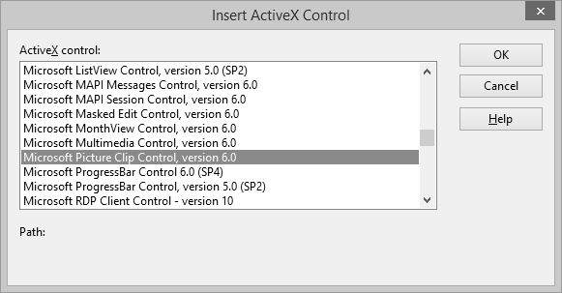

**Step 2** − Select the Microsoft Picture Clip Control and click OK.

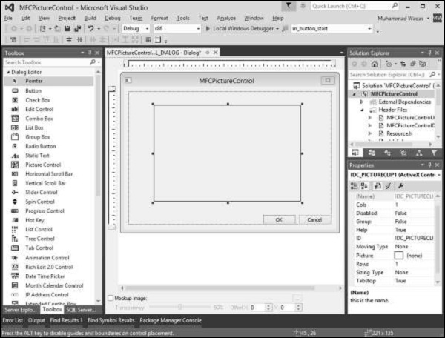

**Step 3** − Resize the Picture control and in the Properties window, click the Picture field.

**Step 4** − Browse the folder that contains Pictures. Select any picture.

**Step 5** − When you run this application, you will see the following output.

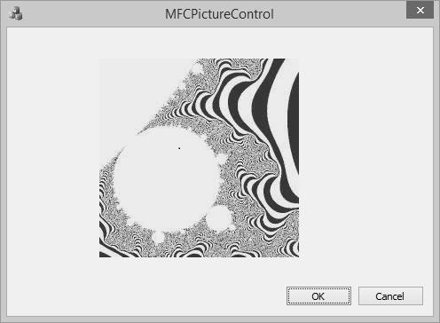

Let us have a look into another simple example.

**Step 1** − Right-click on the dialog in the designer window.

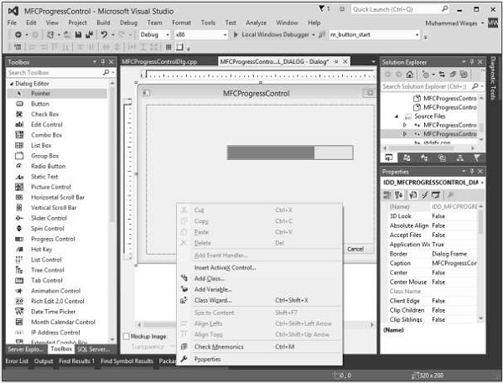

**Step 2** − Select Insert ActiveX Control.

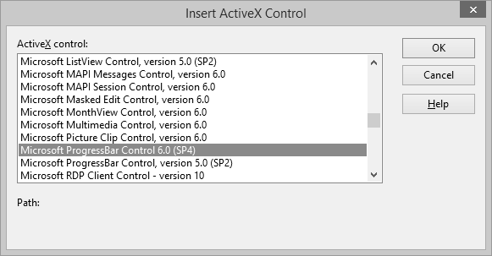

**Step 3** − Select the Microsoft ProgressBar Control 6.0, click OK.

**Step 4** − Select the progress bar and set its Orientation in the Properties Window to **1 – ccOrientationVertical**.

**Step 5** − Add control variable for Progress bar.

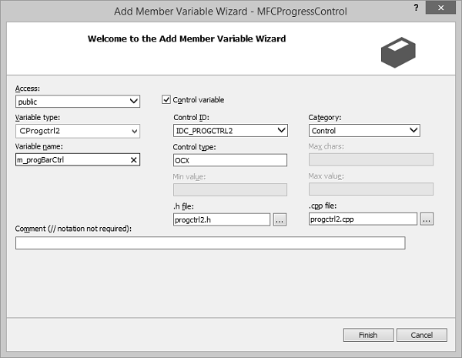

**Step 6** − Add the following code in the OnInitDialog()

m\_progBarCtrl.SetScrollRange(0,100,TRUE);

m\_progBarCtrl.put\_Value(53);

**Step 7** − When you run this application again, you will see the progress bar in Vertical direction as well.

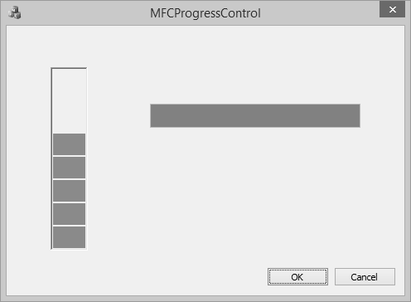

\*\*\*\*\*

**UNIT IV**

**Middleware and Component-based E-commerce Architectures:** CORBA, Java Remote Method Invocation (RMI), Microsoft’s Distributed Component Object Model

**Electronic Data Interchange** (EDI): An Overview of EDI, the Origins of EDI, Understanding EDI, Data Exchange Standards, EDI Architecture, The Significance of EDI in International Trade, Financial EDI, EDI and the Internet.

**Extensible Markup Language** (XML): Standard Generalized Markup Language (SGML), Basics of XML, XML parsers, The Need for a Standard.

**Wireless Application Protocol** (WAP): Limitations of Mobile Devices, The emergence of WAP, WAP Architecture, The WAP Stack, Concerns about WAP and its Future, Alternatives to WAP.

**Middleware and Component-based E-commerce Architectures**

**CORBA:**

The Common Object Request Broker Architecture (CORBA) is a standard developed by the Object Management Group (OMG) to provide interoperability among distributed objects. CORBA is the world's leading middleware solution enabling the exchange of information, independent of hardware platforms, programming languages, and operating systems. CORBA is essentially a design specification for an Object Request Broker (ORB), where an ORB provides the mechanism required for distributed objects to communicate with one another, whether locally or on remote devices, written in different languages, or at different locations on a network.

The CORBA Interface Definition Language, or IDL, allows the development of language and location-independent interfaces to distributed objects. Using CORBA, application components can communicate with one another no matter where they are located, or who has designed them. CORBA provides the location transparency to be able to execute these applications.

CORBA is often described as a "software bus" because it is a software-based communications interface through which objects are located and accessed. The illustration below identifies the primary components seen within a CORBA implementation.

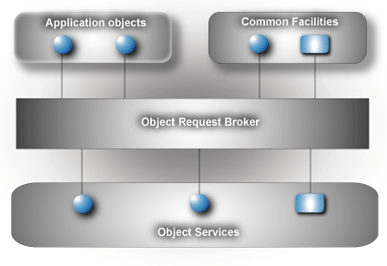

\*\*\*\*\*

**Java Remote Method Invocation (RMI):**

RMI stands for **Remote Method Invocation**. It is a mechanism that allows an object residing in one system (JVM) to access/invoke an object running on another JVM.

RMI is used to build distributed applications; it provides remote communication between Java programs. It is provided in the package **java.rmi**.

**Architecture of an RMI Application:-**

In an RMI application, we write two programs, a **server program** (resides on the server) and a **client program** (resides on the client).

* Inside the server program, a remote object is created and reference of that object is made available for the client (using the registry).
* The client program requests the remote objects on the server and tries to invoke its methods.

The following diagram shows the architecture of an RMI application.

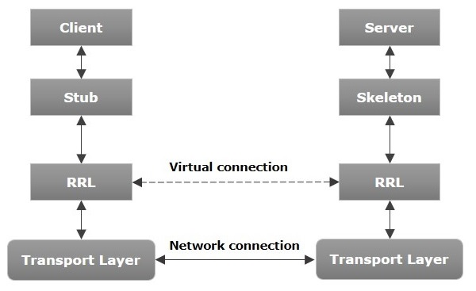

Let us now discuss the components of this architecture.

* **Transport Layer** − This layer connects the client and the server. It manages the existing connection and also sets up new connections.
* **Stub** − A stub is a representation (proxy) of the remote object at client. It resides in the client system; it acts as a gateway for the client program.
* **Skeleton** − This is the object which resides on the server side. **stub** communicates with this skeleton to pass request to the remote object.
* **RRL(Remote Reference Layer)** − It is the layer which manages the references made by the client to the remote object.

**Working of an RMI Application**

The following points summarize how an RMI application works −

* When the client makes a call to the remote object, it is received by the stub which eventually passes this request to the RRL.
* When the client-side RRL receives the request, it invokes a method called **invoke()** of the object **remoteRef**. It passes the request to the RRL on the server side.
* The RRL on the server side passes the request to the Skeleton (proxy on the server) which finally invokes the required object on the server.
* The result is passed all the way back to the client.

**RMI Registry**

RMI registry is a namespace on which all server objects are placed. Each time the server creates an object, it registers this object with the RMIregistry (using **bind()** or **reBind()** methods). These are registered using a unique name known as **bind name**.

To invoke a remote object, the client needs a reference of that object. At that time, the client fetches the object from the registry using its bind name (using **lookup()** method).

The following illustration explains the entire process −

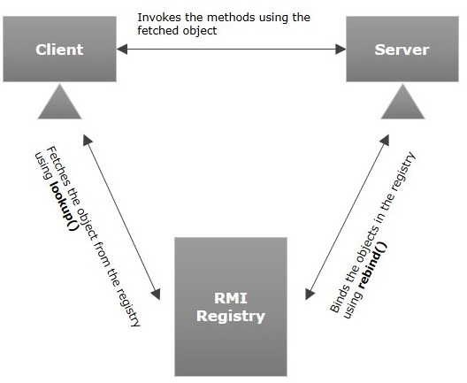

**Goals of RMI**

Following are the goals of RMI −

* To minimize the complexity of the application.
* To preserve type safety.
* Distributed garbage collection.
* Minimize the difference between working with local and remote objects.

\*\*\*\*\*

**Microsoft’s Distributed Component Object Model:**

DCOM is a programming technique that allows a computer to run programmes on a remote computer as if they were running locally. The Distributed Component Object Model (DCOM) is an acronym for Distributed Component Object Model. It is a software component that enables COM objects to communicate over the network.

DCOM is an extension of COM that addresses a few issues with the COM model to make it more beneficial over a network –

* **Marshalling** − Marshalling solves the problem of delivering data from one COM object instance to another on a different machine; in programming words, this is referred to as "passing arguments."
* **Distributed Garbage Collection** − Designed to scale DCOM to handle high-volume internet traffic, Distributed Garbage Collection also includes a mechanism for deleting and reclaiming completed or abandoned DCOM objects, preventing web server memory from being blown up. It then communicates with the other servers in the transaction chain, informing them that the transaction's objects are available for deletion.
* **DCE/RPC is used as the underlying RPC mechanism** − Microsoft built DCE/RPC as the underlying technology for DCOM – where the D in DCOM comes from – to achieve the goals mentioned earlier attempt to scale to support a significant volume of web traffic.

The following table highlights the major points that differentiate COM and DCOM –

| **COM** | **DCOM** |
| --- | --- |
| It stands for Component Object Model. | It stands for Distributed Component Object Model. |
| COM is a set of components tools which are executed on client-side environment. | DCOM runs on the given server. |
| COM objects require installation on machine where it is to be used. | It requires installation somewhere on the same network. |
| COM is an interface standard. | DCOM is a model designed for distributed applications. |
| It allows reusability of objects. | It doesn't allow reusability. |

\*\*\*\*\*

**Electronic Data Interchange (EDI)**

**An Overview of EDI:**

EDI stands for Electronic Data Interchange. EDI is an electronic way of transferring business documents in an organization internally, between its various departments or externally with suppliers, customers, or any subsidiaries. In EDI, paper documents are replaced with electronic documents such as word documents, spreadsheets, etc.

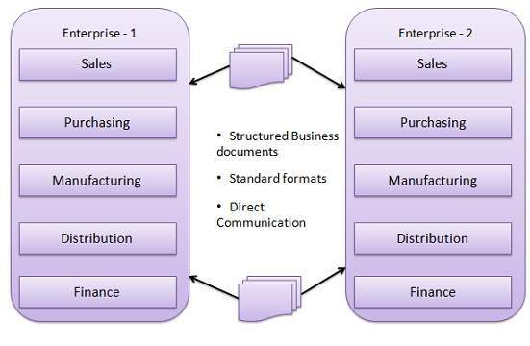

**EDI Documents**

Following are the few important documents used in EDI −

* Invoices
* Purchase orders
* Shipping Requests
* Acknowledgement
* Business Correspondence letters
* Financial information letters

**Steps in an EDI System**

Following are the steps in an EDI System.

* A program generates a file that contains the processed document.
* The document is converted into an agreed standard format.
* The file containing the document is sent electronically on the network.
* The trading partner receives the file.
* An acknowledgement document is generated and sent to the originating organization.

**Advantages of an EDI System**

Following are the advantages of having an EDI system.

* **Reduction in data entry errors.** − Chances of errors are much less while using a computer for data entry.
* **Shorter processing life cycle** − Orders can be processed as soon as they are entered into the system. It reduces the processing time of the transfer documents.
* **Electronic form of data** − It is quite easy to transfer or share the data, as it is present in electronic format.
* **Reduction in paperwork** − As a lot of paper documents are replaced with electronic documents, there is a huge reduction in paperwork.
* **Cost Effective** − As time is saved and orders are processed very effectively, EDI proves to be highly cost effective.
* **Standard Means of communication** − EDI enforces standards on the content of data and its format which leads to clearer communication.

\*\*\*\*\*

**The Origins of EDI:**

Electronic data interchange (EDI) is the computer-to-computer exchange of business documents and information. Fundamentally, EDI is a methodology. It’s a set of best practices, standards, processes and technology that enables the free flow of information between different businesses — specifically, different businesses within a single supply chain.

For example, a car manufacturer (e.g. BMW) buys parts from a load of different companies. It then needs to distribute manufactured cars to auto-dealers — only some of which are under the direct control of BMW. Each of those purchase orders and invoices could be done manually (printing out orders, manually re-entering data, email or mailing invoice etc.). Or it could just be done electronically and automatically using EDI.

However, to automatically exchange information between different companies, the different systems need to be able to understand each other. That means they need to use standardised formatting and compatible technology. EDI is all of the components and processes required to deliver this electronic and automated outcome.

At [Data Interchange,](https://datainterchange.com/) we’ve spent decades helping businesses implement EDI systems, and are pioneering new ways to optimise modern EDI outcomes. Here, we are going to explain EDI, how it works, how it’s changing, and how exactly it stands to shape the future of [supply chain management.](https://datainterchange.com/what-is-the-future-of-supply-chain-management-in-2021/)

\*\*\*\*\*

**Understanding EDI:**

Electronic data interchange (EDI) is the digital exchange of business documents between companies using computers, replacing old school faxing and mailing methods. Standard documents exchanged through EDI include purchase orders, invoices, and shipping documents. EDI is used in a variety of industries by more than 100,000 companies, most of whom require their trading partners also to adopt EDI to ensure continuity, collaboration, and the standardization or ordering and communication.

Electronic data interchange is now widely used both in the United States and globally, based on a number of standards that have been enacted that provide basic guidelines for its use. The two standards bodies that are most frequently associated with Electronic Data Interchange are the ANSI X12 standard, used primarily in the US, and the UN EDIFACT standard that is used outside of the United States.

**Automated Communication**

To truly understand EDI, you need to break down each step in the exchange process. How EDI differs from traditional communication between businesses lies within how information is transferred. EDI is a computer-to-computer exchange, without the need for any manual input. It aims to completely replace the time-consuming nature of mail, fax, or even electronic mail.

When humans intervene in a communication process, it inevitably slows the exchange process while increasing the risk of error. With each supplier and client having unique requirements when it comes to conducting business, trying to remember small nuances can be impossible. EDI uses this data to seamlessly ensure all business requirements are met in order for companies, suppliers, manufacturers, and merchants can meet all expectations.

A traditional ordering process is a long and arduous process, that looks something like this:

1. A buyer fills out a purchasing order and then faxes or mails it to a supplier.

2. The supplier checks inventory and then manually enters the order into an ERP system.

3. The supplier sends an invoice to the buyer and waits.

4. The buyer enters the invoice manually into their ERP system and waits for processing.

5. Once the supplier is paid, they send confirmation of shipment.

EDI dramatically simplifies the exchange between a buyer and supplier. A buyer’s internal system uses EDI to send a purchase order, which is accepted by the supplier’s internal network. Everything is exchanged in real-time without the need for faxing, mailing, or manual entry.

This automated exchange between computer systems allows for much faster and more accurate transactions between businesses. For retailers, distributors, and vendors, speed is necessary to meet the needs of their clients and run a successful company. EDI assists in orchestrating and organizing these transactions so businesses can consistently meet the needs of their customers and clients. While EDI is commonly implemented for the benefit of larger firms, it can be incredibly beneficial for small and mid-sized businesses too. If a company expects explosive growth, having an EDI solution in place will better prepare them for a successful future in meeting increasing demand.

\*\*\*\*\*

**Data Exchange Standards:**

**Data Exchange Standards facilitate the sharing of structured data across different information systems. Data Exchange Standards are optimized to represent CDISC content, and flexible enough to be used by information systems that haven’t implemented the Foundational Standards (e.g., legacy data, academic studies).**

[**Clinical Trial Registry (CTR)-XML**](https://www.cdisc.org/standards/data-exchange/ctr-xml)**:** lets technology vendors implement tools that support a “write once, use many times” solution based on a single XML file that holds the information needed to generate submissions for multiple clinical trials for clinical trial registry submissions primarily to the World Health Organization (WHO),European Medicines Agency (EMA) EudraCT Registry and United States ClinicalTrials.gov.

[**Operational Data Model (ODM)-XML**](https://www.cdisc.org/standards/data-exchange/odm)**:**

 is a vendor-neutral, platform-independent format for exchanging and archiving clinical and translational research data, along with their associated metadata, administrative data, reference data, and audit information. ODM-XML facilitates the regulatory-compliant acquisition, archival and exchange of metadata and data. It has become the language of choice for representing case report form content in many electronic data capture (EDC) tools. ​

[**Study/Trial Design Model in XML (SDM-XML)**](https://www.cdisc.org/standards/data-exchange/sdm-xml)**:**

is an extension of ODM-XML and allows organizations to provide rigorous, machine-readable, interchangeable descriptions of the designs of their clinical studies, including treatment plans, eligibility and times and events. SDM-XML defines three key sub-modules – Structure, Workflow, and Timing – permitting various levels of detail in any representation of a clinical study’s design.

[**Define-XML**](https://www.cdisc.org/standards/data-exchange/define-xml)**:**

transmits metadata that describes any tabular dataset structure. When used with the CDISC Foundational standards, it provides the metadata for human and animal model datasets using the SDTM and/or SEND standards and analysis datasets using ADaM. Define-XML is required by the United States Food and Drug Administration (FDA) and the Japanese Pharmaceuticals and Medical Devices Agency (PMDA) for every study in each electronic submission to inform the regulators which datasets, variables, controlled terms, and other specified metadata were used.

[**Dataset-XML**](https://www.cdisc.org/standards/data-exchange/dataset-xml)**:**

 supports the exchange of dataset data based on Define-XML metadata. Dataset-XML complements Define-XML and provides an alternative to the SAS V5 Transport format for the exchange of study datasets for CDISC's Foundational standards. Dataset-XML is a truly non-proprietary, global standard, removing many SAS V5 Transport file restrictions (the current file format required by the FDA and PMDA), such as 8-character variable names and 200-character text fields.

[**CDISC Standards in RDF**](https://www.cdisc.org/standards/data-exchange/rdf)**:**

 provides a representation of the CDISC Foundational standards in a model based on the Resource Description Framework (RDF). RDF provides executable, machine-readable CDISC standards from [**CDISC Library**](https://www.cdisc.org/cdisc-library). This file format is a “linked data” view of the standards as an ontology.

[**The Laboratory Data Model (**](https://www.cdisc.org/standards/data-exchange/lab)[**LAB**](https://www.cdisc.org/standards/foundational/lab)[**)**](https://www.cdisc.org/standards/transport/lab)**:**

 provides a standard model for the acquisition and exchange of laboratory data, primarily between labs and sponsors or CROs. The LAB standard was specifically designed for the interchange of lab data acquired in clinical trials.

\*\*\*\*\*

**EDI Architecture:**

**EDI architechture specifies 4 layers**:-

1)Semantic (application layer)

2)Standard transaction layer

3)Packing (transport) layer

4)Physical n/w infrastructure layer.

**1)Semantic layer:-** It describes the business application that is driving EDI.

For a procurement application, this translates into requests for quotes, price quotes, purchase orders, acknowledgements & involves.

The [information](https://ecomputernotes.com/fundamental/information-technology/what-do-you-mean-by-data-and-information) seen at this layer must be translated from a company specific from to a more generic form so that it can be send to various trading partners, who could be using a variety of software applications at this end.

When a trading partner sends a document, the EDI translation software converts the proprietary format into a standard mutually agreed on by the processing system. When a company receivers the document, their EDI translation software automatically changes the standard format into proprietary format of their document processing software so that company can manipulate the [information](https://ecomputernotes.com/fundamental/information-technology/what-do-you-mean-by-data-and-information) in whatever way it chooses to.

**2)EDI standards:-** It specify business form structure and it also influence the content at application layer.

The most two important standards are:-

     – EDIPACT

     – ANSI X12

**3.EDI transport layer:-** it corresponds closely with the non-electronic activity of sending a business form from one company A to company B.

The business form could be sent via regular postal service, registered mail, certified mail or private carrier such as united pariel service (UPS) or simply faxed between the companies.

EDI semantic layer application level services

EDI standard layer EDIFACT

ANSI X12

EDI transport layer e- mail X 435

Point2point FTP,www HTTP

**4.Physical layer :-** Dial up lines

\*\*\*\*\*

**The Significance of EDI in International Trade:**

EDI was developed to solve the problems inherent in paper-based transaction processing and in other forms of electronic communication. In solving these problems, EDI is a tool that enables organizations to reengineer information flows and business processes. Problems with the paper-based transaction system are:

* **Time delays:** Delays are caused primarily by two factors. Paper documents may take days to transport from one location to another. In addition, manual processing delays are caused by the need to key, file, retrieve, and compare data.
* **Labor costs:** In non-EDI systems, manual processing is required for data keying, document storing and retrieving, sorting, matching, reconciling, envelope stuffing, stamping, signing, etc. While automated equipment can help with some of these processes, most managers will agree that labor costs for document processing represents a significant proportion of their **overhead.**In general, labor-based processes are much more expensive than non-labor-intensive operations involving computers and telecommunications.
* **Errors:** Because information is keyed multiple times and documents are transported, stored, and retrieved by people, non-EDI systems tend to be error prone.
* **Uncertainty:** Uncertainty exists in two areas. First, paper transportation and other manual processing delays mean that the time the document is received is uncertain. Once a transaction is sent, the sender does not know when the transaction will be received nor when it will be processed. Second, the sender does not even know whether the transaction has been received at all nor whether the receiver agrees with what was sent in the transaction.
* **High Inventories:** Because of time delays and uncertainties in non EDI processing, inventories are often higher than necessary. Lead times with paper processing are long. In a manufacturing firm, it may be virtually impossible to achieve a just-in-time inventory system with the time delays inherent in non-EDI processing systems.
* **Information Access:** EDI permits user access to a vast amount of detailed transaction data—in a non-EDI environment this is possible only with great effort and time delay. Because EDI data is already in computer-retrievable form, it is subject to automated processing and analysis. Such information helps one retailer, for example, monitor sales of toys by model, color, and customer zip code. This enables the retailer to respond very quickly to changes in consumer taste.

\*\*\*\*\*

**Financial EDI:**

EDI technology is used in the Finance/Banking Industry to improve operational efficiency and reduce transaction costs across the supply chain, comprising of Manufacturers, Suppliers, Customers, and Logistics providers, Retailers, Wholesalers etc. Financial EDI allows for funds to be transferred electronically between financial institutions - EDT (Electronic Data Transfer). EDT enables employers to directly deposit payroll cheques, consumer accounts can be directly debited and businesses can pay government taxes electronically.

**Examples of organizations using EDI in the Finance/Banking Industry:-**  
Standard Bank, FNB, Absa, KPMG, Pricewaterhouse Coopers, Ernst & Young, Deloitte, Alexander Forbes, Capitec Bank, Santam Limited, Hollard Insurance Group, Allan Gray.  
  
**Associations for EDI in the Finance/Banking Industry:-** [Bank Of America](https://www.jobisez.com/edi/tp/vendor.aspx?id=Bank%20of%20America), [Finance](https://www.jobisez.com/edi/tp/vendor.aspx?id=Finance), [Christopher and Banks](https://www.jobisez.com/edi/tp/vendor.aspx?id=Christopher%20and%20Banks), [SWIFT](https://www.swift.com/), [ISO](https://www.iso.org/), [NACHA](https://www.nacha.org/), [BIAN](https://www.bian.org/)

\*\*\*\*\*

**EDI and the Internet:**

EDI traditional technology was updated during the Internet/e-business era through the use of EDI/Internet (EDIINT) technology. EDIINT technology makes it feasible for business of all sizes to process transactions in a structured form by computer. EDIINT technology provides compatibility, open standards, analytical capabilities, and an ease of use through the format of eXtensible Markup Language (XML) while preserving EDI traditional structured standards ([Batson, 1997](https://www.tandfonline.com/doi/full/10.1080/15256480903088683)). The purpose of this article is to illustrate that hotels of all sizes can use EDI in the Internet e-business era to conduct business with their trading partners in a cost effective manner.

EDI is define as an interorganizational and intraorganizational, computer-to-computer exchange of business documentation in a structured, computer-processable data format in a timely manner.

This definition distinguishes EDI information flow from the traditional information flow shown in [Figure 1](https://www.tandfonline.com/doi/full/10.1080/15256480903088683#F0001).

**FIGURE 1** Traditional and EDI Information Flow.

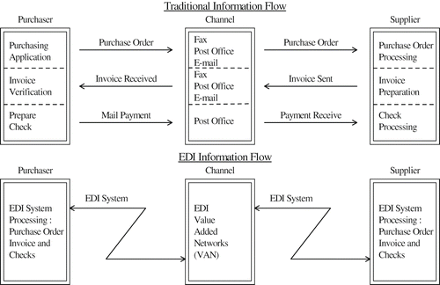

There are a number of key points in the definition that makes EDI a unique form of business data electronically transmitted. Interorganizational means that EDI technology can be used for electronic processing and the communication of information between trading partners. Intraorganizational is the use of EDI within an organization to support internal business processes between individuals and departments. Computer-to-computer indicates a direct link between computer systems. Business documentation implies the use of official paper to support transaction flow. For example, items such as customer name, product number, quantity, unit price, and total value can be structured into an invoice or a purchase order document. Structured means that there should be no discrepancies between the data in a purchase order and the data in an invoice because of the agreed upon method used in presenting the data. *Computer* processable format means that the data must be in some pre-established structured format and can be read and understood by the computer without human interpretation.

This definition distinguishes EDI from other forms of e-commerce because of its structured format of data. Paper documents, e-mails, and faxes do not have a specific, universally accepted data format. These forms of communication are handled using computers, manually, or by a combination of both methods. With EDI, data must be understood by the communicating computer systems. That means data must be preformatted and should be based on standards acceptable to the trading partners, and computers must be programmed to understand the incoming and outgoing data format.

[Figure 2](https://www.tandfonline.com/doi/full/10.1080/15256480903088683#F0002) illustrates the four major groups of EDI applications that can be used in a hotel business environment. Trade data interchange (TDI) is the electronic transfer of trading documents such as purchase orders, invoices and acknowledgements between hotels and their trading partners. Financial electronic data interchange (FEDI) is the electronic transmission of payments deposits and remittance information between a payer, payee and their respective banks ([Pushkin & Morris, 1997](https://www.tandfonline.com/doi/full/10.1080/15256480903088683)). Electronic funds transfer (EFT) is an automatic transfer of debits and credits between banks, in which funds flow directly from the payer's banks to the payee's bank. Value added banks (VAB) are banks that act as communications and network intermediaries for their customers, combining both TDI and FEDI services.

**FIGURE 2** Four major groups as EDI applications that can be used in a hotel.

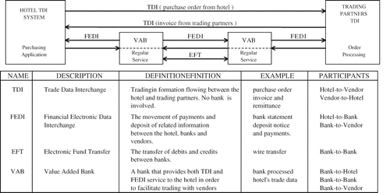

\*\*\*\*\*

**Extensible Markup Language (XML)**

**Standard Generalized Markup Language (SGML):**

 SGML (Standard Generalized Markup Language) is a standard for how to specify a document markup language or tag set. Such a specification is itself a document type definition (DTD). SGML is not in itself a document language, but a description of how to specify one. It is metadata.

SGML is based on the idea that documents have structural and other semantic elements that can be described without reference to how such elements should be displayed. The actual display of such a document may vary, depending on the output medium and style preferences. Some advantages of documents based on SGML are:

* They can be created by thinking in terms of document structure rather than appearance characteristics (which may change over time).
* They will be more portable because an SGML compiler can interpret any document by reference to its document type definition (DTD).
* Documents originally intended for the print medium can easily be re-adapted for other media, such as the computer display screen.

The language that this Web browser uses, Hypertext Markup Language ([HTML](https://www.theserverside.com/definition/HTML-Hypertext-Markup-Language)), is an example of an SGML-based language. There is a document type definition for HTML (and reading the HTML specification is effectively reading an expanded version of the document type definition). In today's distributed networking environment, many documents are being described with the Extensible Markup Language (XML) which is a data description language (and a document can be viewed as a collection of data) that uses SGML principles.

SGML is based somewhat on earlier generalized markup languages developed at IBM, including General Markup Language (GML) and ISIL.

\*\*\*\*\*

**Basics of XML:**

XML stands for **E**xtensible **M**arkup **L**anguage. It is a text-based markup language derived from Standard Generalized Markup Language (SGML).

XML tags identify the data and are used to store and organize the data, rather than specifying how to display it like HTML tags, which are used to display the data. XML is not going to replace HTML in the near future, but it introduces new possibilities by adopting many successful features of HTML.

There are three important characteristics of XML that make it useful in a variety of systems and solutions −

* **XML is extensible** − XML allows you to create your own self-descriptive tags, or language, that suits your application.
* **XML carries the data, does not present it** − XML allows you to store the data irrespective of how it will be presented.
* **XML is a public standard** − XML was developed by an organization called the World Wide Web Consortium (W3C) and is available as an open standard.

**XML Usage:-**

A short list of XML usage says it all −

* XML can work behind the scene to simplify the creation of HTML documents for large web sites.
* XML can be used to exchange the information between organizations and systems.
* XML can be used for offloading and reloading of databases.
* XML can be used to store and arrange the data, which can customize your data handling needs.
* XML can easily be merged with style sheets to create almost any desired output.
* Virtually, any type of data can be expressed as an XML document.

**What is Markup?**

XML is a markup language that defines set of rules for encoding documents in a format that is both human-readable and machine-readable. So *what exactly is a markup language?* Markup is information added to a document that enhances its meaning in certain ways, in that it identifies the parts and how they relate to each other. More specifically, a markup language is a set of symbols that can be placed in the text of a document to demarcate and label the parts of that document.

Following example shows how XML markup looks, when embedded in a piece of text −

<message>

<text>Hello, world!</text>

</message>

This snippet includes the markup symbols, or the tags such as <message>...</message> and <text>... </text>. The tags <message> and </message> mark the start and the end of the XML code fragment. The tags <text> and </text> surround the text Hello, world!.

**Is XML a Programming Language?**

A programming language consists of grammar rules and its own vocabulary which is used to create computer programs. These programs instruct the computer to perform specific tasks. XML does not qualify to be a programming language as it does not perform any computation or algorithms. It is usually stored in a simple text file and is processed by special software that is capable of interpreting XML.

\*\*\*\*\*

**XML parsers:**

**XML parser** is a software library or a package that provides interface for client applications to work with XML documents. It checks for proper format of the XML document and may also validate the XML documents. Modern day browsers have built-in XML parsers.

Following diagram shows how XML parser interacts with XML document −

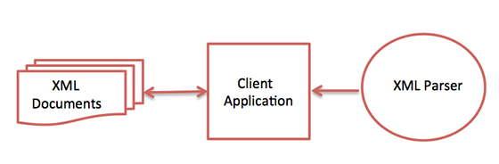

The goal of a parser is to transform XML into a readable code.

To ease the process of parsing, some commercial products are available that facilitate the breakdown of XML document and yield more reliable results.

Some commonly used parsers are listed below –

* **MSXML (Microsoft Core XML Services)** − This is a standard set of XML tools from Microsoft that includes a parser.
* **System.Xml.XmlDocument** − This class is part of .NET library, which contains a number of different classes related to working with XML.
* **Java built-in parser** − The Java library has its own parser. The library is designed such that you can replace the built-in parser with an external implementation such as Xerces from Apache or Saxon.
* **Saxon** − Saxon offers tools for parsing, transforming, and querying XML.
* **Xerces** − Xerces is implemented in Java and is developed by the famous open source Apache Software Foundation.

\*\*\*\*\*

**The Need for a Standard:**

XML has a variety of uses for Web, e-business, and portable applications.

The following are some of the many applications for which XML is useful:

* **Web publishing**: XML allows you to create interactive pages, allows the customer to customize those pages, and makes creating e-commerce applications more intuitive. With XML, you store the data once and then render that content for different viewers or devices based on style sheet processing using an Extensible Style Language (XSL)/XSL Transformation (XSLT) processor.
* **Web searching and automating Web tasks**: XML defines the type of information contained in a document, making it easier to return useful results when searching the Web:

For example, using HTML to search for books authored by Tom Brown is likely to return instances of the term 'brown' outside of the context of author. Using XML restricts the search to the correct context (for example, the information contained in the <author> tag) and returns only the information that you want. By using XML, Web agents and robots (programs that automate Web searches or other tasks) are more efficient and produce more useful results.

* **General applications**: XML provides a standard method to access information, making it easier for applications and devices of all kinds to use, store, transmit, and display data.
* **e-business applications**: XML implementations make electronic data interchange (EDI) more accessible for information interchange, business-to-business transactions, and business-to-consumer transactions.
* **Metadata applications**: XML makes it easier to express metadata in a portable, reusable format.
* **Pervasive computing**: XML provides portable and structured information types for display on pervasive (wireless) computing devices such as personal digital assistants (PDAs), cellular phones, and others. For example, WML (Wireless Markup Language) and VoiceXML are currently evolving standards for describing visual and speech-driven wireless device interfaces.

\*\*\*\*\*

**Wireless Application Protocol (WAP)**

**Limitations of Mobile Devices:**

Along with the numerous benefits, mobile phones also have various limitations. Let's discuss the limitations of using mobile phones in detail.

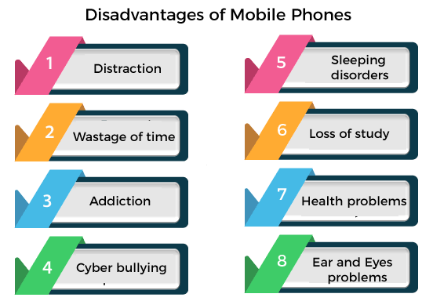

### Distraction:-

Sometimes mobile is a disturbing device that creates a distraction between your works. It is seen in students that are easily distracted from their studies because of mobiles, as the device contains applications that attract users to enjoy their software. One such application is the various mobile games that are being played a couple of days make the people addicted and distracted from their goals.

### Ear problems:-

While listening to songs, watching movies, or calling for a long time with headphones or headset can damage the listening potential of an individual. It has been seen in researches that using headphones with the louder hearing sound seriously disturbs the capability of ears to hear voice properly.

### Wastage of time:-

Although mobiles are helpful in various aspects, it is one of the biggest thing responsible for the wastage of time. Most students and teenagers are affected by it. Students want to play games, watching movies, listening songs, and other kinds of entertainment that waste their precious time.

### Addiction to mobile phone:-

Addiction to mobile phones is termed "Nomophobia". In this mental disorder, people are unable to stop themselves without using mobile phones. They even can't imagine themself without a mobile. Using mobile phones too much makes a person addicted to them.

### Cyberbullying:-

Cyberbullying means to send, post, or share negative, false, and harmful content about someone else. Research shows that most students and teenagers got cyberbullied. Cyberbullying puts someone's life in danger.

### Security issues:-

These are the common issues that happen with mobile users. iPhone IOS is little bit secure but in android phones breaching someone's privacy and data is easier for hackers. Security issues are the dangerous effects of using mobile phones for people. People faced a lot of problems due to security issues, such as loss of money, image, reputation, and others.

### Loss of study:-

Using mobile phones in excessive amounts is a major disadvantage for students. Mobile phones mostly affect the study of students. Mobile phones distract students from the study. Students majorly focus on playing games, watching movies, and other entertainment on mobile that decreases their grades.

### Health problems:-

Excessive use of mobile phones causes the health problems such as swelling of the eyes and other eyesight problems. Mobile phones include mental disorders such as Anger, depression, anxiety, tension, and others.

### Sleeping issues:-

Using the mobile phone in an excessive amount badly affects the sleeping routine. People use mobile even during sleeping time. At night, some people stuck on their mobile phone's screen that disturbed their sleeping routine a lot.

### Accidents:-

People stuck in their mobiles, even walking on roads, or driving a car. Using a mobile phone while driving causes accidents and puts the lives of others at risk. It is very dangerous to use mobile while driving, as mobile users while driving can injure them and can kill other people by accidents.

### Distance from relatives:-

Although mobiles connect the people from a distance and we can communicate with them easily, but if we do not use it properly, it can create distance from friends, relatives, family members that are close to us. It is observed many times that the members of a family are sitting in a restaurant and stuck to their phones and not talking with each other.

\*\*\*\*\*

**The emergence of WAP:**

WAP is a protocol that is introduced in 1999, which stands for Wireless application protocol. It offers Internet communications over wireless devices, such as mobile phones. In the early 2000s, it accomplished some popularity and was mainly superseded by more recent standards by the 2010s. Also, it offers a way of creating web applications for mobile devices, and it is designed for micro-browsers.

Most of the wireless networks are supported by [WAP](https://www.javatpoint.com/wireless-application-protocol-in-mobile-computing), as well as TDMA, [CDMA](https://www.javatpoint.com/cdma-full-form), and [GSM](https://www.javatpoint.com/gsm-full-form). Also, all operating systems can support a wireless application protocol. It enables access to the internet in mobile devices and uses the mark-up language like WML, which stands for Wireless Markup Language that is referred to as [XML](https://www.javatpoint.com/xml-tutorial) 1.0 application. WAP offers the facility to connect interactive wireless devices (like mobile phones) to the internet and enhances wireless specification interoperability.

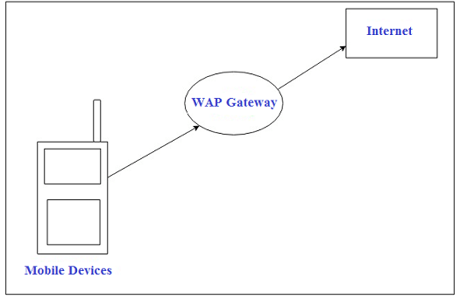

WAP may be created on any kind of operating system, and it acts in an open application environment. It is more beneficial for mobile users as it has the ability to deliver electronic information efficiently. In 1998, Nokia, Motorola, Ericson, and Unwired Planet founded the WAP Forum, whose objective was to standardize several wireless technologies with the help of protocols.

The WAP [CSS (cascading style sheet)](https://www.javatpoint.com/css-tutorial) makes capable of developers to format screen sizes in order to mobile device adaptability. When the WAP CSS content is used, then reformatting is not required. It controls page layout compatibility with different mobile device's display screens.Hello Java Program for Beginners

The transport layer handles the physical network issues, by which wireless gateways can be easily accessed by global wireless operations. A WAP gateway is a server, which provides the facility to access the wireless network. The WAP Forum offers specification development, WAP tool testing and also provides support for all mobile services. Now, the WAP Forum is referred to as the Open Mobile Alliance.

### WAP Model:-

In the mobile device, the user opens the web browser and access the website and visit webpages accordingly. The mobile device forwards the [URL](https://www.javatpoint.com/url-full-form) request to a WAP gateway through the network using the WAP protocol. Then, the WAP gateway refers to this request over the internet after translating it into a conventional [HTTP](https://www.javatpoint.com/http) URL request. The specified Web server accepts the request and processes the request. Then, it returns the response to the mobile device in the WML file through the WAP gateway that will be displayed in the web browser on the device.

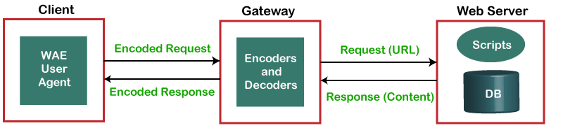

\*\*\*\*\*

**WAP Architecture:**

WAP is designed in a layered fashion, so that it can be extensible, flexible, and scalable. As a result, the WAP protocol stack is divided into five layers –

## Layers of WAP Protocol:-

**Application Layer:-**

Wireless Application Environment (WAE). This layer is of most interest to content developers because it contains among other things, device specifications, and the content development programming languages, WML, and WMLScript.

### Session Layer:-

Wireless Session Protocol (WSP). Unlike HTTP, WSP has been designed by the WAP Forum to provide fast connection suspension and reconnection.

### Transaction Layer:-

Wireless Transaction Protocol (WTP). The WTP runs on top of a datagram service, such as User Datagram Protocol (UDP) and is part of the standard suite of TCP/IP protocols used to provide a simplified protocol suitable for low bandwidth wireless stations.

### Security Layer:-

Wireless Transport Layer Security (WTLS). WTLS incorporates security features that are based upon the established Transport Layer Security (TLS) protocol standard. It includes data integrity checks, privacy, service denial, and authentication services.

### Transport Layer:-

Wireless Datagram Protocol (WDP). The WDP allows WAP to be bearer-independent by adapting the transport layer of the underlying bearer. The WDP presents a consistent data format to the higher layers of the WAP protocol stack, thereby offering the advantage of bearer independence to application developers.

Each of these layers provides a well-defined interface to the layer above it. This means that the internal workings of any layer are transparent or invisible to the layers above it. The layered architecture allows other applications and services to utilise the features provided by the WAP-stack as well. This makes it possible to use the WAP-stack for services and applications that currently are not specified by WAP.

The WAP protocol architecture is shown below alongside a typical Internet Protocol stack.

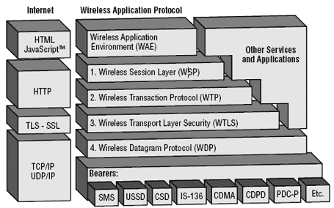

Note that the mobile network bearers in the lower part of the figure above are not part of the WAP protocol stack.

\*\*\*\*\*

**The WAP Stack:**

**1.**[**Application Layer**](https://www.javatpoint.com/computer-network-application-layer)**(WAE)**

The Wireless Application Environment contains content development programming languages like WML and mobile device specifications. It functions much like a [JavaScript](https://www.javatpoint.com/javascript-tutorial) and holds the tools that wireless Internet content developers use. It includes scripting languages such as WML and WMLScript that are used in conjunction with WML.

**2.**[**Session Layer**](https://www.javatpoint.com/iot-session-layer-protocols)**(WSP)**

It determines the session will be connection-oriented or connectionless between the device and the network and offers a reconnection and fast connection suspension. The data is passed both ways between the network and the device in the connection-oriented session. Then, WSP forwards the packet to the next layer WTP (Wireless Transaction Protocol). When the information is being streamed or broadcast from the network to the device, commonly, the connectionless session is used. Then, WSP forwards the packet to the WDP (Wireless Datagram Protocol) layer.

**3. Transaction Layer (WTP)**

The Wireless Transaction Protocol offers transaction support. It is a part of [TCP/IP](https://www.javatpoint.com/computer-network-tcp-ip-model) and runs on top of UDP, which stands for User Datagram Protocol.

**4. Security Layer (WTLS)**

The Wireless Transport Layer Security provides security in terms of data integrity, privacy and authentication that help to save your data. It also has the ability to work like Transport Layer Security. Also, it contains security features that have Transport Layer Security.

**5.**[**Transport Layer**](https://www.javatpoint.com/computer-network-transport-layer)**(WDP)**

With the network carrier layer, the Wireless Datagram Protocol functions in conjunction and presents a constant data format to higher layers of WAP protocol stack.

\*\*\*\*\*

**Concerns about WAP and its Future:**

The future of WAP depends largely on whether consumers decide to use WAP devices to access the Web, and also on whether a new technology comes along that would require a different infrastructure than WAP.

On the consumer side, the factors largely involve the limitations of WAP and of handheld devices, the low bandwidth, the limited input ability, and the small screens all require users to adapt from their regular Web-browsing expectations.

In the next few years, mobile phones will start to benefit from very high bandwidth capabilities. The 2.5G/3G systems will allow much higher capacity and data rates, than can be offered by the restricted bandwidth currently available.

These wireless devices will be supported by a number of emerging technologies including GPRS, EDGE, HSCSD, and UMTS:

So what is the future for WAP? It has been designed to be independent of the underlying network technology. The original constraints WAP was designed for - intermittent coverage, small screens, low power consumption, wide scalability over bearers and devices, and one-handed operation - are still valid in 2.5G and 3G networks.

The bottom line is that WAP is not and can never be the Web on your mobile phone. WAP is great as long as developers understand that it's what's inside the applications that matters, and the perceived value of the content to the user. The browser interface itself, while important will always be secondary to the content.

\*\*\*\*\*

**Alternatives to WAP:**

**Double-barreled** Critical Path Software Inc. rolled out an upgraded version of its server designed to help service providers and businesses deliver two-way text messaging to users.

**Substitute for WAP** Officials with the San Francisco company said InVoke SMS (Short Message Service) Server 4.0 will give customers an alternative to WAP (Wireless Application Protocol) technologies.

**New e-mail client** Among InVokes features are a new IMAP4 e-mail client, a wireless messaging technology for non-WAP devices that mirrors what a user gets using a desktop and a software developers kit.

**Ease of use** Users can send messages across SMS carriers and access e-mail. InVoke Server 4.0 is available now, with pricing averaging $2.50 per subscriber.

\*\*\*\*\*

THE- END